Mine samlede mikro 2 eksamensbesvarelser
Indholdsfortegnelse
Mine samlede mikro 2 eksamensbesvarelser 1
Mikro eksamen juni 2019 3
Question 1 Normal form game mixed strategy and SPNE 3
Question 2 normal form repeated game 5
Question 3 Adverse selection 7
Question 4 Investment opportunity 10
Mikro eksamen august 2019 12
Question 1Normal form game, pure strategy NE 12
Question 2 missing picture 13
Question 3 Competitive screening in labour markets, wage-task pair 13
Question 4 Adverse selection and screening 15
Mikro eksamen juni 2020 17
Question 1 normal form 3x3 matrix, mixed strategy 17
Question 2 Signalling game 18
Question 3 Moral Hazard 20
Question 4 Adverse selection? 22
Mikro eksamen august 2020 26
Question 1 Volunteer’s dilemma 26
Question 2 Prisoner’s dilemma infinitely repeated 28
Question 3 Competitive screening in labour markets 30
Question 4 Government redistribution 32
Mikro eksamen juni 2021 34
Question 1 Signalling game 34
Question 2 Static game of complete information, NE 36
Question 3 signalling in labour markets 40
Question 4 Investment opportunity 43
Mikro eksamen august 2021 46
Question 1 Normal form, mixed strategy game 46
Question 2 Signalling game 49
Question 3 Moral hazard 52
Question 4 Signalling for used cars 55
Mikro eksamen juni 2022 58
Question 1 normal form game infinitely repeated 58
Question 2 signalling game 60
Question 3 Moral Hazard, BoD 63
Question 4 Adverse selection, market for used cars 67
Mikro eksamen august 2022 69
Question 1 static and dynamic incomplete information BNE and PBE 69
Question 2 Signalling game 71
Question 3 Moral Hazard 73
Question 4 Signalling in labour markets 77
Mikro eksamen juni 2023 79
Question 1 Extensive form game SPNE 79
Question 2 Signalling game 83
Question 3 Adverse selection 87
Question 4 Investment opportunity 89
Mikro eksamen august 2023 93
Question 1 Normal form game NE infinitely repeated game 93
Question 2 normal form and SPNE 95
Question 3 Moral Hazard BoD 98
Question 4 Signalling for used cars 101
Mikro eksamen juni 2024 104
Question 1 Normal form volunteer’s dilemma 104
Question 2 SPNE bargaining 105
Question 3 Signalling game 106
Question 4 Moral Hazard 109
Question 5 Signalling market for used goods 115
Mikro eksamen august 2024 117
Question 1 Normal form game NE, prisoners dilemma 117
Question 2 Signalling game as normal form 118
Question 3 Adverse selection 122
Question 4 Adverse selection 125

Mikro eksamen juni 2019

Question 1 Normal form game mixed strategy and SPNE
(20 points) Tom and Jerry drive two trucks loaded with dynamite toward each other on a narrow straight road, with neither willing to turn aside. The first to swerve away yields the road to the other. If both swerve, their utility is 0, and if one swerves and the other does not, the swerving driver’s utility is -1, and the other drivers utility is 1. If neither driver swerves, the result is a collision, with utility of -10 for both. Abbreviate the action swerve by SW and the action to stay on the road by ST.

- Represent this game in normal form and find the pure and mixed-strategy Nash equilibria.
So we have the normal form
Tom / Jerry | SW | ST
SW | 0,0 | -1,1
ST | 1,-1 | -10, -10
The pure strategy equilibria are
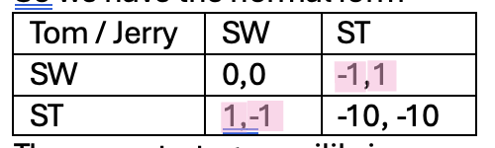
So both
$$\left(ST,SW\right), \left(SW,ST\right)$$
Are equilibria.
Now for mixed strategy equilibria:
Here we look at when they are indifferent between the two options: there is a difference of 9 when the other plays ST, and 1 when the other plays SW so we get
$$\left(\left(\frac{1}{10},\frac{9}{10}\right);\left(\frac{1}{10},\frac{9}{10}\right)\right)$$
As a mixed equilibrium.

- Now suppose that Tom’s steering wheel can be detached, and so he has the choice of throwing his steering wheel out of the window before he and Jerry (simultaneously) decide whether to swerve or not. Assume that if he throws his steering wheel out (call this action T), this would be observed by Jerry.
- B1 Represent this game in normal form and find the pure and mixed-strategy Nash equilibria.
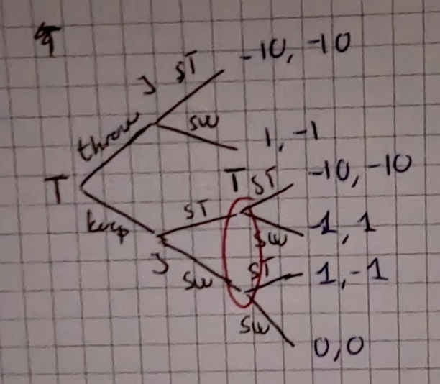

- B2 List Tom’s and Jerry’s pure strategies.
Tom has the pure strategies of $\left(T,ST\right)$, $\left(T,SW\right)$, (som jo egentlig er den samme, men det med hvad gør man hvis noget uventet sker) $\left(Keep,ST\right)$, $\left(Keep,SW\right)$.
Jerry has the pure strategies of ST og SW either given tom throws or keeps the wheel.

- B3 Find all (pure-strategy) subgame perfect Nash equilibria.
We have one subgame perfect nash equilibrium of tom throwing the wheel aways and Jerry swerving. The only other subgame if the one where tom keeps the wheel, then it is the normal form game from above and we have
$$\left(\left(K,ST\right);\left(SW,SW\right)\right), \left(\left(K,SW\right);\left(SW,ST\right)\right),\left(\left(T,ST\right);\left(SW,ST\right)\right)$$
One could argue that given tom keeping the wheel jerry should stay as he assumes if tom were to stay he would have thrown the wheel.
So might only be $\left(\left(T,ST\right);SW\right)$ that is truly subgame perfect as tom moves first.

- B4 Depict the game in normal form and describe one Nash equilibrium which is not subgame perfect.
Tom / Jerry | SW | ST
(K,SW) | 0,0 | -1,1
(K,ST) | 1,-1 | -10, -10
T | 1,-1 | -10, -10
So we get
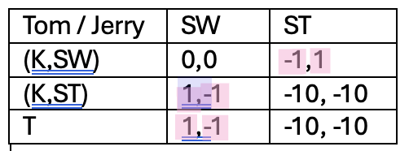
But $\left(\left(K,SW\right);ST\right)$ is not subgame perfect as tom can assure he gets positive payoff from throwing the wheel.

- B5 Which subgane perfect Nash equilibrium gives Tom the highest payoff? Briefly explain - write at most one sentence.
It is to throw the wheel $\left(\left(T,ST\right);SW\right)$ as he then gets a positive payoff certainly.

Question 2 normal form repeated game
Consider the 2-person game G given by
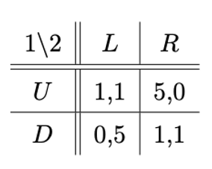
We have the game
1 / 2 | L | R
U | 1,1 | 5,0
D | 0,5 | 1,1

- Describe the outcome of this game when played once.
When we play the game once
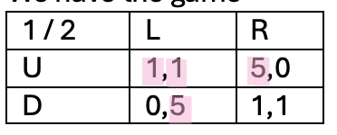
So we see that we end up with $\left(U;L\right)$ as the outcome.

- If the game is played n times with $1<n<∞,$ and both players know that the game is being repeated n times, what are the average payoffs per round for both players? Please justify your answer. Structure your answer into bullet points, write at most four bullets.
Average payoff per round for both players. Now they might be willing to play D and R as they can get a higher payoff, so maybe a strategy of play $\left(D;R\right)$ until the other deviates and then play $\left(U;L\right)$ if someone deviates. Depending on the size of n they would be willing to do this, it is easy to punish at least. So average payoff per round might be a little over 1. Otherwise stick to $\left(U;L\right)$ forever and get 1.

- How many strategies does each player have in $G^{2}$ have, i.e., the repeated game where G is played twice with the outcomes of the stage game being observed after each period? Explain how you derive this number. Structure your answer into bullet points, write at most three bullets.
So they have strategies for how to start, and strategies on what to do depending on what the other did.
- They both have 8 strategies, which one to start with (2) , and which one to play depending on what the other started with (4) and then the combinations of them 8
- could also be written as, play the same as the other or different as the other in round 2
- so for player 1 we have, start with U/D and then either keep or punish

- Depict the feasible payoff vectors of game G in a graph. Provide a calculation showing that (2,2) is a feasible payoff vector.
the feasible payoff vectors are
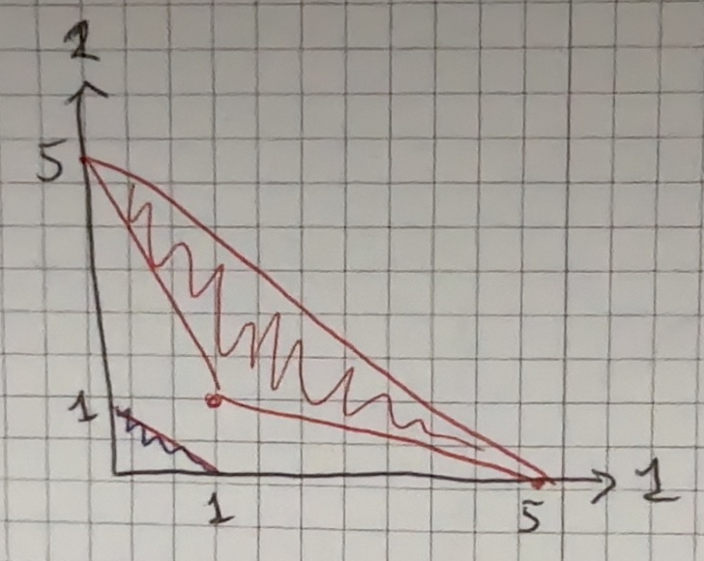
We can also calculate that $\left(2,2\right)$ is a feasible payoff vector, if a player gets 5 is one round(the other gets 0), 0 in the next(because the other player gets 5) and then 1 in the next(both of them) then they get the average payoff per round of 2. So if this is repeated forever we get the payoff vector we would like
$$\frac{5+1+0}{3}=2$$
If we go in one game per probabilities and then payoff then what?

- Consider now the game $G^{∞}$ that consists of playing G infinitely often, and where the payoffs of the infinite game are the average payoffs. Describe an outcome path such that each player achieves an average payoff of 2.5.
If they switch between playing $\left(D;L\right)$ and $\left(U;R\right)$ then they get an average payoff of 2,5 each.

- Describe a strategy profile such that each player achieves an average payoff of 2.5. Assume a discount factor of $δ=0.999$ and verify that the strategy profile is a subgame perfect Nash equilibrium.
Discount factor: $δ=0,999$. I would here call D and R for cooperate and U and L for punish, as they have the same function for both. So it would be the strategy profile of play cooperate of the other played cooperate and play punish if the other played punish, then they should end up differing, cause if they play the same on player will deviate and they end up differing as that is better overall for repeated.
$$\left(1-0,999\right)·\sum_{i=1}^{∞}{{0,999}^{i-1}·\left(\frac{1}{2}·5+\frac{1}{2}·0\right)}=2,5$$
Which is what I wanted to show. It is subgame perfect because in each game they react to the play of the other player, so either punish or cooperate.

- Can you find a subgame-perfect Nash equilibrium under which the average payoff of player 1 is more than 4.5? Briefly explain – write at most two sentences.
No because for a player to get an average payoff of 4,5 they need to get the payoff of 5 in 9 out of 10 rounds, which means the other player gets a payoff of the highest 5 in 1 out of 10 rounds which gives an average payoff of 0,5 which is worse than playing the punish play forever and getting a payoff of 1.

Question 3 Adverse selection
A risk neutral employer owns a factory producing inflatable T-rex costumes and wants to hire workers for production. A worker is supposed to produce q units of a good (costumes). The q units of production can be sold in the stores and their value to the employer can be described as $R(q),$ with $R^{'}(q) > 0$, $R^{''}(q) < 0$ and $R(0)=0$. The workers differ in their marginal cost of producing a costume. In particular, dependent on his type $η∈\left\{\overset{̲}{η},\overline{η}\right\}, \overline{η}>\overset{̲}{η}>0,$the production cost of the worker are:
$$C\left(q,\overset{̲}{η}\right)=\overset{̲}{η}q, with probability λ$$
$$C\left(q,\overline{η}\right)=\overline{η}q, with probability 1-λ$$
The worker’s utility is given as:
$$U\left(w,q,η\right)=w-C\left(q,η\right)$$
The timing is as follows:
- At date 1, the worker learns his type $η∈\left\{\overset{̲}{η},\overline{η}\right\}$
- At date 2, the employer offers a contract to the worker specifying a production level q and a wage w. (Note that the principal may offer a several contracts when there is uncertainty about which type of worker he is contracting with)
- At date 3, the worker can accept or reject the contract. If he rejects it, he receives his reservation utility of zero.
- If the contract is accepted, the contract is executed at date 4, i.e. the worker produces q units and is rewarded as specified in the contract.
In the following, you can assume that parameters are such that an interior solution exists and that the second order conditions are satisfied.
Part 1 First best: Suppose there is no asymmetric information between the employer and the worker, i.e., the employer observes the worker’s type before he offers the contract.
- Formulate the employer’s optimization problem including relevant constraint(s)
We have that he would like to maximize his profit. we say the worker can be low type $\overline{η}$ or high type $\overset{̲}{η}$
$$\max_{w_{L},w_{H},q_{L},q_{G}}\left(1-λ\right)\left(R\left(q_{L}\right)-w_{L}\right)+λ\left(R\left(q_{H}\right)-w_{H}\right)$$
s.t.
$$\begin{aligned}w_{i}-η_{i}·q_{i}≥\overset{̲}{U}=0, i=L,H\#\left(PC\right)\end{aligned}$$
So that each type of worker would participate.

- Solve the employer’s problem, i.e., determine the production level and the wage for each type of worker.
To solve the employers problem because it is first best we can look at maximizing for the two types by themselves, we know the PC must be binding so we can set it equal, and insert. So we get the production level
$$w_{i}-η_{i}·q_{i}=0⇔w_{i}=η_{i}·q_{i}$$
Insert into the maximization problem
$$p·\left(R\left(q_{i}\right)-w_{i}\right)=p·\left(R\left(q_{i}\right)-η_{i}·q_{i}\right)$$
Differentiate and set equal to 0
$$p·R^{'}\left(q_{i}\right)-p·η_{i}=0⇔R^{'}\left(q_{i}\right)=η_{i}$$
And the wage is then
$$w_{i}=R^{'}\left(q_{i}\right)·q_{i}$$
For each type.

- Compare the first best production levels for the two types of workers with each other. Reflect briefly on whether the contracts are efficient.
The contracts are efficient, nothing is lost as the employer knows the type of the worker, no incentive needed.

Part 2 Second best: Assume now that there is asymmetric information between the employer and the worker, i.e., the employer cannot observe the worker’s type (the prior probability distribution is however common knowledge).
- Formulate the principal’s optimization problem including relevant constraint(s).
So now we have the problem
$$\max_{w_{L},w_{H},q_{L},q_{G}}\left(1-λ\right)\left(R\left(q_{L}\right)-w_{L}\right)+λ\left(R\left(q_{H}\right)-w_{H}\right)$$
s.t.
$$\begin{aligned}w_{L}-η_{L}·q_{L}≥\overset{̲}{U}=0\#\left(PC_{L}\right)\end{aligned}$$
$$\begin{aligned}w_{H}-η_{H}·q_{H}≥\overset{̲}{U}=0\#\left(PC_{H}\right)\end{aligned}$$
$$\begin{aligned}w_{H}-η_{H}·q_{H}≥w_{L}-η_{H}·q_{L}\#\left(IC_{H}\right)\end{aligned}$$
$$\begin{aligned}w_{L}-η_{L}·q_{L}≥w_{H}-η_{L}·q_{H}\#\left(IC_{L}\right)\end{aligned}$$
So they both participate and they choose their own contract.

- Go through the constraint(s) and argue which one(s) you expect to be binding and why (structure your answer in bullets and a 1-2 sentences for each constraint).
Because we have that $η_{H}<η_{L}$ it means that
$$w_{H}-η_{H}·q_{H}≥w_{L}-η_{H}·q_{L}>w_{L}-η_{L}·q_{L}≥0$$
And so the $\left(PC_{H}\right)$ is not binding.
We expect the $\left(PC_{L}\right)$ to be binding and the $\left(IC_{H}\right)$ to be binding. These are both proof by contradiction and the $\left(IC_{L}\right)$ is not binding.

- Solve the principal’s problem, i.e., characterize the production levels and wages.
So now we have to binding constraints and two that are not binding this means we can just solve the problem, no need for lagrange.
$$w_{L}-η_{L}·q_{L}=0⇒w_{L}=η_{L}·q_{L}$$
$$w_{H}-η_{H}·q_{H}=w_{L}-η_{H}·q_{L}⇒w_{H}=w_{L}-η_{H}·q_{L}+η_{H}·q_{H}$$
$$=η_{L}·q_{L}-η_{H}·q_{L}+η_{H}·q_{H}=\left(η_{L}-η_{H}\right)·q_{L}+η_{H}·q_{H}$$
So this means we then have the problem
$$\max_{q_{L},q_{H}}\left(1-λ\right)\left(R\left(q_{L}\right)-η_{L}·q_{L}\right)+λ\left(R\left(q_{H}\right)+\left(η_{H}-η_{L}\right)·q_{L}-η_{H}·q_{H}\right)$$
So we differentiate and set equal to 0
$$\frac{∂}{∂q_{L}}=\left(1-λ\right)\left(R^{'}\left(q_{L}\right)-η_{L}\right)+λ\left(η_{H}-η_{L}\right)=0⇒\left(1-λ\right)·R^{'}\left(q_{L}\right)-η_{L}\left(1-λ+λ\right)+λη_{H}=0⇒\left(1-λ\right)·R^{'}\left(q_{L}\right)-η_{L}+λη_{H}=0⇒R^{'}\left(q_{L}\right)=\frac{η_{L}-λη_{H}}{1-λ}$$
$$\frac{∂}{∂q_{H}}=λ\left(R^{'}\left(q_{H}\right)-η_{H}\right)=0⇒R^{'}\left(q_{H}\right)=η_{H}$$

- Compare the second best production levels (derived in 3f) to the first best production levels (derived in 3b) and explain the differences. (3-4 sentences)
So we see that the high type gets the same but the low type does not. No distortion at the top.
The high type producing the same, the low type producing less.

Part 3: Suppose now that the worker only learns his type at date 4 (instead of at date 1): and thus after deciding whether to work for the employer but before choosing the specific contract (the employer still cannot observe the worker’s type).
- Formulate the principal’s optimization problem including relevant constraint(s).
So we need for the employer to incentivize the worker to work for him no matter the type so when the worker has already decided he wants to work for him then just get him to choose the correct contract. So we need to incentive not a specific type of worker but the expected payoff of the worker when he does not know his type needs to be larger than his reservation utility of 0. When he has accepted we have the same incentive constraints as before.
So the principals problem is
$$\max_{w_{L},w_{H},q_{L},q_{G}}\left(1-λ\right)\left(R\left(q_{L}\right)-w_{L}\right)+λ\left(R\left(q_{H}\right)-w_{H}\right)$$
s.t.
$$\begin{aligned}\left(1-λ\right)·\left(w_{L}-η_{L}·q_{L}\right)+λ·\left(w_{H}-η_{H}·q_{H}\right)≥\overset{̲}{U}=0\#\left(PC\right)\end{aligned}$$
$$\begin{aligned}w_{H}-η_{H}·q_{H}≥w_{L}-η_{H}·q_{L}\#\left(IC_{H}\right)\end{aligned}$$
$$\begin{aligned}w_{L}-η_{L}·q_{L}≥w_{H}-η_{L}·q_{H}\#\left(IC_{L}\right)\end{aligned}$$

- Go through the constraint(s) and argue which one(s) you expect to be binding and why (structure your answer in bullets and a 1-2 sentences for each constraint).
I would expect the PC to be binding, this is because the employer would not wish to incentivize the general employer more than needed.
I would expect the $IC_{H}$ to be binding like before, so the high type is indifferent and chooses the higher, we want to low type to choose their own type and so the $IC_{L}$ would not be binding.

- Show that there exists an optimal contract in which the first best production levels are reached.
So we have the two binding constraints which gives us
$$\left(1-λ\right)·\left(w_{L}-η_{L}·q_{L}\right)+λ·\left(w_{H}-η_{H}·q_{H}\right)=0$$
$$w_{H}-η_{H}·q_{H}=w_{L}-η_{H}·q_{L}$$
$⇕$ Ligningssystemet løses for w_L,w_H vha. WordMat's 'Løs Ligninger' funktion,
$$w_{L}=\left(η_{H}-η_{L}\right)·q_{L}·λ+η_{L}·q_{L} ∧ w_{H}=\left(η_{H}-η_{L}\right)·q_{L}·λ+\left(η_{L}-η_{H}\right)·q_{L}+η_{H}·q_{H}$$
So we can insert these into the problem
$$\max_{q_{L},q_{G}}\left(1-λ\right)\left(R\left(q_{L}\right)-\left(\left(η_{H}-η_{L}\right)·q_{L}·λ+η_{L}·q_{L}\right)\right)+λ\left(R\left(q_{H}\right)-\left(\left(η_{H}-η_{L}\right)·q_{L}·λ+\left(η_{L}-η_{H}\right)·q_{L}+η_{H}·q_{H}\right)\right)$$
Differentiate and set equal to 0
$$\frac{∂}{∂q_{L}}=\left(1-λ\right)·\left(R^{'}\left(q_{L}\right)-\left(η_{H}-η_{L}\right)λ-η_{L}\right)+λ·\left(\left(η_{L}-η_{H}\right)λ+\left(η_{H}-η_{L}\right)\right)=0⇒$$
$$\left(1-λ\right)·\left(R^{'}\left(q_{L}\right)-η_{H}λ+η_{L}λ-η_{L}\right)+λ·\left(η_{L}λ-η_{H}λ+η_{H}-η_{L}\right)=0$$
$⇕$ Ligningen løses for x vha. WordMat.
$$R^{'}\left(q_{L}\right)=η_{L}$$
$$\frac{∂}{∂q_{H}}=λ\left(R^{'}\left(q_{H}\right)-η_{H}\right)=0⇒R^{'}\left(q_{H}\right)=η_{H}$$
Which was the same as first best as I had to show.

Question 4 Investment opportunity
Consider the role of a bank facing a lot of small firms who may be interested in a loan. There are two types of firms. One type of firms (F1) have projects which will pay 2500 with 90% probability and 0 with 10% probability. Another type of firms (F2) have projects which will pay 4500 with 40% probability and 0 with 60% probability. All projects require an initial investment of 2000. Assume that each firm has savings $E≤2000$to use and that the rest must be financed by a loan from the bank. The bank requires the amount it loans (L) plus some interest in case the project succeeds (it thus gets L (1 + R) where R is the interest rate). If the project fails, the bank gets 0 (the firm goes bankrupt).
The bank’s risk management division estimates that 70 % of the firms facing the bank are F1 and 30 % are F2.
- Assume that firms have E = 2000. Calculate the expected payoff from both types of projects. Which projects are executed?
So then for the two types of projects we have the expected payoffs of
$$E\left(F_{1} project\right)=2500·0.9-2000=250$$
$$E\left(F_{2} project\right)=4500·0.4-2000=-200$$
So we see only the project of firm 1 will be undertaken in this instance.

- Assume E = 1500 and that firms know their type. What is the maximal interest rate, $R_{max}$, that the bank can charge for each type of firm so that the firms will still be willing to lend money?
So we need to solve for when the expected payoffs from the projects are 0 for the firms, and then the interest that makes this happen. We only need to look at when the project succeeds as this is the only time the bank is paid back.
So for the F1 firm we have
$$E\left(F_{1} project\right)=0⇔2500·0.9-1500-500·\left(1+R\right)·0.9=0$$
$⇕$ Ligningen løses for R vha. WordMat.
$$R_{max}=\frac{2}{3}$$
So an interest rate of 66% which is quite a lot.
For the F2 firm we have
$$E\left(F_{2} project\right)=0⇔4500·0.4-1500-500·0.4·\left(1+R\right)=0$$
$⇕$ Ligningen løses for R vha. WordMat.
$$R_{max}=\frac{1}{2}$$
So we see that here they can charge a lower interest than above.

- Assume E = 500 and that firms know their type. What is the maximal interest rate, $R_{max}$, that the bank can charge for each type of firm so that the firms will still be willing to lend money?
We do the same for the new E, so now they would need to borrow 1500 from the bank to undertake the project.
$$E\left(F_{1} project\right)=0⇔$$
$$2500·0.9-500-1500·\left(1+R\right)·0.9=0$$
$⇕$ Ligningen løses for R vha. WordMat.
$$R_{max}=\frac{8}{27}$$
And
$$E\left(F_{2} project\right)=0⇔$$
$$4500·0.4-500-1500·0.4·\left(1+R\right)=0$$
$⇕$ Ligningen løses for R vha. WordMat.
$$R_{max}=\frac{7}{6}$$

- Compare to your results in (4b) and (4c) and explain the difference. How can the bank use requirements on the size of self-financing as a way to manage potential informational asymmetries regarding firm types? (3-4 sentences, no calculations needed)
So we see that now they can charge a higher interest rate on F2 and a lower interest rate on F1.
So if they want to borrow a lot of money the bank can set the interest rate high and if they say yes they know it is the F2 and if they want to borrow a little money they set the interest rate high and they know it if F1.

Mikro eksamen august 2019

Question 1Normal form game, pure strategy NE
There are $n$ hunters. Simultaneously each hunter chooses between Stag and Rabbit. If a hunter chooses Rabbit, his payoff is $θ$ regardless of what the other hunters do. If he chooses Stag, he gets $v>0$ if at least $k,1≤k≤n-1$,other hunters also choose Stag and gets 0 otherwise. The possible values for $θ$ are $[a, b]$where $a < 0$ and $b > v$.
- Write down the normal form representation of this game when $n = 2$ and $k = 1$.
So we have
1 / 2 | Stag | Rabbit
Stag | $$v,v$$ | $$0,θ$$
Rabbit | $$θ,0$$ | $$θ,θ$$

- Consider again the $n$ person case. Assume that$θ$ is known and state the pure strategy Nash equilibria.
So now $θ$ is known, if it is $a<0$ then all the players will choose Stag and get the payoff of $v>0$. if it is $b>v$ then all the players will play Rabbit and get the sure payoff.
So if it is a the pure strategy Nash equilibria are
$$\left(Stag,…,Stag\right)$$
And if it is b the pure strategy Nash equilibria are
$$\left(Rabbit,…,Rabbit\right)$$

- Assume now that each hunter has K (a positive integer) units of effort that he can allocate between pursuing the stag and catching rabbits. Let $e_{i}, 0≤e_{i}≤K$ denote the effort hunter $i$devotes to pursuing the stag. The chance of catching the stag depends on the smallest of all hunters’ efforts, i.e., $\min_{j}{e_{j}}$
Hunter$i’s$ payoff to the action profile $(e,…,e)$ is
$$u_{i}\left(e_{1},…,e_{n}\right)=2·\min_{j}{e_{j}}-e_{i}$$
Argue that the action profile $(e,…,e)$ in which every hunter devotes the same effort to pursuing the stag is a Nash equilibrium for any value of e.
If every hunter devotes the effort e to the stag then every hunter has the payoff of
$$2·e-e=e$$
And so because it is a minimum function no hunter wishes to deviate and devote a lower effort as they will then get a lower payoff.
$$2·\left(e-ϵ\right)-\left(e-ϵ\right)=e-ϵ<e$$
And so no hunter will devote less, no hunter will denote more either as this would mean they got a lower payoff as well
$$2·e-\left(e+ϵ\right)=e-ϵ<e$$
And therefore it must be a Nash equilibrium for any value of e as no hunter wishes to deviate.

Question 2 missing picture
A new customer enters a bank and asks for a loan. The bank can either accept (yes) or reject (no) his request. The financial status of the customer is private information, but the bank can observe if he arrived by bike or by Porsche. The situation – including the common prior and type-dependent payoffs of bank and customer - is described by the following signaling game:
- Find all pure-strategy perfect Bayesian Nash equilibria of this game.
- Explain the idea of the intuitive criterion, and apply it to the pooling equilibria specified in a).

Jeg kan ikke lave den her opgave da tegningen mangler!!!

Question 3 Competitive screening in labour markets, wage-task pair
There are two firms who compete over a scientist. The scientist can be one of two types who differ in productivity levels. A scientist is a high type ($γ_{H}$) with probability$λ$ and a low type ($γ_{L}$) with probability $1-λ$. The scientist have the possibility of investing in topological analysis skills $s$while studying. The scientists move first and make an investment in$s$. The firms observe$s$ and then offer contracts. A firm cannot observe what type of scientist it is contracting with but the distribution of types is common knowledge.
The firms simultaneously announce a set of contracts which specify a wage-skills pair $(w, s).$
The profit of a firm that hires a scientist of type γ and pays wage $w$ is:
$$Π\left(γ,w\right)=γ-w$$
The scientist will choose whether to accept a contract and if so, which one. If the scientist’s most preferred contract is offered by both firms, the scientist will pick one at random (50-50). If the scientist does not accept any contract he earns zero.
The objective function of a scientist of productivity type$γ$ who accepts a contract with a wage $w$ and skills level $s$ is:
$$U\left(γ, s, w\right)=w-c\left(s, γ\right)$$
Denote $c_{s}\left(s, γ\right)=\frac{∂c\left(s,γ\right)}{∂s}$ and consider the following set of assumptions (referred to below as the single crossing assumption):
$$c\left(0,γ\right)=0, ∀γ∈\left\{γ_{L},γ_{H}\right\}$$
$$c_{s}\left(s,γ\right)>0, ∀s>0, ∀γ∈\left\{γ_{L},γ_{H}\right\}$$
$$c_{ss}\left(s,γ\right)>0 ∈\left\{γ_{L},γ_{H}\right\}$$
$$c_{s}\left(s,γ_{L}\right)>c_{s}\left(s,γ_{H}\right), ∀s>0$$
Note: jeg har kaldt s for e og $γ$ for $θ$ fordi det var I mine noter!!

- What type of game is this and which equilibrium concept is appropriate? What are the equilibrium requirements? (4-5 sentences)
This is a signalling game. So we have pooling and separating equilibriums. That no one wants to deviate.

- Does a separating equilibrium exist? Show graphically and argue why the equilibrium requirements from above are satisfied.
so we draw and see when it might happen.
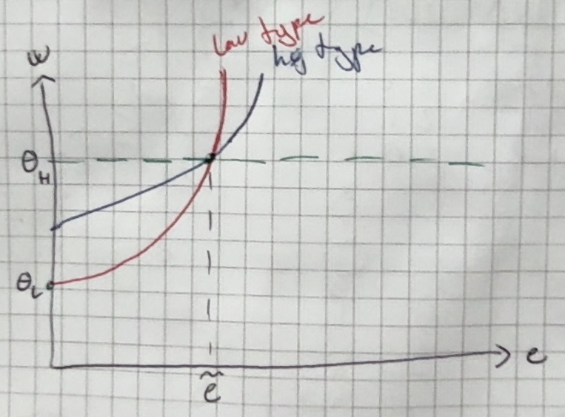
So we see there is a separating equilibrium because the low type will choose the 0 effort and the high type will choose the higher effort. We see there is single crossing assumption. They end up getting the wage that is their type the low ones.

- Does multiple separating equilibria exist? If no, show why. If yes, which of the separating equilibria Pareto dominates the others?
Yes there can be multiple, for any effort level between $\tilde{e}$ and $e^{⋆}$ on the drawing.
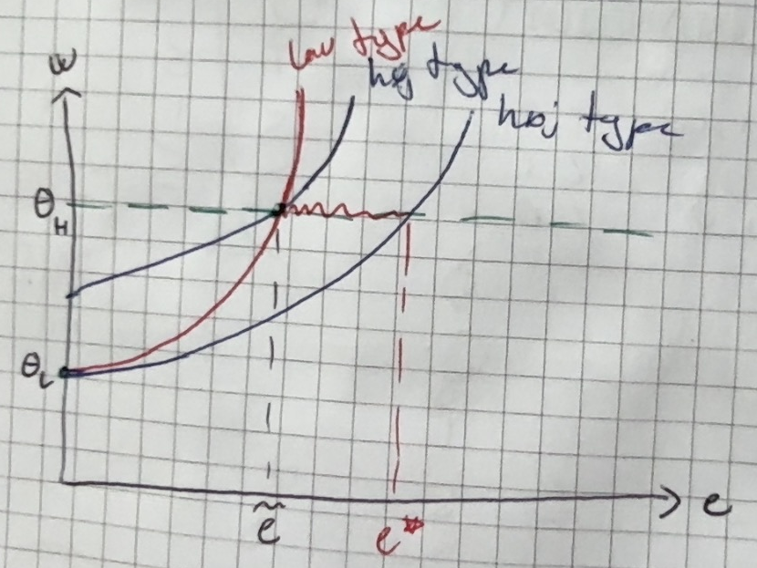
Here we see that the high type would be on a higher indifference curve than it they just took the low types offer of $e=0$. We see however that the offer of $\tilde{e}$ pareto dominates all the others for the high type.

- What do we mean when we talk about self-fulfilling beliefs in this context? Explain by example.
Øhhhh??
That if the players believe something then just because they believe so then it ends up being so. So maybe with the whole $e≥\tilde{e}$ the firms expect it to be the high type and so the high type would never choose under this?

- Briefly introduce the two equilibrium refinements: the dominance criterion and the intuitive criterion. How are they different?
Intuitive criterion: If there is a “message” which is equilibrium dominated for a player then the firm should place no probability on the given player if this message is received as they expect that player would never send that message.
Dominance criterion: if possible, players’ off-equilibrium beliefs should place zero probability on nodes that are only reached if another players plays a strictly dominated action.

- Illustrate a situation in which there are multiple separating equilibria and where the dominance equilibrium refinement can be used to reduce the set of equilibria.
We see that the low type would never play over $\tilde{e}$ and so we can say that the firms can place 0 probability on it being the low type if the effort level is above $\tilde{e}$ they should know it is then the high type.

- Illustrate a situation in which there are multiple separating equilibria and where the intuitive equilibrium refinement can be used to reduce the set of equilibria.
Måske er det her det jeg skrev ovenover?

- Illustrate a situation where the government can actually improve overall welfare (create a Pareto improvement) by banning education.
So now the firms do not know the type, so would pay $E\left(θ\right)$ and so this could mean that they get higher payoff depending on the share of each type.

Question 4 Adverse selection and screening
Consider a competitive labor market where many identical firms are competing in Bertrand competition to hire workers. There is a continuum of workers with mass$N$. The workers differ in their productivity $θ∈\left[\overset{̲}{θ},\overline{θ}\right]$ If a worker works for a firm his productivity is $θ$(and thus the firm gets $θ$ in income), if the worker works at home the worker gets utility is $r(θ).$ Each worker knows his own productivity and is risk neutral.
Each firm is risk neutral. In the second best firms only know the distribution of $θ$ denoted by $F(θ)$ and with density $f(θ)>0$.
- Suppose that the worker’s type $θ$ is observable to firms when trying to hire a worker. What are the equilibrium wage(s) and who works?
So the equilibrium wages are then
$$w=θ$$
And anyone where $r\left(θ\right)≤θ$ works.

- Is the equilibrium above Pareto efficient? Why/Why not?
This is pareto efficient. We have the people who would get a higher payoff from working(under the assumption that the firm would not get negative payoff from hiring them) working and those that would not are home.

- Suppose that workers type $θ$ is not observable to the firms. Suppose further that $r(θ) = r$ for all $θ∈\left[\overset{̲}{θ},\overline{θ}\right]$with $\overset{̲}{θ}<r<\overline{θ}$. What are the equilibrium wage(s) and who works?
So a worker will only work if
$$r\left(θ\right)=r≤w$$
Because the type is not observable to the firm the firm would offer the wage
$$w=r$$
Where all types are willing to work. This means that the firm will only offer this contract if
$$E\left(θ\right)≥r$$
Otherwise they would loose money on this.
So this is the equilibrium wage $w=r$ if $E\left(θ\right)≥r$ otherwise the equilibrium wage is 0.

- Suppose that workers type $θ$ is not observable to the firms. Suppose further that $r(θ) = r$ for all $θ∈\left[\overset{̲}{θ},\overline{θ}\right]$with $\overset{̲}{θ}<r<\overline{θ}$ and that $E\left(θ\right)>r$. Is the equilibrium pareto efficient?
Then the firm would be making a profit. This is not pareto efficient I don’t believe, they have to have 0 profit.

- Suppose that workers type $θ$ is not observable and $r(θ)$varies with $θ$. What are the equilibrium wage(s) and who works?
Here there can be multiple equilibrium wages. If it is the amount of workers where $E\left(t| r\left(t\right)≤w\right)=w$ then the wage is w and the amount working is t. if not such exists then the equilibrium wage is 0 and only the worker with $r\left(θ\right)=0$ works.

- Suppose that workers productivity is not observable and $r(θ)$ varies with $θ.$ Could situations exist where the demand for labor actually increases when wages increase? Explain why/why not.
If $r\left(θ\right)>θ$ for any $θ$ then the demand would not go up. But if $r\left(θ\right)<θ$ then we should have that as the wages go up so can the demand for labour. Because the higher types who are then also willing to work are so much better so that $E\left(θ\right)>w$ as so the firms want to hire more people.

Mikro eksamen juni 2020

Question 1 normal form 3x3 matrix, mixed strategy
Consider a newly founded political party, A, that is challenging an established party, B. The electoral race involves three regions $R_{i}, i∈\{1,2,3\}.$ Party A can launch a strong campaign in only one region. Party B needs to use all its resources to defend its votes in one of the regions, without knowing which region party A has chosen. If A targets region$i$ and party B campaigns in one of the other two regions, then A wins$v_{i}$ votes from $R_{i}$ at the expense of party B. Assume that sizes of the three regions are such that
$$v_{1}>v_{2}>v_{3}>0$$
Party A does not win any votes if it targets the same region as B.
Each party’s payoff corresponds to the expected number of votes it receives. (This could be because seats in parliament are allocated in proportion to vote shares.)
One way to model the situation is the following matrix:
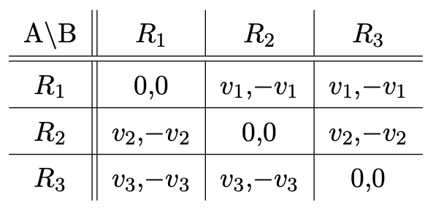
- Does the game have an equilibrium where one player plays a mixed strategy while the other plays a pure strategy? If yes, please state the equilibrium. If no, please state the reason why such an equilibrium does not exist.
We see that player A would prefer to play $R_{1}$ as long as B does not, then they would play $R_{3}$ so we see that a mix of $R_{1}$ and $R_{2}$ dominates $R_{3}$ for player A.
I think there exists one if B plays them so that A becomes indifferent should be an equilibrium.

- Does an equilibrium or multiple equilibria exist where both players randomize between two of their options? If yes, please state all the equilibria, i.e., find randomization probabilities $((p_{1}^{⋆}, p_{2}^{⋆}, p_{3}^{⋆}); (q_{1}^{⋆}, q_{2}^{⋆}, q_{3}^{⋆}))$ (where one probability equals zero for each player). If no, please state the reason why such an equilibrium does not exist.
There exists one for both mixing between 1 and 2.
They would randomize between the same 2, because if A randomizes between 1 and 2 then B would never play 3 as they then get a certain outcome of 0, it is better to randomize between the other two, and if A know B does not play 3 then there is a mix of 1 and 2 that dominates 3 as well. So (might be a little different for B but not sure?)
$$\left(\left(\frac{v_{1}}{v_{1}+v_{2}}, \frac{v_{2}}{v_{1}+v_{2}}, 0\right);\left(\frac{v_{1}}{v_{1}+v_{2}}, \frac{v_{2}}{v_{1}+v_{2}},0 \right)\right)$$
There is not one for if player B mixes between 2 and 3 as then player 1 would always play 1.
When mixing between 1 and 3 for player B there might be a mixed strategy between 1 and 2 for player A but it would have to put very high on 1 which would mean that player B would play 1 I believe, so no actual one here.
So I think there is only 1 equilibrium here.

- Does an equilibrium exist where both players randomize between all three options? If yes, please state the equilibrium, i.e., find randomization probabilities $((p_{1}^{⋆}, p_{2}^{⋆}, p_{3}^{⋆}); (q_{1}^{⋆}, q_{2}^{⋆}, q_{3}^{⋆}))$ If no, please state the reason why such an equilibrium does not exist.
I think this is the opposite of what I said in 1) but if B randomizes between all 3 it might also make A randomize between all 3, so we get
$$\left(\left(\frac{v_{1}}{v_{1}+v_{2}+v_{3}}, \frac{v_{2}}{v_{1}+v_{2}+v_{3}}, \frac{v_{3}}{v_{1}+v_{2}+v_{3}}\right);\left(\frac{v_{1}}{v_{1}+v_{2}+v_{3}}, \frac{v_{2}}{v_{1}+v_{2}+v_{3}}, \frac{v_{3}}{v_{1}+v_{2}+v_{3}}\right)\right)$$
So they randomize in the same way. I think?

- Consider the equilibrium derived in point (2) and that derived in point (3). Interpret the condition under which the first or second type of equilibrium exists.
So I think we need player B to randomize first, so this would force player A also to randomize. If A randomizes. Wait no I think it is ok for A to start. But we need either for 3 not to be part of the randomization or for all to be part of the randomization as it is the worst for B to play and the best for A if B plays.

Question 2 Signalling game
A firm needs to hire or refuse a job applicant. The firm would benefit from hiring a smart applicant independent of her education, but would lose from hiring any dumb one. Unfortunately, there is no direct way to find out the talent of the applicant other than hiring her.
The firm’s commonly known prior belief is that the applicant is smart with probability 1/3 and dumb otherwise. It observes whether the applicant has chosen to obtain a Bachelor degree (BSc) or completed the full Master programme (MSc). The latter would have been costly for both applicant types, but less so for a smart applicant. The situation is described by the following signaling game:
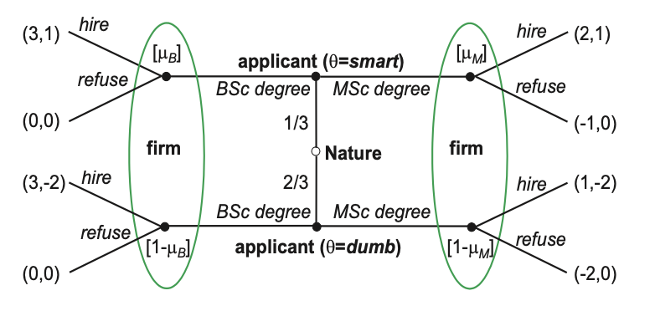

- Does a separating perfect Bayesian equilibrium (PBE) exist in which the smart applicant type chooses M Sc while the dumb type chooses B Sc? If yes, specify it fully. If no, justify your answer.
So we would have
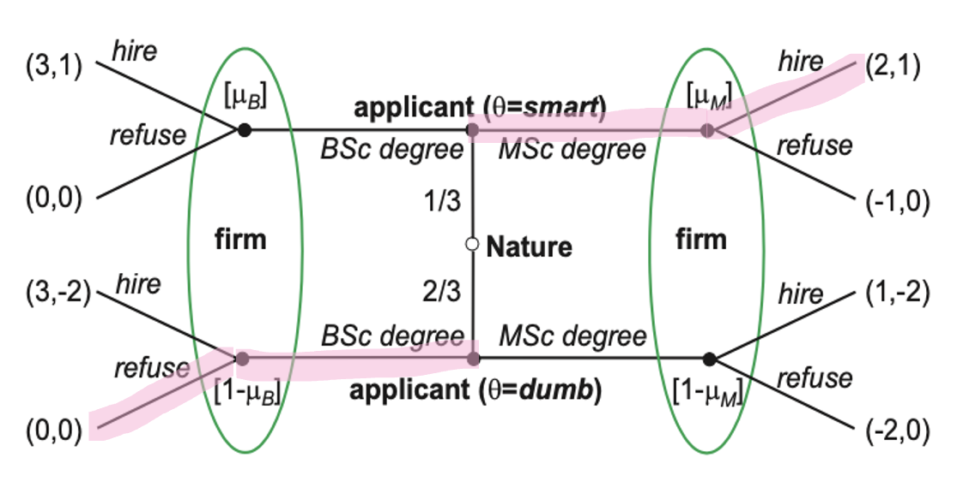
So we see that here the smart applicant would not choose a bachelor as they would then be rejected, but the dumb applicant would choose a masters as they would get a higher payoff, so there is not an equilibrium here.

- Specify all pooling PBE in which both applicant types get a B Sc degree.
So pooling for bachelor is
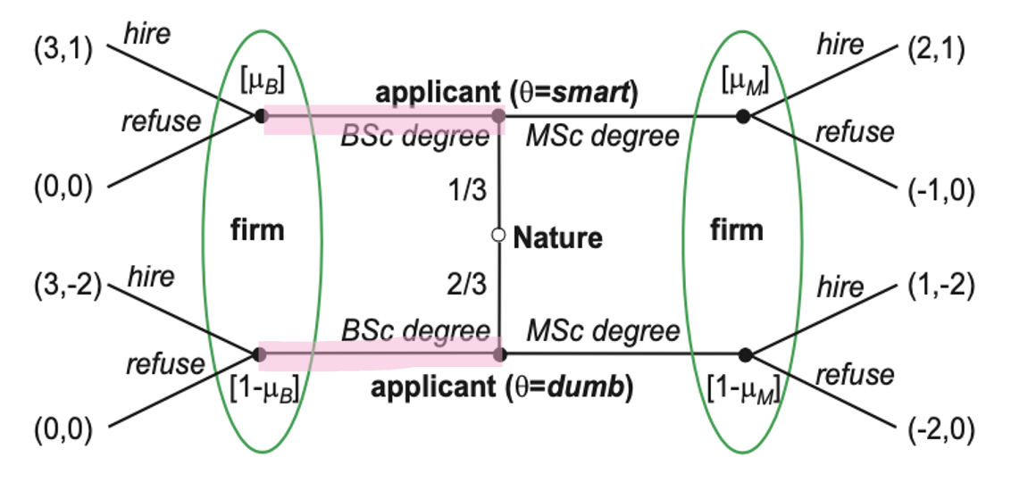
So we need to look at what the firm would choose, here we need to remember their 1/3 expectations of smart, so
$$E\left(hire\right)=1·\frac{1}{3}+\left(-2\right)·\frac{2}{3}=-1$$
$$E\left(refuse\right)=0$$
So we see that the firm would not hire an applicant here.
So the smart person would deflect and get a higher education(maybe even the dumb person might do this?)

- Which of the above equilibria that satisfy the intuitive criterion? Please explain (max. 5 sentences).
I did not find an equilibrium?

Question 3 Moral Hazard
An employer (P - principal) is looking for a new employee (A - agent) to work for him in his firm. Due to a Corona lockdown the employee will be working from home and the employer will therefore not directly observe how active (a) the employee is. Instead P will observe the total sales of his firm determined as $q=a+ε$ where $ε$ is a normally distributed random variable with mean 0 and variance$σ^{2}$. Due to unions and boring legal stuff the employer is further only able to offer linear contracts of the form $w=t+sq$ where$t$ is thus a base amount and $s$ governs how close the wage of the employee is linked to firm performance. The employer is risk neutral and interested in maximizing the expected profits of his firm.
The agent has CARA preferences represented as:
$$u (w, a)=-e^{-η\left(w-ψ\left(a\right)\right)}$$
where $w$ is the wage the agent gets when working and $η>0$ is the coefficient of absolute risk aversion. The function $ψ(a)$ gives the cost of being active at level $a$ and is given by $ψ\left(a\right)=\frac{1}{2}ca^{2}$ where $c>0$. The outside option of the agent is given as:
$$u (\overline{w}) = -e^{-η\left(\overline{w}\right)}$$
- For a given (accepted) contract $(t, s)$formulate the maximization problem of the agent when deciding on the level of$a$.
Hint: The agent is maximizing expected utility. When $ε$ is normally distributed with zero mean and variance $σ^{2}$ we have that for any (non-random) $γ$ the following holds: $E\left(e^{γϵ}\right)=e^{\frac{γ^{2}σ^{2}}{2}}$
So he would like to maximize his expected utility not just his utility as he does not know precisely, we have that $E\left(ϵ\right)=0$.
$$E\left(u\right)=E\left(-e^{-η·\left(w-\frac{1}{2}·c·a^{2}\right)}\right)=E\left(-e^{-η·\left(t+s·\left(a+ϵ\right)-\frac{1}{2}·c·a^{2}\right)}\right)=E\left(-e^{-η·s·ϵ-η\left(t+s·a-\frac{1}{2}·c·a^{2}\right)}\right)$$
Now we use the hint and split it up so we have
$$-e^{-η\left(t+s·a-\frac{1}{2}·c·a^{2}\right)}·E\left(e^{-η·s·ϵ}\right)=-e^{-η\left(t+s·a-\frac{1}{2}·c·a^{2}\right)+\frac{1}{2}·η^{2}·s^{2}·σ^{2}}$$
So we have the problem of
$$\max_{a}{-e^{-η\left(t+s·a-\frac{1}{2}·c·a^{2}\right)+\frac{1}{2}·η^{2}·s^{2}·σ^{2}}}=\min_{a}{e^{-η\left(t+s·a-\frac{1}{2}·c·a^{2}\right)+\frac{1}{2}·η^{2}·s^{2}·σ^{2}}}$$
Now because $\min{e^{-x}}=\max{x}$ we then again have
$$=\max{η\left(t+s·a-\frac{1}{2}·c·a^{2}\right)+\frac{1}{2}·η^{2}·s^{2}·σ^{2}}$$
So this is the optimization problem for the agent.

- Solve for the level of a chosen by the agent, i.e. derive the first order condition and find an expression for a that satisfies the first order condition.
So we differentiate and set equal to 0
$$\frac{∂}{∂a}=η·s-η·c·a=0⇔s=c·a⇔a=\frac{s}{c}$$
Which is then the level chosen by the agent.

- Having solved for a for a given contract $(t, s),$ formulate the principal’s problem under the second best.
Hint: Instead of an IC constraint use the expression for a from above.
The principal would like to maximize their expected profit
$$E\left(profit\right)=E\left(a+ϵ-w\right)=E\left(a+ϵ-\left(t+s·\left(a+ϵ\right)\right)\right)=E\left(\left(1-s\right)\left(a+ϵ\right)-t\right)$$
Now we use that $E\left(ϵ\right)=0$ and use the a we found above so
$$=\left(1-s\right)\left(\frac{s}{c}\right)-t$$
So the principals maximization problem is then
$$\max_{t?}\left(1-s\right)\left(\frac{s}{c}\right)-t$$
And the participation constraint PC is
$$E\left(u\left(w,a\right)\right)≥u\left(\overline{w}\right)$$
Which we can insert to get
$$-e^{-η\left(t+s·a-\frac{1}{2}·c·a^{2}\right)+\frac{1}{2}·η^{2}·s^{2}·σ^{2}}≥-e^{-η·\overline{w}}$$
$$⇔e^{-η\left(t+s·a-\frac{1}{2}·c·a^{2}\right)+\frac{1}{2}·η^{2}·s^{2}·σ^{2}}≤e^{-η·\overline{w}}$$
$$⇔-η\left(t+s·a-\frac{1}{2}·c·a^{2}\right)+\frac{1}{2}·η^{2}·s^{2}·σ^{2}≤-η·\overline{w}$$
$$⇔η\left(t+s·a-\frac{1}{2}·c·a^{2}\right)-\frac{1}{2}·η^{2}·s^{2}·σ^{2}≥η·\overline{w}$$
$$⇔t+s·a-\frac{1}{2}·c·a^{2}-\frac{1}{2}·η·s^{2}·σ^{2}≥\overline{w}$$
Now we insert the value for a again
$$⇔t+s·\frac{s}{c}-\frac{1}{2}·c·{\left(\frac{s}{c}\right)}^{2}-\frac{1}{2}·η·s^{2}·σ^{2}≥\overline{w}$$
$$\begin{aligned}⇔t+\frac{s^{2}}{c}-\frac{s^{2}}{2c}-\frac{η}{2}·s^{2}·σ^{2}≥\overline{w}\#\left(PC\right)\end{aligned}$$
And we don’t have an IC because we just use the a we know the agent will use.

- Argue that the PC constraint is binding under the second best, and use this to formulate the constraint as $\overline{w}=t+\frac{s^{2}}{c}-\frac{c}{2}\frac{s^{2}}{c^{2}}-\frac{η}{2}s^{2}σ^{2}$
To argue that the PC constraint is binding under second best we write up lagrange and see
$$L=\left(1-s\right)\left(\frac{s}{c}\right)-t+λ·\left(t+\frac{s^{2}}{c}-\frac{s^{2}}{2c}-\frac{η}{2}·s^{2}·σ^{2}-\overline{w}\right)$$
FOCS
$$\frac{∂L}{∂t}=-1+λ=0⇔λ=1$$
And therefor the PC binds. We can just use what we would in 4) and then because it binds we have
$$t+\frac{s^{2}}{c}-\frac{s^{2}}{2c}-\frac{η}{2}·s^{2}·σ^{2}=\overline{w}$$
Which is what we needed to show.

- Calculate the two first order conditions and interpret them.
We find the other FOC then differentiating wrt. s
$$\frac{∂L}{∂s}=\frac{1}{c}-\frac{2s}{c}+λ·\left(\frac{2s}{c}-\frac{2s}{2c}-\frac{η}{2}·2s·σ^{2}\right)=0$$
$$⇔\frac{1-2s}{c}+λ·\left(\frac{s}{c}-η·s·σ^{2}\right)=0$$
$⇕$ Ligningen løses for s vha. WordMat.
$$s=\frac{1}{\left(c·η·σ^{2}-1\right)·λ+2}$$
We can now use that $λ=1$ and so
$$s=\frac{1}{c·η·σ^{2}+1}$$
So we see that if any of these 3 goes up then s goes down. Which would make the agents pay less correlated to the performance of the firm, so just the base pay.

Question 4 Adverse selection?
A small IT firm is owned by a risk-averse current owner (A) with initial wealth $W_{0}$ and an increasing, strictly concave von Neumann-Morgenstern utility function $u_{E}\left(w\right)$ where$w$ is the final wealth (i.e. including initial wealth, the value of the firm and any transfers) of the individual. The current owner is considering selling (a part of) his firm. There is only one potential buyer, Googles, (P) which acts like a monopolistic risk neutral buyer and proposes a contract consisting of $(x, T)$where $x∈[0, 1]$ is the share of the firm the current owner keeps (he thus sells the share $1-x$ to Googles) and $T≥0$ is the payment to the current owner. The value of the firm is given by $θ+γ$ where $θ$ and $γ$ are two independent random variables. The value of $θ$ is known to its current owner but not to anyone else. It is however known to all players that$θ$ can take two values $θ_{L}$ and $θ_{H}$with probability $β$ and $1-β$ respectively and $θ_{L}<θ_{H}$. $γ$ is a continuous random variable and its expected value is 0. $γ$ is only realized in the future (i.e. after a potential trade of the firm) and is thus unknown to all at the time of purchase.
The timing of the game is as follows:
- Nature chooses $θ$
- Googles proposes the terms of trade (i.e. offers a contract)
- The current owner accepts or rejects the contract.
If the current owner rejects the contract he gets the full value of the firm, if he accepts the contract he gets a transfer $T$ and a share of the value of the firm $x$. We can therefore express the expected utility of a current owner of type$θ_{i}$ associated with a given contract $(x,T)$ as:
$$E\left(u_{E}\left(w\right)\right)=\int{u\left(x·\left(θ_{i}+γ\right)+T+W_{0}\right)f\left(γ\right)dγ}$$
Under the first best both the current owner and Googles know the type $θ$.
- Formulate the participation constraint and discuss how the participation constraint differs from the screening problems studied in Lecture Note 4.
The participation constraint is
$$E\left(u_{E}\left(w\right)\right)=\int{u\left(x·\left(θ_{i}+γ\right)+T+W_{0}\right)f\left(γ\right)dγ}≥u_{E}\left(θ+W_{0}\right)$$
So the left part is if they participate, and the right part should be if they do not, so just the value of their firm and initial wealth. And then in the integral because I think it need to be in this instance?

- Explain why the PC constraint is binding under the first best and why we expect Googles to offer a contract where $x = 0$ (2-3 sentences).
Under first best the principal knows the type of the company and because the principal is risk neutral he would just buy the whole firm, hence $x=0$ so the owner keeps nothing. So then the current owner knows his expected utility is constant which is nice when one is risk averse.

- Formulate the first best problem. Show that the first order conditions imply efficient risk sharing. Explain the intuition (2 sentences).
The first best problem, here the principal would like to maximize expected profits.
$$\max_{x,T}{E\left(\left(θ_{i}+γ\right)\left(1-x\right)-T\right)}=\max_{x,T}{θ\left(1-x\right)-T}$$
s.t.
$$\begin{aligned}\int{u_{E}\left(x·\left(θ_{i}+γ\right)+T+W_{0}\right)f\left(γ\right)dγ}≥u_{E}\left(θ+W_{0}\right)\#\left(PC\right)\end{aligned}$$
Write up lagrange
$$L=θ\left(1-x\right)-T+λ·\left(\int{u_{E}\left(x·\left(θ_{i}+γ\right)+T+W_{0}\right)f\left(γ\right)dγ}-u_{E}\left(θ+W_{0}\right)\right)$$
Then I have to find FOC
$$\frac{∂L}{∂T}=-1+λ·\int{u_{E}^{'}\left(x·\left(θ_{i}+γ\right)+T+W_{0}\right)f\left(γ\right)dγ}=0$$
$$\frac{∂L}{∂x}=-θ+λ·\int{u_{E}^{'}\left(x·\left(θ_{i}+γ\right)+T+W_{0}\right)\left(θ_{i}+γ\right)f\left(γ\right)dγ}=0$$
Now if we call $w=x·\left(θ_{i}+γ\right)+T+W_{0}$ then we have
$$\int{u_{E}^{'}\left(w\right)f\left(γ\right)dγ}=\frac{1}{λ}$$
$$\frac{1}{θ}·\int{u_{E}^{'}\left(w\right)\left(θ+γ\right)f\left(γ\right)dγ}=\frac{1}{λ}$$
These two we can set equal to each other and solve for $θ$
$$\int{u_{E}^{'}\left(w\right)f\left(γ\right)dγ}=\frac{1}{θ}·\int{u_{E}^{'}\left(w\right)\left(θ+γ\right)f\left(γ\right)dγ}$$
$$⇔θ=\frac{\int{u_{E}^{'}\left(w\right)\left(θ+γ\right)f\left(γ\right)dγ}}{\int{u_{E}^{'}\left(w\right)f\left(γ\right)dγ}}$$
And this somehow implies efficient risk sharing because we have the $\left(θ+γ\right)$ as extra up top and so this fits. I’m not sure completely why with the integral?

- Are the first best contracts incentive compatible under the second best?
No because someone would lie about their type, googles would end up buyin the firm for too much.

- Write down the second best problem and assume that the second best contract will have $x_{L}=0$. Go through the different constraints and discuss which of them we can expect to be binding.
So we need to add two IC constraints as well
$$\max_{x_{L},T_{L},x_{H},T_{H}}{β·\left(θ_{L}\left(1-x_{L}\right)-T_{L}\right)+\left(1-β\right)·}\left(θ_{H}\left(1-x_{H}\right)-T_{H}\right)$$
s.t.
$$\begin{aligned}\int{u_{E}\left(x_{L}·\left(θ_{L}+γ\right)+T_{L}+W_{0}\right)f\left(γ\right)dγ}≥u_{E}\left(θ_{L}+W_{0}\right)\#\left(PC_{L}\right)\end{aligned}$$
$$\begin{aligned}\int{u_{E}\left(x_{H}·\left(θ_{H}+γ\right)+T_{H}+W_{0}\right)f\left(γ\right)dγ}≥u_{E}\left(θ_{H}+W_{0}\right)\#\left(PC_{H}\right)\end{aligned}$$
$$\begin{aligned}\int{u_{E}\left(x_{L}·\left(θ_{L}+γ\right)+T_{L}+W_{0}\right)f\left(γ\right)dγ}≥\int{u_{E}\left(x_{H}·\left(θ_{L}+γ\right)+T_{H}+W_{0}\right)f\left(γ\right)dγ}\#\left(IC_{L}\right)\end{aligned}$$
$$\begin{aligned}\int{u_{E}\left(x_{H}·\left(θ_{H}+γ\right)+T_{H}+W_{0}\right)f\left(γ\right)dγ}≥\int{u_{E}\left(x_{L}·\left(θ_{H}+γ\right)+T_{L}+W_{0}\right)f\left(γ\right)dγ}\#\left(IC_{H}\right)\end{aligned}$$
So both types participate and both types choose their contract.
When we assume that $x_{L}=0$ we can rewrite this problem a little shorter
$$\max_{x_{L},T_{L},x_{H},T_{H}}{β·\left(θ_{L}-T_{L}\right)+\left(1-β\right)·}\left(θ_{H}\left(1-x_{H}\right)-T_{H}\right)$$
s.t.
$$\begin{aligned}\int{u_{E}\left(T_{L}+W_{0}\right)f\left(γ\right)dγ}≥u_{E}\left(θ_{L}+W_{0}\right)\#\left(PC_{L}\right)\end{aligned}$$
$$\begin{aligned}\int{u_{E}\left(x_{H}·\left(θ_{H}+γ\right)+T_{H}+W_{0}\right)f\left(γ\right)dγ}≥u_{E}\left(θ_{H}+W_{0}\right)\#\left(PC_{H}\right)\end{aligned}$$
$$\begin{aligned}\int{u_{E}\left(T_{L}+W_{0}\right)f\left(γ\right)dγ}≥\int{u_{E}\left(x_{H}·\left(θ_{L}+γ\right)+T_{H}+W_{0}\right)f\left(γ\right)dγ}\#\left(IC_{L}\right)\end{aligned}$$
$$\begin{aligned}\int{u_{E}\left(x_{H}·\left(θ_{H}+γ\right)+T_{H}+W_{0}\right)f\left(γ\right)dγ}≥\int{u_{E}\left(T_{L}+W_{0}\right)f\left(γ\right)dγ}\#\left(IC_{H}\right)\end{aligned}$$
So now because of this we end up seeing that the ones without the gamma we can rewrite even shorter, so we actually have
$$\max_{x_{L},T_{L},x_{H},T_{H}}{β·\left(θ_{L}-T_{L}\right)+\left(1-β\right)·}\left(θ_{H}\left(1-x_{H}\right)-T_{H}\right)$$
s.t.
$$\begin{aligned}u_{E}\left(T_{L}+W_{0}\right)≥u_{E}\left(θ_{L}+W_{0}\right)\#\left(PC_{L}\right)\end{aligned}$$
$$\begin{aligned}\int{u_{E}\left(x_{H}·\left(θ_{H}+γ\right)+T_{H}+W_{0}\right)f\left(γ\right)dγ}≥u_{E}\left(θ_{H}+W_{0}\right)\#\left(PC_{H}\right)\end{aligned}$$
$$\begin{aligned}u_{E}\left(T_{L}+W_{0}\right)≥\int{u_{E}\left(x_{H}·\left(θ_{L}+γ\right)+T_{H}+W_{0}\right)f\left(γ\right)dγ}\#\left(IC_{L}\right)\end{aligned}$$
$$\begin{aligned}\int{u_{E}\left(x_{H}·\left(θ_{H}+γ\right)+T_{H}+W_{0}\right)f\left(γ\right)dγ}≥u_{E}\left(T_{L}+W_{0}\right)\#\left(IC_{H}\right)\end{aligned}$$
Here we would assume that the $PC_{L}$ is binding as it would make no sense for the principal to offer above $θ_{L}$ when $x_{L}=0$ as they would then be paying over what they need to.
To deter the high type from pretending to be the low type we would expect $IC_{H}$ to bind.

- Identify and explain the central trade-off between rent extraction and risk premiums which the second best problem describes.
So the high type gets informational rent for saying they are the high type. The low type has no risk premium, the high type does. The low type gets no extra.
High type has some risk because googles is not sure who they are. So in first best the principal took all the risk, and it is still like this for the low type, but not for the high type as the risk is part of the incentive for the high type to show they are the high type.

Mikro eksamen august 2020

Question 1 Volunteer’s dilemma
Consider a situation where n persons are present in a large public place when a man drops down, apparently suffering an epileptic seizure. Suppose each of the $n$persons is able to help, e.g., call a taxi and accompany the man to hospital. Each person has the actions {help, don’t help} available. An individual’s preferences are as follows:
- Payoff is $0$ if no one helps.
- Payoff is $v-c$ if the individual himself helps (i.e., the cost of helping is c).
- Payoff is $v$ if at least one other person helps. where $v>c>0$.

- Does the game have one or multiple Nash equilibria in pure strategies? If no, please state the reason why such an equilibrium does not exist. If yes, please describe the equilibrium or equilibria.
We look at 4 possible scenarios, if no one helps, everyone helps or number in between helps or if 1 person helps.
If no one helps everyone gets payoff of 0 and it is worth it for someone to deviate as they then get payoff $v-c>0$ so not equilibrium.
If everyone helps most people will stop helping to not get the negative payoff of c from being the person helping.
If a number above 1 people help it is the same as if everyone helps, most will stop.
If only 1 person helps then no one wants to deviate, the people not helping don’t wish to help, and the person helping would get a lower payoff from not helping because they are the only one helping.

- Write down the condition that needs to be satisfied in a mixed-strategy equilibrium. Please explain briefly why this condition needs to be satisfied (max. 2 sentences).
So it would be something like:
Help if no help is offered, otherwise don’t help.

We would need someone to help but only one person.

- Calculate the probability $q^{⋆}$ with which each person helps in a symmetric mixed-strategy equilibrium.
So the probability that a person helps is then
You help if
$$v-c≥\left(n-1\right)·q·v$$
So if the payoff from yourself helping is above the expected payoff if someone else helps, so the chance of a person helping, times the amount of people(minus yourself) times v the payoff you get if someone else helps, so we get
$$\frac{1-\frac{c}{v}}{n-1}≥q$$
And we can set it equal
$$q^{⋆}=\frac{1-\frac{c}{v}}{n-1}$$
Where n is the amount of people.
Because the more people there are the more other people could be the one to be helping.

- Now suppose that only two persons (besides the man suffering the seizure) are present in the large place. Each of them is not sure whether the other person has noticed the man having the seizure. Denote by $ρ$ the probability that each person assigns to being the only one who noticed. Then, $1-ρ$ is the probability each person assigns to the event that they have both noticed.
  - State the condition on ρ such that the game has a pure Nash equilibrium in which each person helps (when she has noticed).
We need to look at a Nash equilibrium where each person helps if they noticed, not really dependent on whether the other person noticed.
If they help then no matter if the other person helps they get a payoff of
$$v-c$$
If they do not help then they get an expected payoff(depending on if the other person helped or not) of
$$v·ρ+\left(1-ρ\right)·0=v·ρ$$
So we would need for their payoff from helping to be higher than their payoff of not helping.
$$v-c≥v·ρ⇒1-\frac{c}{v}≥ρ$$
For them to always help. So we have the pure Nash equilibrium
$$\left(help;help\right) if 1-\frac{c}{v}≥ρ$$

  - Find the symmetric mixed strategy Nash equilibrium of the game.
I think it is then what I found above. because we need to have it covering all the possibilities of $ρ$.
$$\left(\left(help, if 1-\frac{c}{v}≥ρ, don^{'}t help if 1-\frac{c}{v}<ρ\right);\left(help, if 1-\frac{c}{v}≥ρ, don^{'}t help if 1-\frac{c}{v}<ρ\right)\right)$$

Maybe not, now we don’t have to have that they help if they have seen, maybe it is just
$$\left(\left(ρ,1-ρ\right);\left(ρ,1-ρ\right)\right)$$
Where the first one is help and the second is don’t help?
Or maybe???
$$\left(\left(1-\frac{c}{v},\frac{c}{v}\right);\left(1-\frac{c}{v},\frac{c}{v}\right)\right)$$

  - Briefly compare your result with your finding from (c) for $n = 2$.
So this fits that there is $\frac{1}{2}$ chance of helping in 3) when $n=2$ and we see here that if $ρ$is uniformly distributed then there is also $\frac{1}{2}$ chance here.

Question 2 Prisoner’s dilemma infinitely repeated
Consider the infinitely repeated Prisoner’s Dilemma with stage game
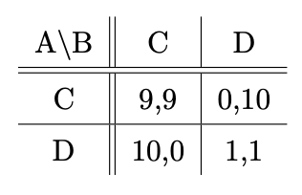
The common discount factor is $δ=0.99$.
- Find an outcome path in which the average payoff of each player is between 1.4 and 1.5. Hint: Construct an outcome path that consists of (C,C) and (D,D) outcomes that achieves the required average payoff.
If we are to be between 1.4 and 1.5 we would need need for them to play (D,D) most of the time and then sometimes play (C,C)
I need them to play (D,D) most of the time, so if we assume they play that for a long period and then one play of (C,C) then we need about
$$\frac{16+9}{17}=\frac{25}{17}≈1,470588$$
So over 17 rounds they play (D,D) 16 times and once they play (C,C) so they have an average outcome of
$$\left(1-0.99\right)·\left(\sum_{i=1}^{∞}{{0.99}^{\frac{i·17}{16}-1}}+\sum_{i=1}^{∞}{9·{0.99}^{i·17-1}}\right)≈1,428801$$
And we see that the average payoff is if between 1.4 and 1.5

- State a subgame-perfect Nash equilibrium in pure strategies, i.e., a strategy profile, that gives rise to the outcome path from (1). Show that the strategy profile you suggested is indeed subgame-perfect given the common discount factor.
We know that D dominates for both of them, which is why they would not end up in (C,C) in the one time game, but now we can have the strategy of
Play D for 16 rounds, then play C once. If the other did not play C same time as you then keep playing D until the other plays C once, then start over.
This would mean the other player would not know when they would like
Here we could have that in the one round they play C the other player might play D, but because it is infinite we see that even if they do not differ at the same time one gets payoff of 10 then they can keep playing D until the other also deviates, and so should get about the same payoff.

- Find a subgame-perfect Nash equilibrium in pure strategies in which the average payoff of player 1 is at least 9.6.
To achieve this we would need for (D,C) to be played quite often. Something like (D,C), (D,C), (C,C) should give an average payoff of
$$\frac{10+10+9}{3}=\frac{29}{3}≈9,666667$$
And for the second player a payoff of
$$\frac{9}{3}=3$$
So they also get a higher payoff that if they were to play (D,D) forever.
So if player 1 has a strategy of:
Play 2 times D and one times C. if player 2 plays 2 only plays C, if player 2 plays D then paly D forever.
Then because of the infinitely repeated game it should not be worth it for player 2 to deviate.
$$\left(1-0.99\right)·\left(\sum_{i=1}^{∞}{{10·0.99}^{\frac{i·3}{2}-1}}+\sum_{i=1}^{∞}{9·{0.99}^{i·3-1}}\right)≈9,619802$$
Which gives us the payoff we would like, for player 2 we have
$$\left(1-0.99\right)·\left(\sum_{i=1}^{∞}{9·{0.99}^{i·3-1}}\right)≈2,9699$$
So they should not wish to deviate, I think? Because they could first deviate in the third round which should not be worth it.

- Show that your strategy profile from (3) in indeed a subgame-perfect Nash equilibrium given the common discount factor.
It is easy to see that if player 2 deviates in round 1 they get a lower payoff
$$\left(1-0.99\right)·\left(\sum_{i=1}^{∞}{{0.99}^{i-1}}\right)=1$$
Of 1 because that is the payoff they get every round. If they deviate in the third round they get the payoff
$$\left(1-0.99\right)·\left({0.99}^{2}·10+\sum_{i=4}^{∞}{{0.99}^{i-1}}\right)≈1,068309$$
So we see that this would also not be worth it, and so because it is infinitely repeated player 2 would not deviate because the cost is too big.
Also player 1 will not deviate as they would certainly get a lower payoff.

- Can you find a subgame-perfect Nash equilibrium in pure strategies in which the average payoff of player 1 is more than 9.9? If yes, please state the equilibrium. If no, please explain.
So we would need for player 2 to have the average payoff over 1, because we would need for them to play (D,C) almost always.
$$\left(1-0.99\right)·\left(\sum_{i=1}^{∞}{{10·0.99}^{\frac{i·x}{x-1}-1}}+\sum_{i=1}^{∞}{9·{0.99}^{i·x-1}}\right)≥9.9$$
$$\left(1-0.99\right)·\left(\sum_{i=1}^{∞}{9·{0.99}^{i·x-1}}\right)≥1$$
We would need for these two to hold at the same time for the same x I cannot solve this but will try the easier way
$$\frac{10·\left(x-1\right)+9}{x}=9.9$$
$⇕$ Ligningen løses for x vha. WordMat.
$$x=10$$
So we would need for them to play (D,C) 9 times and (C,C) one time, this gives average payoffs for player 2 of
$$\left(1-0.99\right)·\left(\sum_{i=1}^{∞}{9·{0.99}^{i·10-1}}\right)≈0,8598446$$
So this is below 1 and would not work, I even think it might have to be higher when we actually calculate the real average payoff for player 1 and so we see that even more it would not work.
So there is not a subgame-perfect Nash equilibrium in pure strategies in which the average payoff of player 1 is more than 9.9.

Question 3 Competitive screening in labour markets
Consider the problem of a risk neutral worker who is hired (contracted) by a risk neutral firm. The worker may spent time obtaining $y≥0$ years of yoga experience prior to the potential hiring process. A worker can be of two types: high (H) or low (L). Types differ in their productivity and in their cost of acquiring $y$. A worker’s productivity level can be either $r_{L}$ or$r_{H}$ with $r_{H}>r_{L}>0$ ($r_{H}$ is the productivity of a high type worker), and having yoga experience does not make the worker more (or less) productive. A worker can get$y$ at the cost $θ_{i}y$ before entering the market where $θ_{i}∈\{θ_{L},θ_{H}\}$ and $θ_{H}<θ_{L}$ ($θ_{H}$ is the marginal cost of acquiring Yoga skills for a high type worker). The firm does not observe the type of worker he is dealing with, but does observe the value of$y$. Let $β(L)∈\left[0,1\right]$ be the firm’s initial (unconditional) belief that the worker is of type L, and let $β\left(L | y\right)$ be the firm’s belief that the worker is of type L for a given observed $y$.
The timing of the game is as follows:
- Workers choose y
- Firms observe y and offer wages.
Workers are willing to work for any wage $w>0$. To decide on a final wage the firm and the worker bargain. We assume that the worker has all the bargaining power such that the firm will accept any requirement from the worker of a wage less than (or equal to) the worker’s expected productivity (given the firm’s belief).
- Write up the worker’s expected productivity and the wage function in equilibrium given the belief of the firm.
So the expected productivity, here I am going to use the $β\left(L | y\right)$ so we assume the firm saw a level of y.
$$E\left(r\right)=r_{H}·\left(1-β\left(L | y\right)\right)+β\left(L | y\right)·r_{L}$$
The wage function is then
$$w=E\left(r\right)$$
Because of the fact that they are willing to pay the expected productivity level.

- Explain the concept of a PBE and express the equilibrium requirements in relation to the current game.
A PBE is a combination of a strategy profile and beliefs. So a player must always have a belief about how the game looks, and the probability distribution is over the different nodes.
There are 2 equilibrium requirements:
1: Given their beliefs, the players’ strategies must be sequentially rational. So they always need to make the move that is most optimal given their beliefs.
2: The players’ beliefs in every information set (on and off the equilibrium path) are determined by the players’ equilibrium strategies and Bayes’ rule whenever applicable
So they incorporate all information given to them also off the equilibrium path.

- Write up the IC constraints which determines the set of values of $y$ which can be used as signals from the high type in a separating PBE.
So we need for them to want to choose their own contract when the company wishes to offer two contracts one for each type. The separating PBE.
$$\begin{aligned}w_{H}-θ_{H}·y_{H}≥w_{L}-θ_{H}·y_{L}\#\left(IC_{H}\right)\end{aligned}$$
$$\begin{aligned}w_{L}-θ_{L}·y_{L}≥w_{H}-θ_{L}·y_{H}\#\left(IC_{L}\right)\end{aligned}$$
So it is the set of $y_{H}$ which makes these two true that can separate the high type from the low type. Specifically we can look at $IC_{L}$and see
$$w_{L}-w_{H}≥θ_{L}·y_{L}-θ_{L}·y_{H}$$
$$⇔w_{L}-w_{H}≥θ_{L}\left(y_{L}-y_{H}\right)$$
$$⇔y_{H}≥y_{L}-\frac{w_{L}-w_{H}}{θ_{L}}$$
So any of the $y_{H}$ where this is true would be making sure it was a high type, at least if it is > it should be true.

- Write up a separating PBE, i.e. specify equilibrium strategies, beliefs etc.
So for the worker we should have the strategy of:
Choose $y_{H}$ if $θ_{H}$ and $y_{L}$ if $θ_{L}$.
For the firm we have the strategy:
Offer $w_{H}$ if $y_{H}>y_{L}-\frac{w_{L}-w_{H}}{θ_{L}}$ else $w_{L}$.
The beliefs of the firm are then:
High type if $y_{H}>y_{L}-\frac{w_{L}-w_{H}}{θ_{L}}$ else low type.

- Write up a pooling PBE, i.e. specify equilibrium strategies, beliefs etc.
So now both types choose the same y and so the firms have to act on their beliefs like in 1)
The workers have the strategy:
Choose y.
The firm has the strategy:
Offer
$$w=E\left(r\right)=r_{H}·\left(1-β\left(L | y_{i}\right)\right)+β\left(L | y_{i}\right)·r_{L}$$
If $y_{i}=y$ and 0 else. (so the low type does not go lower or the high type goes higher?)
And the beliefs of the firm are just
$$E\left(r\right)=r_{H}·\left(1-β\left(L | y_{i}\right)\right)+β\left(L | y_{i}\right)·r_{L}$$
I think, so if $y_{i}=y$ then they expect the normal and if it something else I’m not sure what they expect but might be the low type no matter what? Again so that the high type does not go higher.

Question 4 Government redistribution
Consider a setting where a government is choosing how to design a tax system. In this setting the income, $q$, of worker $i$ is determined as a function of his effort $e$ and type $θ$ as $q=θe$.
$θ$ represents the productivity type of the individual. There are two types of individuals: a low type $θ_{L}$ and a high type $θ_{H}$ (where $θ_{H}>θ_{L}$). The probability that a random individual is of low type is$β$ and he is of high type with probability $1-β$.
All individuals in this economy have the same increasing and strictly concave von Neumann- Morgenstern utility function given by $u \left(q-t-ψ \left(e\right)\right)$ where $t$ is the net tax (or subsidy) which the individual has to pay (receive) and $ψ (e)$ is an increasing and convex cost function.
The government is utilitarian and wants to maximize the sum of utilities in the economy (or simply the expected utility of individual $i$ without knowing his type). To achieve this goal the government can redistribute income across individuals through the tax scheme satisfying the following budget constraint: $βt_{L}+\left(1 - β\right)t_{H}=0$ where $t_{L}$ is the tax revenue (cost) from L-types and$t_{H}$ is the tax revenue (cost) from the H-types.
Assume further that the government can simply require participation from its workers and therefore we do not need to consider participation constraints below.
First best: Assume that the government observes the type $θ_{i}$of individua$l i$.
- Formulate the government’s maximization problem which determines the choice of $t_{L},e_{L},t_{H},e_{H}$ under the first best.
Jeg har svaret til hele denne opgave I TØ 12 og pdf sendt ud I sammenhæng med TØ 12. Der er 2 løsninger til en del af opgaven som begge er rigtige!

- Characterize the first best solution and interpret the first order conditions.

Second Best A: Income contingent taxes: Assume now that the government can specify taxes dependent on the realization of income $q$ but do not directly observe the individual components$θ$ and $e$. This means that an individual with productivity $θ_{j}$ can always pretend to be of type $θ_{i}$by effort level $\frac{θ_{i}e_{i}}{θ_{j}}$.
- Formulate two IC constraints for the analysis under the second best, and explain why we can still cast the problem of the government as one of choosing levels of $t_{L},e_{L},t_{H},e_{H}$. Hint: Because the utility function has only one argument/composite index $\left(q-t-ψ \left(e\right)\right)$ the constraints can simply be formulated as comparing the index (and not the utility) across alternatives.

- Show that the first best contract (i.e. with the first best level of $q_{i}$ and $t_{i}$) from above is not implementable under the second best.

- Formulate the government’s maximization problem under the second best.

- Briefly explain the meaning and intuition of the term “no distortions at the top” used in the lectures (2-3 sentences). And show that the first order condition for $e_{H}$implies no “distortion at the top”.

Second Best B: Effort contingent taxes: Assume now that the government can directly specify the effort level required by individual$i$ but do not directly observe the individual components $θ_{i}$and $q$.
- Formulate the government’s maximization problem under the second best.

Mikro eksamen juni 2021

Question 1 Signalling game
A dam that a construction firm built for a municipality has collapsed. The construction firm knows whether the collapse was due to negligence on its part or due to circumstances outside of its control. The municipality does not observe which of these two states is the true one. Both sides know that in a court trial, the true state will eventually be uncovered.
After observing the state of the world, the firm tries to arrive at a out-of-court settlement with the municipality. It has two alternatives: to make a low settlement offer, under which it pays $300,000, or a high offer, under which it pays the municipality $500,000.
After the firm has submitted the settlement offer, the municipality decides whether to accept it or not. In case that the municipality rejects the offer, the matter is settled in a court trial. Both parties are aware of the fact that the firm’s lawyer fees in case of a trial will be $600,000, and that, in addition to this, if the firm is found guilty of negligence, it will be required to pay the municipality $500,000 in damages. The municipality has no lawyer costs to pay in case of a trial.
Note den her har vi også lavet som aflevering!

- Draw the game tree that describes this situation, assuming that the root of the game tree is a move by nature that assigns equal probability to the firm being negligent or non-negligent.
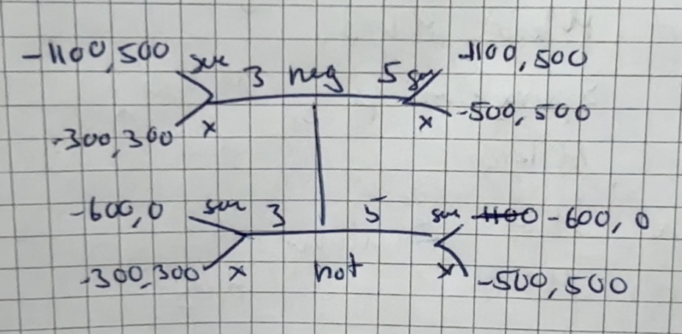

- Find all the pure-strategy Perfect Bayesian equilibria (PBE) of the game specified in (1).
So we need to look at the two pooling and two equilibrium strategies and see which ones are equilibrium. We have equal possibility for negligent and non-negligent!
- Pooling on 300
Here the municipality gets the expected payoffs of
$$E\left(sue\right)=\frac{1}{2}·500+\frac{1}{2}·0=250$$
$$E\left(x\right)=\frac{1}{2}·300+\frac{1}{2}·300=300$$
So the municipality would choose to take the offer. We see that the firm cannot get a higher payoff by deviating and so this is a PBE.
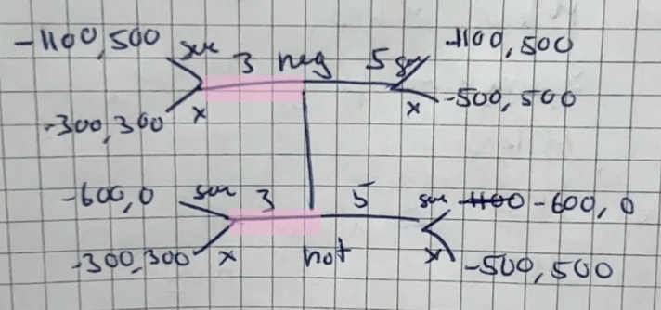

- Pooling on 500
Here the municipality gets the expected payoffs of
$$E\left(sue\right)=\frac{1}{2}·500+\frac{1}{2}·0=250$$
$$E\left(x\right)=\frac{1}{2}·500+\frac{1}{2}·500=500$$
So they would again take the bribe.
This is a PBE if they firm of either types believes there is a big enough possibility that the municipality would sue if they offered the low offer. If they believe that the municipality will not sue they would deviate to get a better payoff. So it is a PBE if
$$300·μ_{L}+\left(1-μ_{L}\right)·300≤0·μ_{L}+500·\left(1-μ_{L}\right)$$
$⇕$ Uligheden løses for mu_L vha. WordMat.
$$μ_{L}≤\frac{2}{5}$$
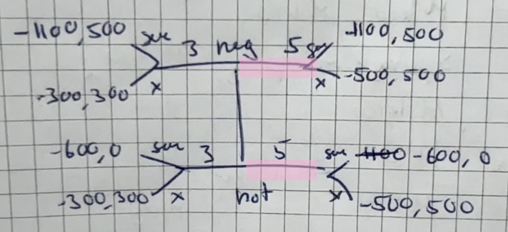

- Separating (300,500)
So if they are negligent they offer 300, else 500.
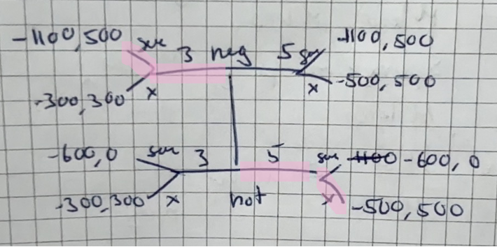
So we see that if they are negligent they would diverge and offer 500 instead for a petter payoff. So not a PBE.

- Separating (500,300)
So we have
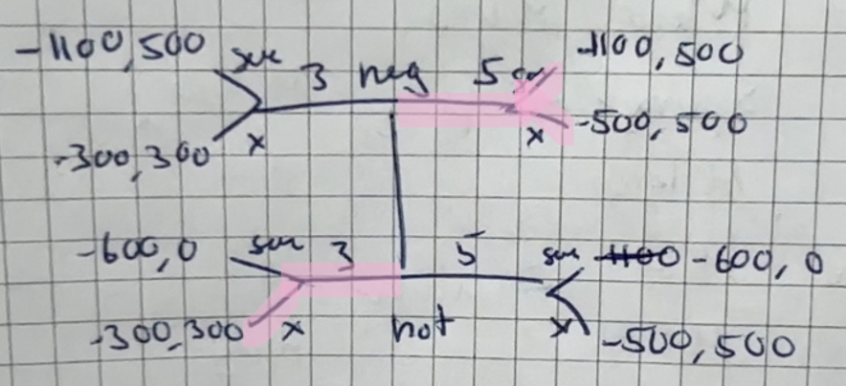
Here we see that for the negligent one the municipality does not care, so if they want what is best for the firm or not. The non negligent so not wish to deviate, but the negligent do they can get better payoff. So not PBE.

- Which of the above equilibria satisfy the intuitive criterion? Please explain (write max. 6 sentences).
When pooling on low we see that the firm can never get a better payoff than -300 and so would never deviate from here.
For pooling on high check aflevering.

Question 2 Static game of complete information, NE
There are $n$ manufacturers of electrically-powered boats. The manufacturing cost of each boat is $100,000 and the selling price of each boat is $\$200, 000 -\sum_{i=1}^{n}{x_{i}}$, where $x_{i}$ is the number of boats manufactured annually by manufacturer$i$. Manufacturers simultaneously choose how many boats to produce. For computational ease, assume that $x_{i}$can be any non-negative real number, i.e., not necessarily an integer. The payoff of each manufacturer corresponds to his profit.
- Derive the unique symmetric Nash equilibrium (that is, an equilibrium where $x_{i}=x_{j}$ for all $i$ and $j$).
So we would need to maximize profit for each person where they produce the same amount, so they get ( I am working in thousands)
$$\max_{x_{j}}\left(x_{j}·\left(200-\sum_{i=1}^{n}{x_{i}}\right)-100·x_{j}\right)$$
As they sell $x_{j}$ amount for the price of $200-\sum_{i=1}^{n}{x_{i}}$. They have production costs of 100.000 times the amount they produce $x_{j}$.
So we maximize it by differentiating and setting equal to 0.
$$200-2x_{j}-\sum_{i=1, i≠j}^{n}{x_{i}}-100=0$$
$$⇔x_{j}=\frac{200-\sum_{i=1, i≠j}^{n}{x_{i}}-100}{2}=\frac{100-\sum_{i=1, i≠j}^{n}{x_{i}}}{2}$$
Because we are looking for the unique symmetric Nash equilibrium where they all produce the same this gives us
$$\sum_{i=1, i≠j}^{n}{x_{i}}=\left(n-1\right)·x_{j}$$
And so we have
$$x_{j}=\frac{100-\left(n-1\right)·x_{j}}{2}$$
$⇕$ Ligningen løses for x_j vha. WordMat.
$$x_{j}=\frac{100}{n+1}$$
And so this is the unique symmetric Nash equilibrium where $x_{j}=\frac{100}{n+1} ∀j$.
This gives each individual seller a profit of
$$\frac{100}{n+1}·\left(200-n·\frac{100}{n+1}\right)-100·\frac{100}{n+1}=\frac{10000}{n+1}-\frac{10000·n}{n^{2}+2·n+1}$$

- Suppose that the manufacturers plan to form a cartel, choosing jointly the number of boats that each of them will produce, with the objective of maximizing the sum of profits. The manufacturers will then equally divide this number between them.
  - Show that to maximize profit, collective output needs to equal 50,000 boats.
The total profit is then, now we call x the total amount of boats produced, not by type.
$$\max_{x}\left(x·\left(200-x\right)-100·x\right)$$
So it is total amount produced times selling price of 200.000 minus total amount produced, this we differentiate and set equal to 0
$$200-2x-100=0$$
$⇕$ Ligningen løses for x vha. WordMat.
$$x=50$$

  - Derive the profit of each manufacturer.
The total profit here is
$$50·\left(200-50\right)-100·50=2500$$
So the profit for each manufacturer is then
$$\frac{2500}{n}$$

- Consider now the infinitely repeated game of the stage game described above. Let $δ∈[0, 1)$ be the common discount factor of the manufacturers. Is the strategy vector at which each manufacturer produces $\frac{50.000}{n}$ boats in each stage an equilibrium of the infinitely repeated game, for every $δ∈[0, 1)$? Justify your answer.
No. this is asking if they will always keep to the cartel. But if $δ$ is low enough so they only really value the money they get now and not the money they get in the future, then it can very well be worth it to deviate and produce more to begin with
Also depending on whether they would get punished for deviating then it is always worth it, even for a high $δ$ if there is no punishment and the other companies keep producing the same amount.

- Consider a strategy $σ_{i}$ for each manufacturer $i$ that is defined as follows:
- In the first stage, produce $\frac{50.000}{n}$boats
- For each $t>1$, the number of boats to produce is determined as follows:
- if in each of the previous stages, every manufacturer produced $\frac{50.000}{n}$ boats, then produce $\frac{50.000}{n}$ boats in stage $t$;
- otherwise, produce $\frac{100.000}{n+1}$boats in stage$t$.
For which value of $n$ and which discount factor $δ$ is the strategy vector $(σ_{1},…,σ_{n})$ a Nash equilibrium of the infinitely repeated game? [Hint: Use average payoffs to analyze when player i would have an incentive to deviate from $σ_{i}$.] What can we conclude about the stability of cartels, given these results?
So we see this is a strategy of keep the cartel going until someone deviates and then punish them forever. So there is incentive to keep to the cartel.
If no one ever deviates everyone gets the payoff of
$$\left(1-δ\right)·\sum_{i=1}^{∞}{δ^{i-1}·\frac{2500}{n}}=\frac{2500}{n}$$
So of course they would get the average payoff of the payoff they get every round. So if they can get a higher payoff than this it is worth it to deviate.
We are not sure the payoff they would get if they deviate. We can find it by maximizing their payoff given everyone else produces $\frac{50}{n}$ so we have
$$\max_{x_{j}}\left(x_{j}·\left(200-x_{j}-\left(n-1\right)·\frac{50}{n}\right)-100·x_{j}\right)$$
Differentiate and set equal to 0
$$200-2x_{j}-\left(n-1\right)·\frac{50}{n}-100=0$$
$⇕$ Ligningen løses for x_j vha. WordMat.
$$x_{j}=\frac{25·n+25}{n}$$
Which would give them a payoff of
$$\frac{25·n+25}{n}·\left(200-\frac{25·n+25}{n}-\left(n-1\right)·\frac{50}{n}\right)-100·\frac{25·n+25}{n}=\frac{1250}{n}+\frac{625}{n^{2}}+625$$
If we assume they deviate in the first round. After the first one everyone plays as in 1) and so then they get an average payoff of:
$$\left(1-δ\right)·\left(\frac{1250}{n}+\frac{625}{n^{2}}+625+\sum_{i=2}^{∞}{δ^{i-1}·\left(\frac{100}{n+1}·\left(200-n·\frac{100}{n+1}\right)-100·\frac{100}{n+1}\right)}\right)=\left(1-δ\right)·\left(\frac{δ·\left(\frac{100·\left(200-\frac{100·n}{n+1}\right)}{n+1}-\frac{10000}{n+1}\right)}{1-δ}+\frac{1250}{n}+\frac{625}{n^{2}}+625\right)$$
So it is worth it to deviate if
$$\left(1-δ\right)·\left(\frac{δ·\left(\frac{100·\left(200-\frac{100·n}{n+1}\right)}{n+1}-\frac{10000}{n+1}\right)}{1-δ}+\frac{1250}{n}+\frac{625}{n^{2}}+625\right)≥\frac{2500}{n}$$
Now I cannot just solve this with my calculator, so we will look at some different n-values and see it is worth it to deviate.
If $n=2$ we have
$$\left(1-δ\right)·\left(\frac{δ·\left(\frac{100·\left(200-\frac{100·2}{2+1}\right)}{2+1}-\frac{10000}{2+1}\right)}{1-δ}+\frac{1250}{2}+\frac{625}{2^{2}}+625\right)≥\frac{2500}{2}$$
$⇕$ Uligheden løses for delta vha. WordMat.
$$δ≤0,5294118$$
So here we see it is worth it to deviate for a low enough delta.
For $n=3$ we have
$$\left(1-δ\right)·\left(\frac{δ·\left(\frac{100·\left(200-\frac{100·3}{3+1}\right)}{3+1}-\frac{10000}{3+1}\right)}{1-δ}+\frac{1250}{3}+\frac{625}{3^{2}}+625\right)≥\frac{2500}{3}$$
$⇕$ Uligheden løses for delta vha. WordMat.
$$δ≤0,5714286$$
So again low delta, but this time it can be a little higher when there are more people.
If $n=100$ we see
$$\left(1-δ\right)·\left(\frac{δ·\left(\frac{100·\left(200-\frac{100·100}{100+1}\right)}{100+1}-\frac{10000}{100+1}\right)}{1-δ}+\frac{1250}{100}+\frac{625}{{100}^{2}}+625\right) ≥\frac{2500}{100}$$
$⇕$ Uligheden løses for delta vha. WordMat.
$$δ≤0,9622677$$
So here we see it is almost always worth it to deviate.
So if there is enough people and a low enough $δ$ it is worth it to deviate. We can also check for which n we have for specific deltas.
For $δ=0.99$ we have
$$\left(1-0.99\right)·\left(\frac{0.99·\left(\frac{100·\left(200-\frac{100·n}{n+1}\right)}{n+1}-\frac{10000}{n+1}\right)}{1-0.99}+\frac{1250}{n}+\frac{625}{n^{2}}+625\right)≥\frac{2500}{n}$$
$⇕$ Uligheden løses for n vha. WordMat.
$$n≤-1 ∨ \left(n≥-1 ∧ n≤0\right) ∨ \left(n≥0 ∧ n≤0,002538087\right) ∨ n≥393,9975$$
So we see if there are enough companies then it is worth it to deviate even for a $δ$ that is almost 1.

Question 3 signalling in labour markets
Consider a setting where two types of job seekers (type-H and type-L, respectively) are hired by firms and where job seekers can invest in education $y$ prior to entering the job market. Suppose that in the population of job seekers 1/4 are type-H and the remaining 3/4 are type-L individuals.
Education affects the productivity of individuals $x_{i}(y)$ as follows
$$x_{H}\left(y\right)= 8y, x_{L}(y) = 4y$$
The type specific costs of education are
$$c_{H}\left(y\right)=\frac{1}{2}y^{2}, c_{L}\left(y\right)=\frac{3}{4}y^{2}$$
A job seeker’s utility is given by the wage received minus the cost of education:
$$u_{i}(w, y) = w - c_{i}(y) for i ∈ \{L, H\}$$
All workers have an outside option normalized to zero.
There are $m≥2$ firms which can hire as many workers as they want to. A firm’s profits per worker are given by the worker’s productivity $x$ net of the wage $w$ paid to the worker: $π\left(x, w\right)=x-w$. If firms offer the same wages the job seekers will choose a firm at random.
Part 1: Suppose that there is complete information about worker types, i.e., firms observe both the type $i∈\{L, H\}$ and the educational attainment $y$ of a job seeker.
- Derive the equilibrium wage schedules.
Hint: Determine the type specific wage schedule (as a function of y) which a firm will offer.
So now the firms know the type and can then offer two different wages, we see that the workers have reservation wage of 0, the firms will have 0 profit because of multiple firms. So
$$x\left(y\right)=w\left(y\right)$$
So for the high type we have
$$w_{H}\left(y\right)=8y$$
And for the low type
$$w_{L}\left(y\right)=4y$$

- Show that in equilibrium type-H individuals are going to choose $y_{H}=8$. Determine the equilibrium education level $y_{L}$ which type-L individuals are going to choose.
We see that the workers will maximize their utility, so we are looking for (for the high type)
$$\max_{y}{8y-\frac{1}{2}y^{2}}$$
Differentiate and set equal to 0
$$8-y=0⇔y=8$$
As we had to show.
For the low type we get
$$\max_{y}{4y-\frac{3}{4}y^{2}}$$
Differentiate and set equal to 0
$$4-\frac{3}{4}·2y=0$$
$⇕$ Ligningen løses for y vha. WordMat.
$$y=2,666667$$
So the low type will choose $2,67$.

Part 2: Suppose now only job seekers are informed about their type, i.e., firms can only observe a job seeker’s educational attainment $y$.
- Determine the wage schedule (as a function of $y$) which would arise in a pooling equilibrium where both types invest in the same education level y.
So then we would have the expected productivity of the worker which is
$$w\left(y\right)=E\left(x\right)=\frac{1}{4}·8y+\frac{3}{4}·4y=5·y$$

- Analyze whether the wage schedule
$$w\left(y\right)=\left\{\begin{aligned}4y, if y<\overline{y} \\ 5y, if y≥\overline{y}\end{aligned}\right.$$
is part of a pooling equilibrium if the education threshold is$\overline{y}=3$. What are we assuming about firms’ beliefs when they observe $y<\overline{y}$?
So we will look at the low type if the wage function is $w\left(y\right)=5y$ and see which y they choose.
$$\max_{y}{5y-\frac{3}{4}y^{2}}$$
Differentiate and set equal to 0
$$5-\frac{3}{4}·2y=0$$
$⇕$ Ligningen løses for y vha. WordMat.
$$y=\frac{10}{3}$$
Here the low type has a utility of
$$u_{over}=5·\frac{10}{3}-\frac{3}{4}·{\left(\frac{10}{3}\right)}^{2}=\frac{25}{3}≈8,333333$$
If they go for a lower y they would have to maximize
$$\max_{y}{4y-\frac{3}{4}y^{2}}$$
So
$$4-\frac{3}{4}·2y=0$$
$⇕$ Ligningen løses for y vha. WordMat.
$$y=\frac{8}{3}$$
With a utility of
$$u_{under}=4·\frac{8}{3}-\frac{3}{4}·{\left(\frac{8}{3}\right)}^{2}≈5,333333$$
So we see that the low type would choose to be over the threshold, this gives a higher payoff.
And for the high type
$$\max_{y}{5y-\frac{1}{2}y^{2}}$$
Differentiate and set equal to 0
$$5-y=0⇔y=5$$
And if they choose the other we get
$$\max_{y}{4y-\frac{1}{2}y^{2}}⇒y=4$$
And so the high type gets the two utilities of
$$u_{under}=4·4-\frac{1}{2}·4^{2}=8$$
Den med under er ikke lige rigtig her fordi de jø højest kan vælge 3 for at y<3(kontinuert så vi må godt sætte y=3 og regne med den) men hvis vi så viser at 4 er et maksimum prøver vi så med 3 og ser at de får lavere nytte af at vælge under stadig!
$$u_{over}=5·5-\frac{1}{2}·5^{2}=\frac{25}{2}=12,5$$
So we see that both types would choose a level over the threshold,
But because they do not choose the same amount even though they are both over the threshold it is actually not an equilibrium.
So it is a mistake if they are under 3, so the firm has no beliefs about who they are.

- Analyze whether the wage schedule
$$w\left(y\right)=\left\{\begin{aligned}4y, if y<\overline{y} \\ 5y, if y≥\overline{y}\end{aligned}\right.$$
is part of a pooling equilibrium if the education threshold is $\overline{y}=5$.
We can here use the calculations from above, we saw the for the wage scheme of $5y$ the low type would not choose a y over 5, if they had to be over 5 they would get the utility of
$$5·5-\frac{3}{4}·5^{2}=6,25$$
Which we see is over the utility they would get for choosing a y lower than 5. And so this is a pooling equilibrium, because they both choose specifically $y_{L}=y_{H}=5$.
Because we see that the high type would still choose a y over the threshold.

- Show that the wage schedule
$$w\left(y\right)=\left\{\begin{aligned}4y, if y<\overline{y} \\ 8y, if y≥\overline{y}\end{aligned}\right.$$
is part of a separating equilibrium if the education threshold is $\overline{y}=10$. Which education levels, $y_{L}$ and $y_{H}$, are workers choosing in equilibrium?
So for the wage of $4y$ we know what y both would choose and their utility is
$$u_{under}^{L}=5,333333$$
$$u_{under}^{H}=8$$
So we need to check if they would choose the higher one. If we let them maximize their utility under the wage scheme of $8y$ they would choose, for the low type:
$$\max_{y}{10y-\frac{3}{4}y^{2}}⇒10-\frac{3}{4}·2y=0$$
$⇕$ Ligningen løses for y vha. WordMat.
$$y=6,666667$$
So it is below, if they choose 10 they get the utility
$$u_{over}^{L}=8·10-\frac{3}{4}·{\left(10\right)}^{2}=5$$
So the low type would get a higher payoff from choosing a y under 10.
For the high type we get
$$\max_{y}{8y-\frac{1}{2}y^{2}}⇒y=8$$
So we also need to look at if they choose 10 instead, they then get a utility of
$$u_{over}^{H}=8·10-\frac{1}{2}{10}^{2}=30$$
So we see that the high type would choose to be over the threshold.
And so this is a separating equilibrium.

Question 4 Investment opportunity
A risk-neutral entrepreneur has to choose between two different types of projects (E1 and E2, respectively). E1 projects pay 3500 with 80% probability and 0 with 20% prob- ability. E2 projects pay 4000 with 60% probability and 0 with 40% probability. Both types of projects require an initial investment of 2500. Assume that the entrepreneur has savings $E<2500$. To secure enough funds for the initial investment the entrepreneur can obtain a loan from an investor. The investor is risk neutral and requires the amount he loans out (L) plus some interest in case the chosen project succeeds. In particular, the investor requires a return payment of $L(1+R)$ if the project succeeds and if the project fails the investor gets 0 (since the entrepreneur goes bankrupt).
Part 1: Assume the investor observes the type of project.
- Calculate the expected payoff from each type of projects. If an entrepreneur has$E=2500$, which project is implemented? From an efficiency point of view, which projects should be implemented?
So we get the expected payoffs
$$E\left(E1\right)=3500·0.8-2500=300$$
$$E\left(E2\right)=4000·0.6-2500=-100$$
So we see that it would only be E1 that is implemented.

- Assume $E=500$. What is the maximal interest rate, $R^{max}$, that the investor can charge for each type of project?
So we here remember the investor is only paid back if the project is successful, and we assume that they take the investment if $E\left(project\right)=0$. They need to borrow 2000 from the investor.
so we get for E1
$$0.8·\left(3500-2000·\left(1+R\right)\right)-500=0$$
$⇕$ Ligningen løses for R vha. WordMat.
$$R^{max}=0,4375$$
So the maximal interest rate for E1 is $R^{max}=0,4375$. For E2 we have
$$0.6·\left(4000-2000·\left(1+R\right)\right)-500=0$$
$⇕$ Ligningen løses for R vha. WordMat.
$$R=0,5833333$$
So here for E2 we have $R=0,583$.

- Assume $E=1500$. What is the maximal interest rate, $R^{max}$, that the investor can charge for each type of project? Compare to your results in (2) and explain the difference.
We do the same with a little different numbers as they only need to borrow 1000 now
For E1 we have
$$0.8·\left(3500-1000·\left(1+R\right)\right)-1500=0$$
$⇕$ Ligningen løses for R vha. WordMat.
$$R=0,625$$
And for E2 we have
$$0.6·\left(4000-1000·\left(1+R\right)\right)-1500=0$$
$⇕$ Ligningen løses for R vha. WordMat.
$$R=0,5$$
So we see that for E1 the less they have to borrow the higher the interest rate, and it is the opposite for E2, probably because it has a higher chance of failing, and this a higher chance of them not having to pay anything back.

Part 2: Assume the investor does not observe the type of project.
- For a given interest rate $R$ how large would $E$ have to be to secure that the entrepreneur choose project 1? Interpret the result.
So we need to look at when the entrepreneur gets the highest payoff. So it is when
$$0.8·\left(3500-\left(2500-E\right)·\left(1+R\right)\right)-E≥0.6·\left(4000-\left(2500-E\right)·\left(1+R\right)\right)-E$$
$⇕$ Uligheden løses for E vha. WordMat.
$$\left(0,2·E-500\right)·R+0,2·E-100≥0$$
$$⇔0,2E\left(R+1\right)-500R-100≥0$$
$$⇔0,2E\left(R+1\right)≥500R+100$$
$$⇔E\left(R+1\right)≥2500R+500$$
$$⇔E≥\frac{2500R+500}{R+1}$$
Which means that if $R=\frac{1}{2}$ we need
$$\frac{2500·\frac{1}{2}+500}{\frac{1}{2}+1}≈1166,667$$
For E to be larger than $1166,7$.
In general we see that as R goes up then so does the E we need for the entrepreneur to choose project 1. Which fits with what we saw in part 1.

- Assume now $E<2500$ and that the potential investor believes that there is a 75 % chance that an entrepreneur chooses the E1 project. What is the minimum interest rate the investor charges?
Hint: Write up the expected return payment given the beliefs of the investor and set it equal to the initial investment.
So this means he would set it so the expected return for him is equal to the initial investment, because we are looking at the minimum interest rate and at least he wants to get his initial investment back.
$$Expected return=initial investment$$
The investor only gets the $\left(2500-E\right)·\left(1+R\right)$ back, so we get
$$0.75\left(0.8·\left(2500-E\right)·\left(1+R\right)\right)+0.25\left(0.6·\left(2500-E\right)·\left(1+R\right)\right)=2500-E$$
$⇕$ Ligningen løses for R vha. WordMat.
$$R=0,3333333$$
So we see that the minimum interest rate the investor charges is 0,33 no matter what E is.

Mikro eksamen august 2021

Question 1 Normal form, mixed strategy game
Country A plans to develop nuclear weapons and is building the necessary facilities. Country B sends a spy to country A to determine, whether nuclear weapons are already under development, and considers bombing the new facilities. The spy is of quality $α$; that is, with probability $α$, she will correctly report that Country A develops nuclear weapons if it actually does, and with probability $1-α$, she will report a false negative. Similarly, if Country A does not develop nuclear weapons, the spy will correctly report this with probability $α$ and report a false positive with probability $1-α$.
Country A decides whether or not to develop nuclear weapons. Country B receives the spy report and then decides whether or not to bomb country A’s facilities. Payoffs are given in the following table:
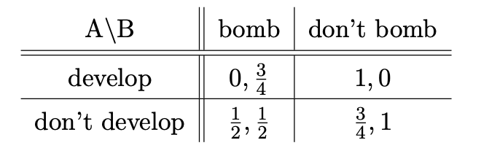
- Write down Country B’s four pure strategies.
So country B has 4 strategies because they can choose to bomb or not bomb and they can choose to trust /listen to the agent or not.
- Bomb no matter what
- Never bomb
- Bomb if the agent says develop
- Bomb if the agent says not developed.

- Use your answer in (1) to represent the situation described in the text as a normal-form game. Are there any dominating strategies in the game?
So now we use the 4 strategies of country B
A / B | bomb | Don’t bomb | Bomb if said | Bomb if said not
Develop | $$0,\frac{3}{4}$$ | $$1,0$$ | $$1-α, α·\frac{3}{4}$$ | $$α,\left(1-α\right)\frac{3}{4}$$
Don’t develop | $$\frac{1}{2},\frac{1}{2}$$ | $$\frac{3}{4},1$$ | $$\frac{1}{2}+\frac{1}{4}α, \frac{1}{2}+\frac{1}{2}·α$$ | $$\frac{3}{4}-\frac{1}{4}·α, 1-\frac{1}{2}·α$$
Explanations:
- (develop, bomb if said)
For the (develop, bomb if said) we get this because there is alpha chance of the agent being correct which means there is alpha chance of them bombing, so the expected payoff for country A is
$$1-α$$
Because there is $\left(1-α\right)$ chance of her saying they did not develop, and so the payoff is $1·\left(1-α\right)=1-α$ because they get 0 payoff if they bomb here and 1 if they do not.
Country B gets payoff of $\frac{3}{4}$ if they bomb, which they do with probability $α$ and 0 if they do not, hence $α·\frac{3}{4}$.

- (don’t develop, bomb if said)
For the (don’t develop, bomb if said) the payoff for country A is there is $α$ chance that the spy is correct(so say they did not develop) where they would then not bomb and get payoff $\frac{3}{4}$ and there is $\left(1-α\right)$ chance she says they did develop and so they would bomb and get payoff of $\frac{1}{2}$ therefore we get
$$α·\frac{3}{4}+\left(1-α\right)·\frac{1}{2}=\frac{1}{2}+\frac{1}{4}α$$
For country B we then have the same with their payoffs, so
$$α·1+\left(1-α\right)·\frac{1}{2}=\frac{1}{2}+\frac{1}{2}·α$$

- (develop, bomb if said not)
Then we go kinda the other way. So it is the same payoffs as the one where they bomb if she said if we switch $α$ and $1-α$ so we get the payoff for country A is $α$ and for country B is it $\left(1-α\right)·\frac{3}{4}$.

- (don’t develop, bomb if said not)
So again we switch them around and get
$$\left(1-α\right)·\frac{3}{4}+α·\frac{1}{2}=\frac{3}{4}-\frac{1}{4}·α$$
For country A and for B
$$\left(1-α\right)·1+α·\frac{1}{2}=1-\frac{1}{2}·α$$

Now I also need to check for dominating strategies:
I am not sure if there are any?
Could be depending on $α$ we see that

- Describe verbally what it means that the quality of the spy is $α=\frac{1}{2}$? What if $α=1$? (Write max. 3 sentences.)
If $α=\frac{1}{2}$ it means that the spy is right half the time and wrong half the time, so it does not help the government at all, they cannot use the spy’s information for anything.
If $α=1$ it means that the spy is always right, so country B would not have to wonder, they can just trust what the agent says and then act accordingly.

- For each $α∈\left[\frac{1}{2} , 1\right],$ find the game’s equilibria. [Hint: Consider first the cases that $α=1$ and $α=\frac{1}{2}$ in turn. Then consider $α∈(12,1).]$
For $α=1$ we have
A / B | bomb | Don’t bomb | Bomb if said | Bomb if said not
Develop | $$0,\frac{3}{4}$$ | $$1,0$$ | $$0, \frac{3}{4}$$ | $$1,0$$
Don’t develop | $$\frac{1}{2},\frac{1}{2}$$ | $$\frac{3}{4},1$$ | $$\frac{3}{4}, 1$$ | $$\frac{1}{2},\frac{1}{2}$$
Here we draw and get
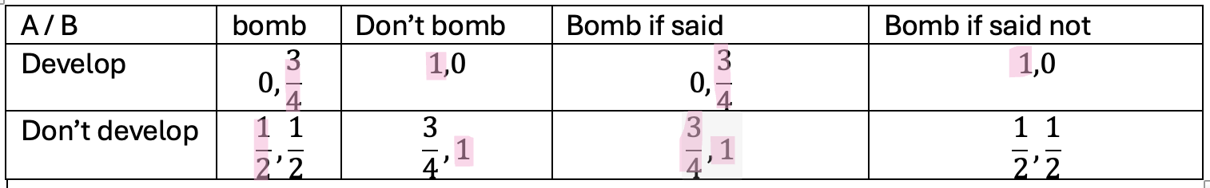
So we see that (don’t develop, bomb if said) is the only equilibrium in pure strategies.

For $α=\frac{1}{2}$ we have
A / B | bomb | Don’t bomb | Bomb if said | Bomb if said not
Develop | $$0,\frac{3}{4}$$ | $$1,0$$ | $$\frac{1}{2}, \frac{3}{8}$$ | $$\frac{1}{2},\frac{3}{8}$$
Don’t develop | $$\frac{1}{2},\frac{1}{2}$$ | $$\frac{3}{4},1$$ | $$\frac{5}{8},\frac{3}{4}$$ | $$\frac{5}{8},\frac{3}{4}$$
Here we get:
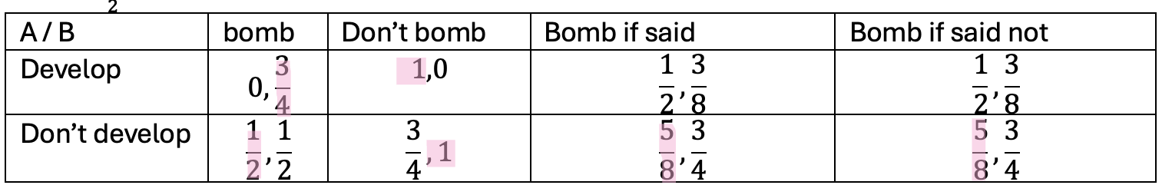
So we see there is no equilibrium in pure strategies here.

We must then have at some point it becomes so there is an equilibrium. We can see that it would have to be when country B chooses bomb if said only if $\frac{1}{2}+\frac{1}{2}·α=1$ which only happens when $α=1$ because otherwise they would not choose to.
A / B | bomb | Don’t bomb | Bomb if said | Bomb if said not
Develop | $$0,\frac{3}{4}$$ | $$1,0$$ | $$1-α, α·\frac{3}{4}$$ | $$α,\left(1-α\right)\frac{3}{4}$$
Don’t develop | $$\frac{1}{2},\frac{1}{2}$$ | $$\frac{3}{4},1$$ | $$\frac{1}{2}+\frac{1}{4}α, \frac{1}{2}+\frac{1}{2}·α$$ | $$\frac{3}{4}-\frac{1}{4}·α, 1-\frac{1}{2}·α$$

So the only equilibrium in pure strategies is when $α=1$ and it is (don’t develop, bomb if said).

There are also mixed strategy equilibria, check the notes from Nicola.

- Determine the equilibrium payoffs. How do they depend on $α$?
These are dependent on what one found before. Check again.

- What is the probability that country A will manage to develop nuclear weapons without being bombed, if both countries play their equilibrium strategies and $α=1$?
It is 0 because we saw that if $α=1$ then B will always know, so they cannot get away with it, and if they developed and B knows they will always bomb.

Question 2 Signalling game
Xavi (X) is the chef of restaurant “Le gourmet enchainé”. Yves (Y ) is a food nerd considering going to the restaurant, but is not sure about Xavi’s type which can be either average (a) or brilliant (b). Yves believes both types to be equally likely. After learning his type, Xavi makes a decision to either offer Yves a menu with three options (meat, fish, vegetarian) or a menu with two options (fish, vegetarian). The following game tree describes the situation:
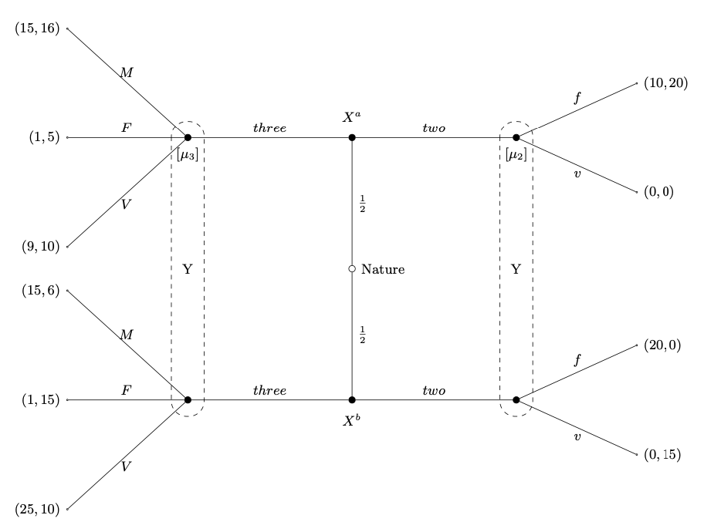
- Find all the pure-strategy Perfect Bayesian equilibria (PBE) of the game.
So we look at the different possibilities of pooling and separating.
- Pooling on three
Here we get
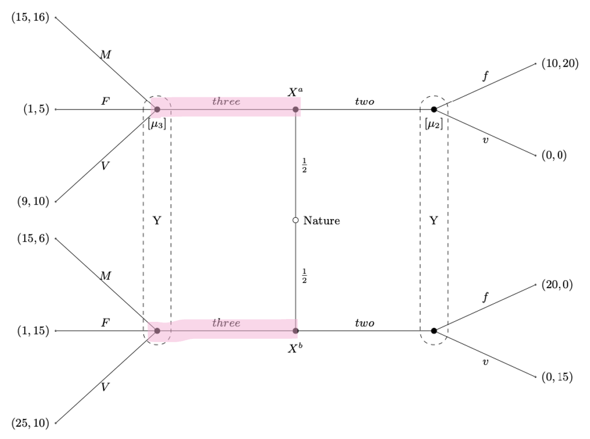
So then Y does not know where he is and will take it by what he believes, he has expected payoff of
$$E\left(M\right)=\frac{1}{2}·16+\frac{1}{2}·6=11$$
$$E\left(F\right)=\frac{1}{2}·5+\frac{1}{2}·15=10$$
$$E\left(V\right)=\frac{1}{2}·10+\frac{1}{2}·10=10$$
So we see he would choose M. here we see that the a type will not deviate, cannot get a better payoff. The b type will also not deviate.
So it is equilibrium, PBE.

- Pooling on two
So we have
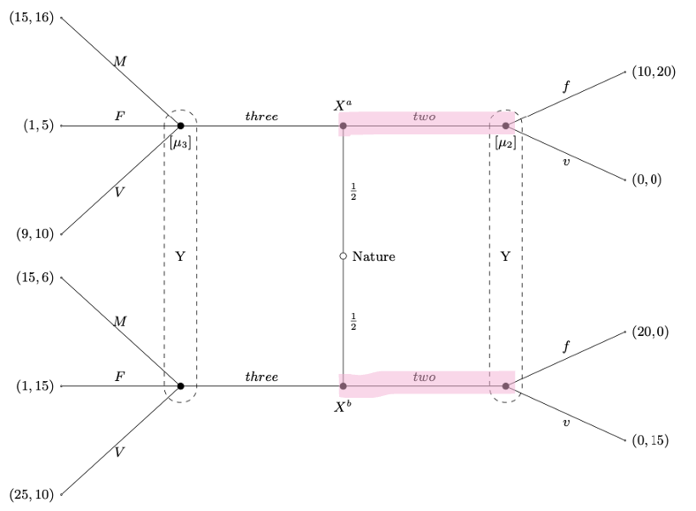
So again look at expected payoff
$$E\left(f\right)=\frac{1}{2}·20+\frac{1}{2}·0=10$$
$$E\left(v\right)=\frac{1}{2}·0+\frac{1}{2}·15=7,5$$
So we see that if the a type believes that player B will play M we will deviate, and the b type will deviate if he believes that he will play V. so we need to look at the expected payoffs for player B for the 3 different plays he can play
$$E\left(M\right)=16·μ_{3}+6·\left(1-μ_{3}\right)=10·μ_{3}+6$$
$$E\left(F\right)=5·μ_{3}+15·\left(1-μ_{3}\right)=15-10·μ_{3}$$
$$E\left(V\right)=10·μ_{3}+10·\left(1-μ_{3}\right)=10$$
So we see that player a will deviate if we have
$$10·μ_{3}+6>15-10·μ_{3}$$
$⇕$ Uligheden løses for mu_3 vha. WordMat.
$$μ_{3}>0,45$$
And
$$10·μ_{3}+6>10$$
$⇕$ Uligheden løses for mu_3 vha. WordMat.
$$μ_{3}>0,4$$
So as long as $μ_{3}>0,45$ he will deviate, and so it is not a PBE.
We also need to check when b will deviate as we need for neither of them to deviate if it is a PBE. He will deviate as long as
$$10>10·μ_{3}+6$$
$⇕$ Uligheden løses for mu_3 vha. WordMat.
$$μ_{3}<0,4$$
And
$$10>15-10·μ_{3}$$
$⇕$ Uligheden løses for mu_3 vha. WordMat.
$$μ_{3}>0,5$$
So we see that there is no $μ_{3}$ for which the b type would deviate as Y will not play V.
So if we put these two together we see that neither will deviate when $μ≤0,45$and so it is a PBE here.

- Separating three, two
So the a type gives 3 and the b type gives 2.
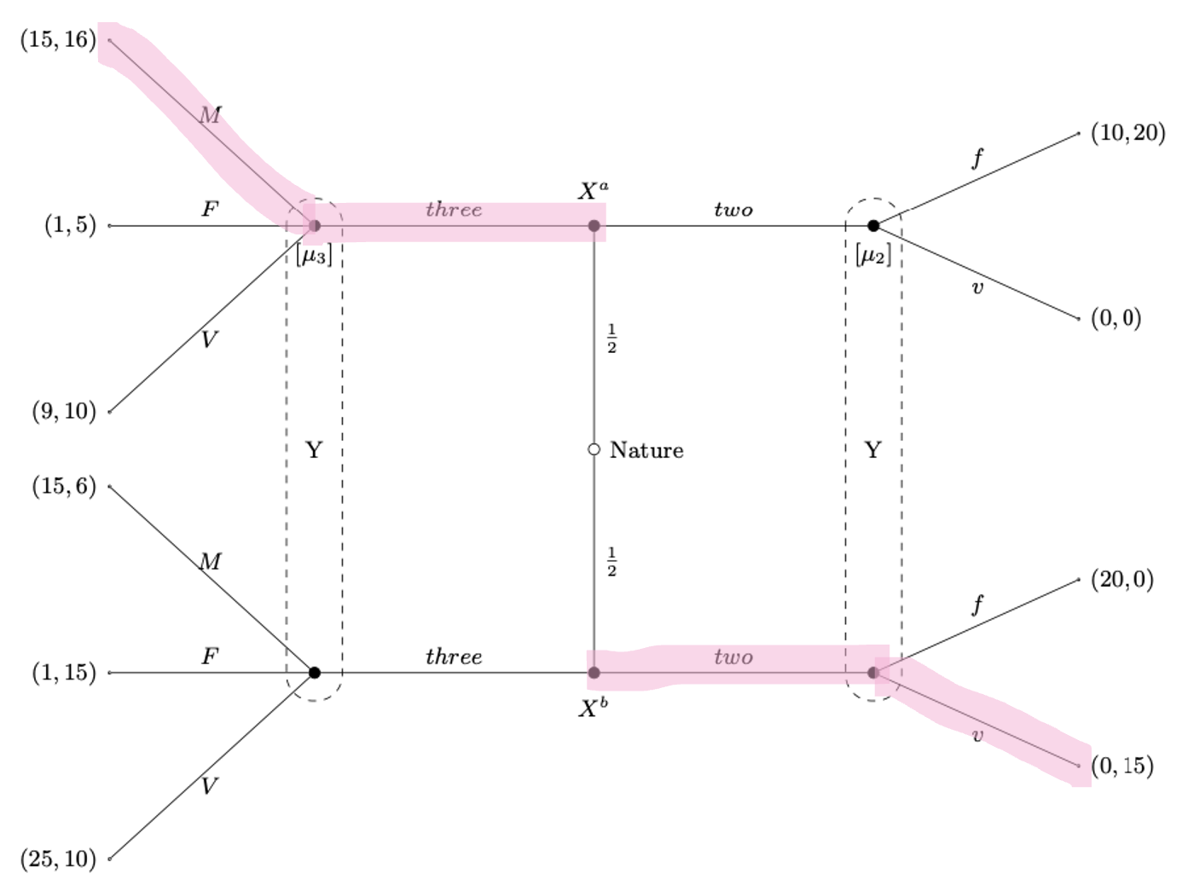
Here we see that the b type will deviate as they get a payoff of 0 and can get 15 for deviating. so not a PBE.

- Separating two, three
So the a type gives 2 and the b type gives 3.
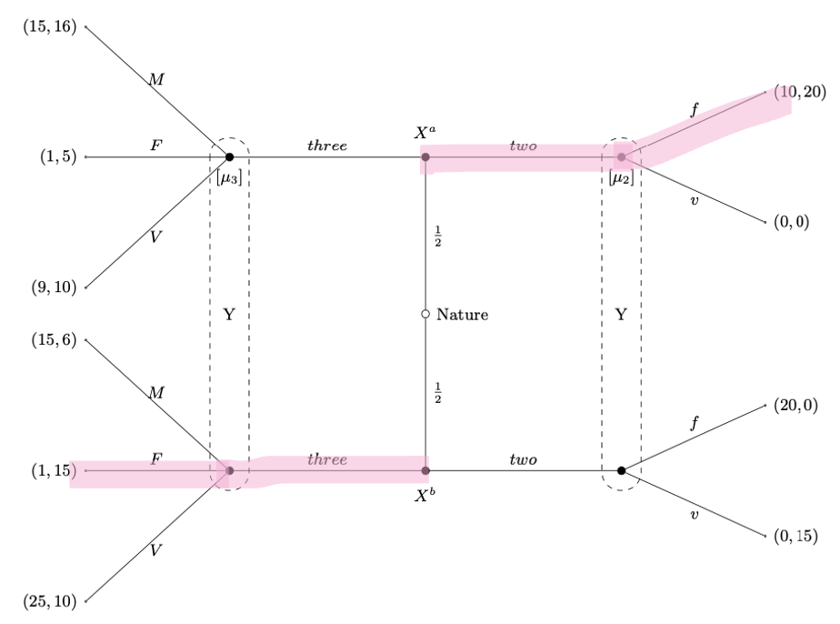
Here we see that the b type will deviate so they can get a higher payoff. So not a PBE.

So the only PBE is pooling on three.

- Which of the equilibria satisfy the intuitive criterion? Please explain.
The pooling on 3 survives. The a type cannot get a higher payoff at all, and the low type could but knows it cannot happen Y would get 0 and so not probable.
I don’t believe the pooling on 2 survives. I think the a type can get better for deviating, but not 100% sure.

Question 3 Moral hazard
Consider a risk neutral principal who wants to delegate to an agent the production of $q$ units of a good. The value for the principal of these $q$ units of the good is $p·q$, where $p$ is the price of the good the principal gets in the market. The principal tries to hire the agent to work for him by offering a contract specifying a total payment,$t$, and a required level of goods to be produced $q$.
The agent can be one of two types$θ∈\left\{\overset{̲}{θ},\overline{θ}\right\}$. The utility of the agent $θ$ is given by
$$u \left(t, q, θ\right)=t-C\left(q, θ\right)$$
where the production costs of the agent are: $C\left(q, \overset{̲}{θ}\right)=\overset{̲}{θ}·q^{2}$ or C $C\left(q, \overline{θ}\right)=\overline{θ}·q^{2}$, respectively. The outside option of the agent is 0 regardless of his type.
The timing of the game is as follows.
- At date 1, the agent learns his type $θ∈\left\{\overset{̲}{θ},\overline{θ}\right\}$
- At date 2, the principal offers a contract(s) to the agent consisting of a production level $q$ and a transfer $t$.
- At date 3, the agent can accept or reject the contract. If he rejects it, he receives his reservation utility of zero. If he accepts it, the contract is executed at date 4.
Part 1: Suppose there is no asymmetric information between the principal and the agent, i.e., the principal observes the agent’s type before a contract is offered.
- State the principal’s optimization problem and solve the principal’s problem, i.e., characterize the first best production levels and the first best transfers for each type.
So he would like to maximize his profit, I set $λ$ as the probability of $θ_{1}$ and so we have
$$\max_{q_{1},t_{1},q_{2},t_{2}}{λ\left(p·q_{1}-t_{1}\right)+\left(1-λ\right)·\left(p·q_{2}-t_{2}\right)}$$
s.t.
$$\begin{aligned}t_{i}-θ_{i}·q_{i}^{2}≥0\#\left(PC\right)\end{aligned}$$
For $i=1,2$.
We know that the two PC will be equalities and so we have
$$t_{i}=θ_{i}·q_{i}^{2}$$
So we get
$$\max_{q_{1},q_{2}}{λ\left(p·q_{1}-θ_{1}·q_{1}^{2}\right)+\left(1-λ\right)·\left(p·q_{2}-θ_{2}·q_{2}^{2}\right)}$$
Differentiate and set equal to 0
$$\frac{∂}{∂q_{1}}=λ·p-λ·θ_{1}·2q_{1}=0$$
$⇕$ Ligningen løses for q_1 vha. WordMat.
$$q_{1}=\frac{0,5·p}{θ_{1}}$$
$$\frac{∂}{∂q_{2}}=\left(1-λ\right)·p-\left(1-λ\right)·θ_{2}·2q_{2}=0$$
$⇕$ Ligningen løses for q_2 vha. WordMat.
$$q_{2}=\frac{0,5·p}{θ_{2}}$$
So we see they produce 0,5 times their probability over their type.
And the t given is
$$t_{1}=θ_{1}·{\left(\frac{0,5·p}{θ_{1}}\right)}^{2}=\frac{0,25·p^{2}}{θ_{1}}$$
$$t_{2}=θ_{2}·{\left(\frac{0,5·p}{θ_{2}}\right)}^{2}=\frac{0,25·p^{2}}{θ_{2}}$$

- Compare the first best production levels for the two types with each other and discuss whether the solution is efficient.
The solution is efficient, they get according to their type, otherwise the same, no informational rent.

Part 2: From now on assume that there is asymmetric information between the principal and the agent, i.e., the principal cannot observe the agent’s type (the prior probability distribution is however common knowledge). Suppose the principal offers a contract $(\overset{̲}{t},\overset{̲}{q})$ designed for type $\overset{̲}{θ}$ and $\left(\overline{t},\overline{q}\right)$for type $\overline{θ}$. Assume that the share of agents who are of type $θ$ is $λ$.
- Is the first best solution implementable, i.e., would the first best contracts lead to a separating equilibrium?
No, they would not necessarily choose their correct contract.

- State the principal’s optimization problem.
The principal now has the problem
$$\max_{q_{H},t_{H},q_{L},t_{L}}{λ\left(p·q_{H}-t_{H}\right)+\left(1-λ\right)·\left(p·q_{L}-t_{L}\right)}$$
s.t.
$$\begin{aligned}t_{H}-θ_{H}·q_{1}^{2}≥0\#\left(PC_{H}\right)\end{aligned}$$
$$\begin{aligned}t_{L}-θ_{L}·q_{L}^{2}≥0\#\left(PC_{L}\right)\end{aligned}$$
$$\begin{aligned}t_{H}-θ_{H}·q_{H}^{2}≥t_{L}-θ_{H}·q_{L}^{2}\#\left(IC_{H}\right)\end{aligned}$$
$$\begin{aligned}t_{L}-θ_{L}·q_{L}^{2}≥t_{H}-θ_{L}·q_{H}^{2}\#\left(IC_{L}\right)\end{aligned}$$

- Explain the meaning of the different constraints, and for each constraint discuss whether we should expect it to be binding or non-binding (max 2-3 sentence(s) per constraint)
So we have to participation constraints ensuring that both types would say yes to an offered contract. And then we have the two incentive compatibility constraints, they ensure that a specific type will choose the contract designed for their type and not the other type.
We go through them and see it they are binding.
Note: we have that $θ_{L}<θ_{H}$! (normally we have so I assume here also)
- $\left(PC_{H}\right)$ is slack
We see this from $\left(IC_{H}\right)$ and $\left(PC_{L}\right)$
$$t_{H}-θ_{H}·q_{H}^{2}≥t_{L}-θ_{H}·q_{L}^{2}>t_{L}-θ_{L}·q_{L}^{2}≥0$$
- $\left(PC_{L}\right)$ binds
This is proof by contradiction. If it does not we could not have been in optimum.
- $\left(IC_{H}\right)$ binds
Because $\left(PC_{H}\right)$ is slack. Again proof by contradiction.
$$t_{H}-θ_{H}·q_{H}^{2}>t_{L}-θ_{H}·q_{L}^{2}>t_{L}-θ_{L}·q_{L}^{2}=0$$
So we see that q could be raised a small bit and still in optimum and so it is binding in optimum.
- $\left(IC_{L}\right)$ is slack
Because $\left(IC_{H}\right)$ binds we have
$$t_{H}-θ_{H}·q_{H}^{2}=t_{L}-θ_{H}·q_{L}^{2}⇔t_{H}-t_{L}=θ_{H}·\left(q_{H}^{2}-q_{L}^{2}\right)$$
And because $θ_{L}<θ_{H}$ we then have
$$t_{H}-t_{L}<θ_{L}·\left(q_{H}^{2}-q_{L}^{2}\right)⇔t_{H}-θ_{L}·q_{H}^{2}<t_{L}-θ_{L}·q_{L}^{2}$$
Which we see means that the $IC_{L}$ is slack.

- Solve the principal’s problem.
So now we solve. We can here use we have to binding constraints and two slack constraints, this means we can rewrite the two binding constraints as
$$t_{L}-θ_{L}·q_{L}^{2}=0⇔t_{L}=θ_{L}·q_{L}^{2}$$
And
$$t_{H}-θ_{H}·q_{H}^{2}=t_{L}-θ_{H}·q_{L}^{2}⇔t_{H}=t_{L}-θ_{H}·q_{L}^{2}+θ_{H}·q_{H}^{2}=θ_{L}·q_{L}^{2}-θ_{H}·q_{L}^{2}+θ_{H}·q_{H}^{2}$$
So we get the problem of
$$\max_{q_{H},q_{L}}{λ\left(p·q_{H}-θ_{L}·q_{L}^{2}+θ_{H}·q_{L}^{2}-θ_{H}·q_{H}^{2}\right)+\left(1-λ\right)·\left(p·q_{L}-θ_{L}·q_{L}^{2}\right)}$$
So we differentiate and set equal to 0 and solve
$$\frac{∂}{∂q_{H}}=λ·\left(p-θ_{H}·2q_{H}\right)=0$$
$⇕$ Ligningen løses for q_H vha. WordMat.
$$q_{H}=\frac{0,5·p}{θ_{H}}$$
$$\frac{∂}{∂q_{L}}=λ·\left(-θ_{L}·2q_{L}+θ_{H}·2q_{L}\right)+\left(1-λ\right)·\left(p-θ_{L}·2q_{L}\right)=0$$
$⇕$ Ligningen løses for q_L vha. WordMat.
$$q_{L}=\frac{p·λ-p}{2·θ_{H}·λ-2·θ_{L}}$$

- Compare the second best production levels to the first best production levels (derived in part 1) and explain the results.
We see there is no distortion at the top, the high level gets the same in both, but the lower level gets different.

Question 4 Signalling for used cars
Imagine a situation with a large number of potential buyers who would like to buy a car in the second hand market (i.e. a market for used cars). The buyers compete with each other by offering a price $p$ for a car. There are two types of cars available in the market (T1 and T2, respectively).
Prior to entering the market, a seller can visit the local auto repair shop and improve the value of the car with repairs $r$ and pay costs $c_{i}(r).$ Importantly, the cost $c_{i}(r)$ depends on the type of the car. The cost of repairs $r$ for a type T1 and T2 car are:
$$c_{T1}\left(r\right)=\frac{1}{2}r^{2}$$
$$c_{T2}\left(r\right)=\frac{3}{4}r^{2}$$
The value of a used car to a buyer depends on the level of repairs $r$ and the type of the car. Importantly, the buyers cannot observe which type of car they try to buy (they only realize ex post), but they can observe $r$. The value for a type T1 car to a buyer is $v_{T1}\left(r\right)=4r$, and if the car is type T2, the value is $v_{T2}\left(r\right)=2r$.
A buyer’s overall utility is given by the value of the car they buy ($v$) net of the price$p$ paid to the seller:
$$π\left(v, p\right)=v_{i}-p$$
A seller’s utility is given by the payment the seller receives minus the cost of repairs:
$$u_{i}\left(p, r\right)=p-c_{i}\left(y\right), for i ∈ \left\{T1, T2\right\}$$
Both buyers and sellers have an outside option normalized to zero. Further, if buyers offer the same price the seller will simply choose a buyer at random.
- Briefly discuss what needs to hold in a separating equilibrium in this game (max 3-4 bullets). Illustrate the requirements to the equilibrium signals $r_{T1}$ and $r_{T2}$ as two IC constraints.
In a separating equilibrium we would need for the two different cars to
In a competitive market price must be equal to value.
We need the IC constraints to be
$$p_{T1}-\frac{1}{2}·r_{T1}^{2}≥p_{T2}-\frac{1}{2}·r_{T2}^{2}$$
$$p_{T2}-\frac{3}{4}·r_{T2}^{2}≥p_{T1}-\frac{3}{4}·r_{T1}^{2}$$

- Show that the price schedule
$$p\left(r\right)=\left\{\begin{aligned}2r, if r<\overline{r} \\ 4r, if r≥\overline{r}\end{aligned}\right.$$
is part of a separating equilibrium if $\overline{r}=5$. Which are the equilibrium levels of $r_{T1}$and $r_{T2}$ (i.e. the level of repairs for type T1 and T2 cars, respectively)?
So we need to look at which of the two each type would choose. If we look at T1, if we have $p\left(r\right)=2r$ then the r they choose is
$$\max_{r}{2r-\frac{1}{2}·r^{2}}$$
Differentiate and set equal to 0
$$2-r=0⇒r=2$$
Gives a utility to the seller of
$$u_{under}^{T1}=2·2-\frac{1}{2}·2^{2}=2$$
And if they choose $p\left(r\right)=4r$ we get
$$\max_{r}{4r-\frac{1}{2}·r^{2}}⇒r=4$$
And they need to be over 5, so if we check for 5
$$u_{over}^{T1}=4·5-\frac{1}{2}·5^{2}=7,5$$
So we see that the T1 type would get highest utility for being over $r=5$.
Now we look at the same for T2. If $p\left(r\right)=2r$ they would choose
$$\max_{r}{2r-\frac{3}{4}·r^{2}}⇒2-\frac{3}{4}·2r=0$$
$⇕$ Ligningen løses for r vha. WordMat.
$$r=\frac{4}{3}$$
With utility of
$$u_{under}^{T2}=2·\frac{4}{3}-\frac{3}{4}·{\left(\frac{4}{3}\right)}^{2}=\frac{4}{3}$$
And for $p\left(r\right)=4r$ we get
$$\max_{r}{4r-\frac{3}{4}·r^{2}}⇒4-\frac{3}{4}·2r=0$$
$⇕$ Ligningen løses for r vha. WordMat.
$$r=\frac{8}{3}$$
Which is under 5 so we need to check for 5
$$u_{over}^{T2}=4·5-\frac{3}{4}·5^{2}=\frac{5}{4}$$
Because $\frac{4}{3}>\frac{5}{4}$ then the T2 type will chose to be under $r=5$ and therefore we have a separating equilibrium.
So the equilibrium levels are
$$r_{T1}=5$$
$$r_{T2}=\frac{4}{3}$$

- Suppose that in the population of cars the share of T1 cars is 1/2. For the price schedule below determine$θ$ and a cutoff $\overline{r}$ which would lead to a pooling equilibrium.
$$p\left(r\right)=\left\{\begin{aligned}2r, if r<\overline{r} \\ θr, if r≥\overline{r}\end{aligned}\right.$$
Hint: in a pooling equilibrium you need to ensure that $r_{T1}=$ $r_{T2}$
So we need to look at when $r_{T1}=$ $r_{T2}$.
If we have a pooling equilibrium we need them to be pooling on the high one, so on $θr$. Because we are in a competetive market the expected utility of the buyers will be 0. So we must have
$$E\left(utility\right)=\frac{1}{2}·\left(4·r-θ·r\right)+\frac{1}{2}·\left(2·r-θ·r\right)=0$$
$⇕$ Ligningen løses for θ vha. WordMat.
$$θ=3$$
So we have $θ=3$. So now we can decide for the buyers the r they will choose the same way as above. For the “under” so $p\left(r\right)=2r$ we have from above
$$u_{under}^{T1}=2$$
$$u_{under}^{T2}=\frac{4}{3}$$
So we just need to check for $p\left(r\right)=3r$and see which one they would choose:
For T1 we have
$$\max_{r}{3r-\frac{1}{2}·r^{2}}⇒r=3$$
And they need to be over a value r, so if we check for r
$$u_{over}^{T1}=3·r-\frac{1}{2}·r^{2}=3·r-\frac{r^{2}}{2}$$
And for T2 we have
$$\max_{r}{3r-\frac{3}{4}·r^{2}}⇒3-\frac{3}{4}·2r=0$$
$⇕$ Ligningen løses for r vha. WordMat.
$$r=2$$
Also over r so we check
$$u_{over}^{T2}=3·r-\frac{3}{4}·r^{2}=3·r-\frac{3·r^{2}}{4}$$
So the T1 type chooses over when
$$3·r-\frac{r^{2}}{2}≥2$$
$⇕$ Uligheden løses for r vha. WordMat.
$$r≥0,763932 ∧ r≤5,236068$$
And the T2 type chooses over when
$$3·r-\frac{3·r^{2}}{4}≥\frac{4}{3}$$
$⇕$ Uligheden løses for r vha. WordMat.
$$r≥0,509288 ∧ r≤3,490712$$
So we see that when $r∈\left(0.76, 3.49\right)$ they both choose over, and when $r<0,51$ or $r>5,23$ they both choose under. So these are the two possible pooling equilibriums we have.

- Discuss how beliefs are set on and off the equilibrium path in the separating and pooling equilibria above.

Mikro eksamen juni 2022

Question 1 normal form game infinitely repeated
Anna (A) works as a financial consultant and can exert either high or low effort in managing the finances of her client Bo (B). Bo can choose whether to pay her a high fee or a low fee. Suppose that the following stage game is infinitely repeated:
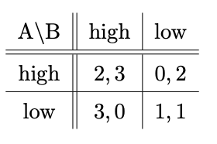
Anna and Bo have the same discount factor $δ∈(0,1).$
- Draw the convex hull of average payoffs and indicate the average payoffs that can be supported in a subgame-perfect Nash equilibrium if $δ$ is sufficiently close to 1.
The convex hull of the average payoffs when $δ$ is sufficiently close to 1 is the convex hull of the payoffs for the stage game, so we have
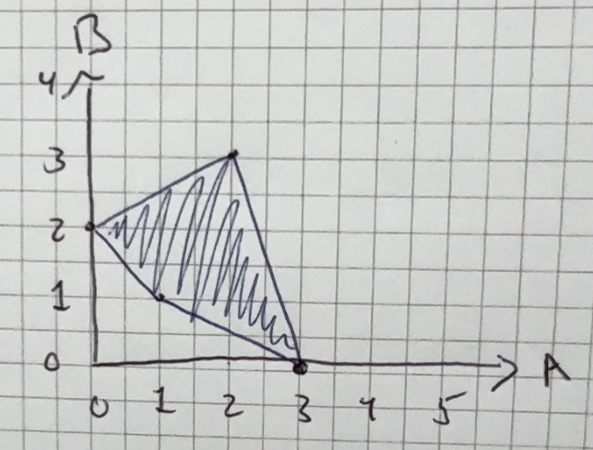

- For what values of the common discount factor $δ$ is (grim trigger; grim trigger) a subgame perfect equilibrium involving high effort and high fees in every period?
So the grim trigger strategy means they play the “better” outcome which is not the outcome in a one stage game and then punish forever if no one follows. So we need to look at average payoffs for keeping with the strategy for each person and their average payoffs for deviating(this is done in the first round) and see when it is worth it to deviate or not, if it is not worth it then the strategy is a subgame perfect equilibrium.
The average payoff for sticking with the strategy for A:
$$\left(1-δ\right)·\sum_{i=1}^{∞}{2·δ^{i-1}}=2$$
And for B:
$$\left(1-δ\right)·\sum_{i=1}^{∞}{3·δ^{i-1}}=3$$
If A deviates in the first round they get the average payoff of
$$\left(1-δ\right)·\left(3+\sum_{i=2}^{∞}{1·δ^{i-1}}\right)=\left(1-δ\right)·\left(\frac{δ}{1-δ}+3\right)$$
We see that B will never deviate as they get the highest payoff from (high,high) so now we just look at when A will deviate, they will deviate if
$$\left(1-δ\right)·\left(\frac{δ}{1-δ}+3\right)≥2$$
$⇕$ Uligheden løses for delta vha. WordMat.
$$δ≤\frac{1}{2}$$
So for $δ>\frac{1}{2}$ this grim trigger strategy is subgame perfect, no one wants to deviate here.

- Find an outcome path such that Anna’s average payoff is close to 2.5.
If Anna plays high in every second round and low in every second round, and Bo always plays high then anna gets average payoff of
$$\left(1-δ\right)·\left(\sum_{i=1}^{∞}{3·δ^{2i-1}}+\sum_{i=2}^{∞}{2·δ^{2i-1}}\right)=$$
$$\left(1-δ\right)·\left(\frac{3}{1-δ^{2}}+\frac{2δ}{1-δ^{2}}\right)=\frac{3}{1+δ}+\frac{2δ}{1+δ}$$
It is not letting me calculate it but is should be about 2.5

- State a strategy profile that gives rise to the outcome path you suggested in part (c). For which values of $δ$ is the strategy profile you suggested a subgame-perfect Nash equilibrium?
So the strategy for Anna would be play high every second round, low every second round and if B plays low play low forever.
The strategy for B would maybe be paly high unless A plays low two rounds in a row then play low forever.
So they are both also having some form of grim trigger as punishment.
The average payoff of B under this strategy is
$$\frac{3}{1+δ}$$
A would not deviate in the first round(lower payoff, but if they deviate in the second round they get average payoff of
$$\left(1-δ\right)·\left(3+\sum_{i=2}^{∞}{1·δ^{i-1}}\right)=\left(1-δ\right)·\left(\frac{δ}{1-δ}+3\right)$$
So B does not deviate as long as
$$\left(1-δ\right)·\left(\frac{δ}{1-δ}+3\right)≤\frac{3}{1+δ}$$
$⇕$ Uligheden løses for delta vha. WordMat.
$$\left(δ≥-1 ∧ δ≤0\right) ∨ δ≥\frac{1}{2}$$
So for $δ≥\frac{1}{2}$ it is equilibrium. A could also deviate in the first round and play low instead, they would then get the average payoff of
$$\left(1-δ\right)·\left(3+\sum_{i=2}^{∞}{1·δ^{i-1}}\right)=\left(1-δ\right)·\left(\frac{δ}{1-δ}+3\right)$$
So A does not deviate when
$$\left(1-δ\right)·\left(\frac{δ}{1-δ}+3\right)≤\frac{3}{1+δ}+\frac{2δ}{1+δ}$$
$⇕$ Uligheden løses for delta vha. WordMat.
$$\left(δ≥-1 ∧ δ≤-\left(\frac{1}{2}\right)\right) ∨ δ≥0$$
So we see that A would never deviate. So it is an equilibrium as long as $δ≥\frac{1}{2}$.
Det her er nok ikke helt rigtigt, evt tjek andet svar hvis får noget der minder om, men stammer fra problemer med wordmat der skal regne det tror jeg.

Question 2 signalling game
The ambitious politician A contests the leadership of his party against the battered party chairman B. With probability $p, 0<p<1$, A’s wooing of allies has been successful so that he is strong . With probability $1-p$, he has not succeeded in finding enough allies and is therefore weak. A knows his type, but B does not. According to the party rules, A can choose between two procedures to challenge B: a direct (D) leadership contest or a more indirect (I) confidence vote. B observes which of these two procedures is chosen by A and decides whether to fight (f) or resign (r). The following game tree describes the situation:
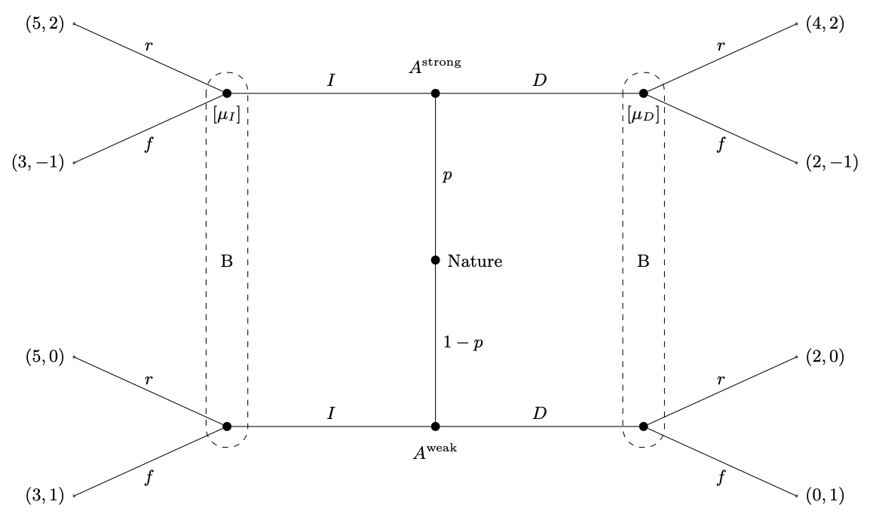

- Find all the pure-strategy Perfect Bayesian equilibria (PBE) of the game specified above.
So we need to look at the two pooling equilibria and two separating and check which ones are PBE. We go through them:

- Pooling on I
So we have
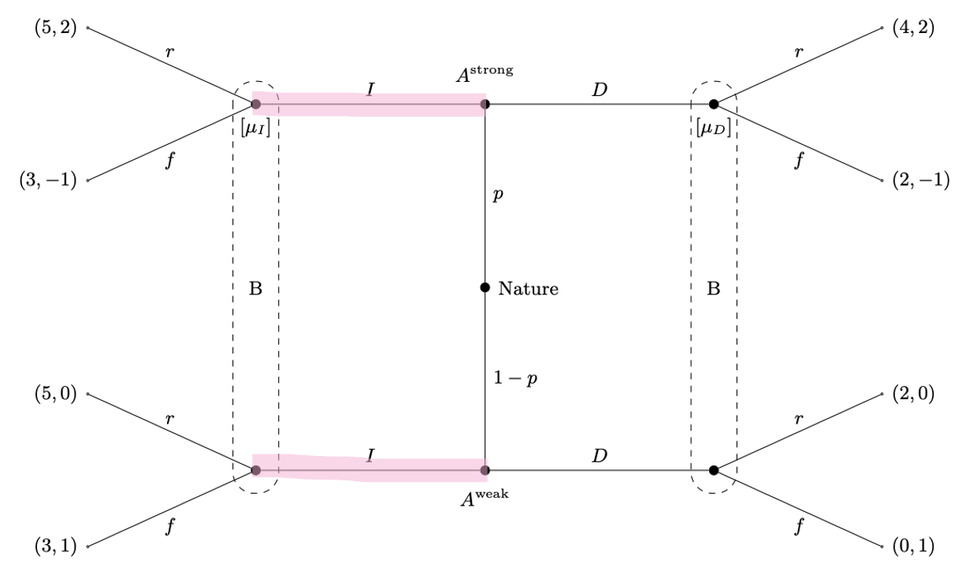
Which means that B chooses depending on where he gets the highest expected payoff:
$$E\left(r_{I}\right)=p·2+\left(1-p\right)·0=2·p$$
$$E\left(f_{I}\right)=p·\left(-1\right)+\left(1-p\right)·1=1-2·p$$
So we see that B chooses r when
$$2·p≥1-2·p$$
$⇕$ Uligheden løses for p vha. WordMat.
$$p≥\frac{1}{4}$$
When B chooses r we have a PBE as neither the weak or strong A will deviate as they cannot get a better payoff anywhere than 5. If he chooses f, so if $p<\frac{1}{4}$ the strong type might deviate if he believes he will play $r_{D}$. So we need to look at when B will play $r_{D}$, so we look at his expected outcomes on the other side
$$E\left(r_{D}\right)=μ_{D}·2+\left(1-μ_{D}\right)·0=2·μ_{D}$$
$$E\left(f_{D}\right)=μ_{D}·\left(-1\right)+\left(1-μ_{D}\right)·1=1-2·μ_{D}$$
We are looking for when it is a PBE, so it is when A believes B will play $f_{D}$ as A will then not deviate. So it is when
$$1-2·μ_{D}>2·μ_{D}$$
$⇕$ Uligheden løses for mu_D vha. WordMat.
$$μ_{D}<\frac{1}{4}$$
So pooling on I is a PBE if $p≥\frac{1}{4}$ or if $μ_{D}<\frac{1}{4}$.

- Pooling on D
So we have
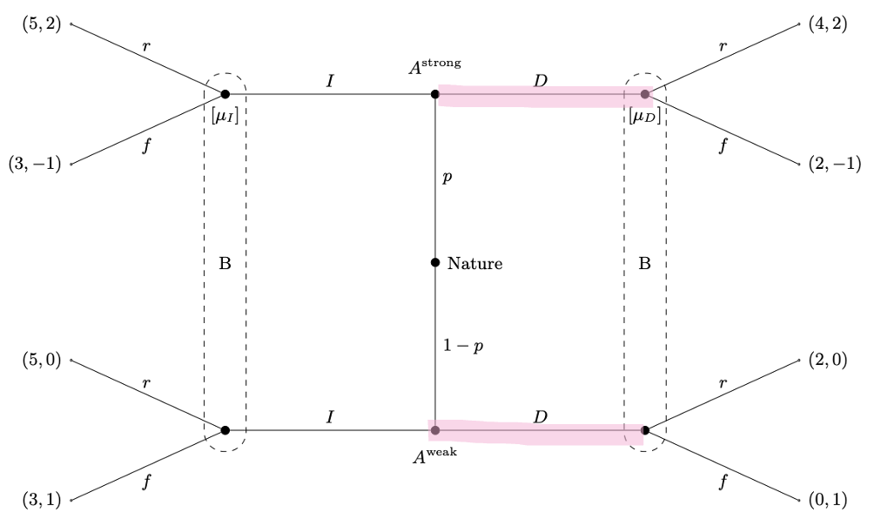
We do not really have to look at anything here as we see that for the weak type it is always worth it to deviate, they can get payoffs of 0 or 2 if they stay, but 3 or 5 if they deviate. So this is not a PBE.

- Separating I,D
So strong type plays I weak type plays D. we see again that the weak type would always deviate and so it is not a PBE.

- Separating D, I
So strong type plays D, weak type plays I. so we have:
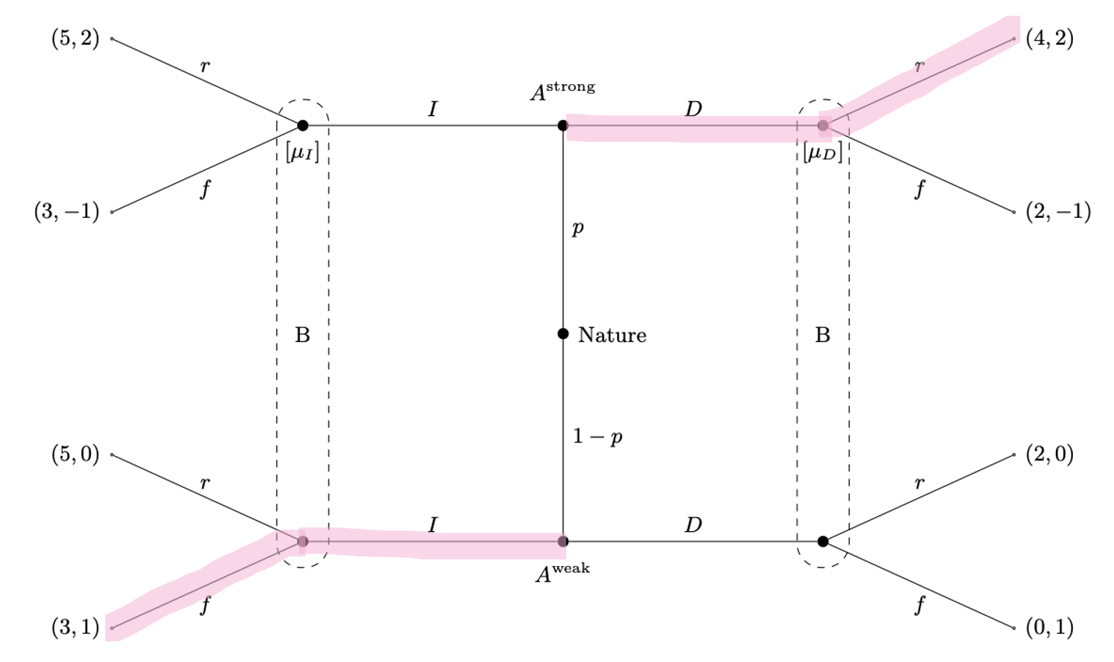
We see gain that the weak type will never deviate. The high type will also not deviate as they have a payoff of 4 now and will get a payoff of 3 if they deviate. So this is a PBE.

So overall we have
Pooling on I is a PBE if $p≥\frac{1}{4}$ or if $μ_{D}<\frac{1}{4}$.
Separating D, I is a PBE.
Written out it should be something like
$$PBE: \left(\left(I,I\right);\left(r,f\right)\right), if p≥\frac{1}{4} or μ_{D}<\frac{1}{4}$$
$$PBE:\left(\left(D,I\right);\left(r,r\right)\right)$$

Question 3 Moral Hazard, BoD
Consider the following principal-agent problem: a firm needs a manager to run its operations. The company’s Board of Directors (BoD) can observe the company’s gross earnings $π$, but not necessarily how much effort $e$ the manager puts in.
The firm will have gross earnings of either $π_{H}=1000$ or $π_{L}=400$. The manager can either work hard (W) or shirk (S). His effort determines the probability of high vs. low earnings: If $e=W$, it is $prob(π_{H}|W)=\frac{2}{3}$, while if $e=S$, it is $prob(π_{H}|S)=\frac{1}{5}$.
The manager’s utility when he is paid salary $C$and puts in effort $e$ is
$$u(C, e) = v(C) - g(e)$$
Where $v\left(C\right)=\sqrt{C}$and $g(W)=8$, while $g(S)=5$. The manager could find a job giving him net utility $\overline{u}=0$ elsewhere.
The BoD has to choose a compensation scheme $(C_{H},C_{L}),$ where $C_{H}$ denotes the manager’s compensation if profits are $π_{H}$ and $C_{L}$denotes the manager’s compensation if profits are $π_{L}$. Moreover, the BoD chooses which effort level it wants to implement.
When the manager signs his contract with the company, he does not yet know whether earnings will be high or low, so he maximizes his expected utility:
$$prob\left(π_{H} | e\right)\left(v\left(C_{H}\right)-g\left(e\right)\right)+\left(1-prob\left(π_{H} | e\right)\right)\left(v\left(C_{L}\right)-g\left(e\right)\right)$$
The BoD aims to maximize the shareholders’ expected utility, which is given by the expected net profits of the firm:
$$prob\left(π_{H} | e\right)(π_{H}-C_{H} )+\left(1-prob\left(π_{H} | e\right)\right)\left(π_{L}-C_{L}\right)$$

- Suppose first that the BoD could observe and verify the manager’s effort.
- Write down the constraint(s) the BoD faces when maximizing the shareholders’ expected utility.
So because the BoD can verify the effort level they only need the Participation constraints, so for the high effort level we need
$$prob\left(π_{H} | W\right)·\sqrt{C_{H}}+\left(1-prob\left(π_{H} | W\right)\right)·\sqrt{C_{L}}-8=\frac{2}{3}·\sqrt{C_{H}}+\frac{1}{3}·\sqrt{C_{L}}-8≥\overline{u}=0$$
And for the low effort level we need
$$prob\left(π_{H} | S\right)·\sqrt{C_{H}}+\left(1-prob\left(π_{H} | S\right)\right)·\sqrt{C_{L}}-5=\frac{1}{5}·\sqrt{C_{H}}+\frac{4}{5}·\sqrt{C_{L}}-5≥\overline{u}=0$$

- What is the optimal compensation scheme if the BoD wants to implement $e=W$?
They know the effort level the agent is taking so just need to maximize their profit given this
$$\max_{C_{H},C_{L}}{prob\left(π_{H} | W\right)\left(π_{H}-C_{H} \right)+\left(1-prob\left(π_{H} | W\right)\right)\left(π_{L}-C_{L}\right)}$$
So we have
$$\max_{C_{H},C_{L}}{\frac{2}{3}·\left(1000-C_{H}\right)+\frac{1}{3}·\left(400-C_{L}\right)}$$
We expect the PC to be binding under first best, so
$$\frac{2}{3}·\sqrt{C_{H}}+\frac{1}{3}·\sqrt{C_{L}}-8=0$$
$⇕$ Ligningen løses for C_L vha. WordMat.
$$C_{L}=4·C_{H}-96·\sqrt{C_{H}}+576$$
Insert and differentiate
$$\max_{C_{H}}{\frac{2}{3}·\left(1000-C_{H}\right)+\frac{1}{3}·\left(400-4·C_{H}+96·\sqrt{C_{H}}-576\right)}$$
$$\frac{∂}{∂C_{H}}=-\frac{2}{3}+\frac{1}{3}·\left(-4+96·\frac{1}{2}·\frac{1}{\sqrt{C_{H}}}\right)=0$$
$⇕$ Ligningen løses for C_H vha. WordMat.
$$C_{H}=64$$
And
$$C_{L}=4·64-96·\sqrt{64}+576=64$$
So the optimal compensation scheme when they want to implement high effort is to pay a constant wage here as they can condition on the effort.

- What is the optimal compensation scheme if the BoD wants to implement $e=S$?
So same as above for S this time
$$\max_{C_{H},C_{L}}{prob\left(π_{H} | S\right)\left(π_{H}-C_{H} \right)+\left(1-prob\left(π_{H} | S\right)\right)\left(π_{L}-C_{L}\right)}$$
So we have
$$\max_{C_{H},C_{L}}{\frac{1}{5}·\left(1000-C_{H}\right)+\frac{4}{5}·\left(400-C_{L}\right)}$$
And we have
$$\frac{1}{5}·\sqrt{C_{H}}+\frac{4}{5}·\sqrt{C_{L}}-5=0$$
$⇕$ Ligningen løses for C_H vha. WordMat.
$$C_{H}=16·C_{L}-200·\sqrt{C_{L}}+625$$
So we get
$$\max_{C_{L}}{\frac{1}{5}·\left(1000-16·C_{L}+200·\sqrt{C_{L}}-625\right)+\frac{4}{5}·\left(400-C_{L}\right)}$$
Differentiate and set equal to 0
$$\frac{∂}{∂C_{L}}=$$
$$\frac{1}{5}·\left(-16+200·\frac{1}{2}·\frac{1}{\sqrt{C_{L}}}\right)-\frac{4}{5}=0$$
$⇕$ Ligningen løses for C_L vha. WordMat.
$$C_{L}=25$$
And
$$C_{H}=16·25-200·\sqrt{25}+625=25$$
So a constant wage of 25, again because they condition on e.

- What is the shareholders’ expected utility (i.e. net profits) when $e=W$ and $e=S$, respectively?
Now we know their payments so just need to look at the shareholders expected utility under these payment schemes.
When $e=W$ they have expected utility of
$$prob\left(π_{H} | W\right)\left(π_{H}-C_{H} \right)+\left(1-prob\left(π_{H} | W\right)\right)\left(π_{L}-C_{L}\right)=\frac{2}{3}·\left(1000-64\right)+\frac{1}{3}·\left(400-64\right)=736$$
And for $e=S$ we have
$$prob\left(π_{H} | S\right)\left(π_{H}-C_{H} \right)+\left(1-prob\left(π_{H} | S\right)\right)\left(π_{L}-C_{L}\right)=\frac{1}{5}·\left(1000-25\right)+\frac{4}{5}·\left(400-25\right)=495$$

- Which effort level should the BoD implement and what will the compensation scheme be?
We see from the expected utility that they would like to implement high effort, where the compensation scheme is that the agent gets 64 no matter the outcome.

- Suppose now that the manager’s effort is unobservable and unverifiable to the BoD.
- Write down the constraint(s) the BoD faces if it wants to implement $e=W$.
So we also need an incentive compatibility constraint, so the agent chooses the effort level we would like. If they want to implement high effort they need
$$\frac{2}{3}·\sqrt{C_{H}}+\frac{1}{3}·\sqrt{C_{L}}-8≥\frac{1}{5}·\sqrt{C_{H}}+\frac{4}{5}·\sqrt{C_{L}}-5$$
As well as the participation constraint from before:
$$\frac{2}{3}·\sqrt{C_{H}}+\frac{1}{3}·\sqrt{C_{L}}-8≥\overline{u}=0$$

- What is the optimal compensation scheme if the BoD wants to implement $e=W$?
So they have the problem
$$\max_{C_{H},C_{L}}{\frac{2}{3}·\left(1000-C_{H}\right)+\frac{1}{3}·\left(400-C_{L}\right)}$$
s.t.
$$\frac{2}{3}·\sqrt{C_{H}}+\frac{1}{3}·\sqrt{C_{L}}-8≥0$$
$$\frac{2}{3}·\sqrt{C_{H}}+\frac{1}{3}·\sqrt{C_{L}}-8≥\frac{1}{5}·\sqrt{C_{H}}+\frac{4}{5}·\sqrt{C_{L}}-5$$
Here we can assume that both of them bind, so we get
$$\frac{2}{3}·\sqrt{C_{H}}+\frac{1}{3}·\sqrt{C_{L}}-8=0$$
$$\frac{2}{3}·\sqrt{C_{H}}+\frac{1}{3}·\sqrt{C_{L}}-8=\frac{1}{5}·\sqrt{C_{H}}+\frac{4}{5}·\sqrt{C_{L}}-5$$
$⇕$ Ligningssystemet løses for C_H,C_L vha. WordMat's 'Løs Ligninger' funktion,
$$C_{H}=102,8776 ∧ C_{L}=13,79592$$

So the optimal compensation scheme when they want to implement the high effort under second best is $C_{L}=3,46$ and $C_{H}=144$.

- What is the optimal compensation scheme if the BoD wants to implement $e=S$?
When implementing the low effort they can just use the compensation scheme from first best, so $C_{L}=25$ and $C_{H}=25$.

- What is the shareholders’ expected utility (i.e. net profits) when $e=W$ and $e=S$, respectively?
So we calculate for $e=W$
$$prob\left(π_{H} | W\right)\left(π_{H}-C_{H} \right)+\left(1-prob\left(π_{H} | W\right)\right)\left(π_{L}-C_{L}\right)=\frac{2}{3}·\left(1000-102,8776\right)+\frac{1}{3}·\left(400-13,79592\right)≈726,8163$$
And for $e=S$ we had $495$

- Which effort level should the BoD implement and what will the compensation scheme be?
So under second the best the BoD would also like to implement the high effort.

- What is the cost of not being able to observe the manager’s effort?
This would then be the difference for the first and second best, so there is only a cost when they want to implement the high effort. Under first best they have expected profit of $736$ and under second best they have $726,8$ so the cost is therefore
$$736-726,8163≈9,1837$$
For not being able to observe the agents effort.

Question 4 Adverse selection, market for used cars
Consider the market for used cars. Suppose that there are 100 cars in the population. Assume that used cars can be either “lemons” or “cream puffs”. Suppose that exactly 50 of the 100 cars are lemons. Current owners know whether their cars are lemons and value lemons at $1000 and cream puffs at $2000. There are 110 individuals who would like to own a used car but do not. They value lemons at $1100 and cream puffs at $2200.
- What is the allocation of the stock of used cars amongst current and potential owners, which maximizes aggregate surplus?
We see that the buyers value the cars more, so it would be if all the cars we sold. So 50 cars sold of the lemons type and 50 cars sold of the cream puffs type, and 10 buyers not getting a car.

- Suppose potential owners can tell whether a used car is a cream puff or a lemon. What would be the competitive equilibrium allocation of the stock of used cars? What would be the prices of cream puffs and lemons?
So there are two separate markets. The sellers are willing to sell when
$$u\left(cars\right)=\left\{\begin{aligned}0, &for p<1000 \\ 50, &for 1000≤p<2000 \\ 100, &for p≥2000\end{aligned}\right.$$
And the demand
$$d\left(cars\right)=\left\{\begin{aligned}100, &for p≤1100 \\ 50, &for 1100<p≤2200 \\ 0, &for p>2200\end{aligned}\right.$$
So we see that all the lemons would be sold for 1100 and the cream puffs for 2200.
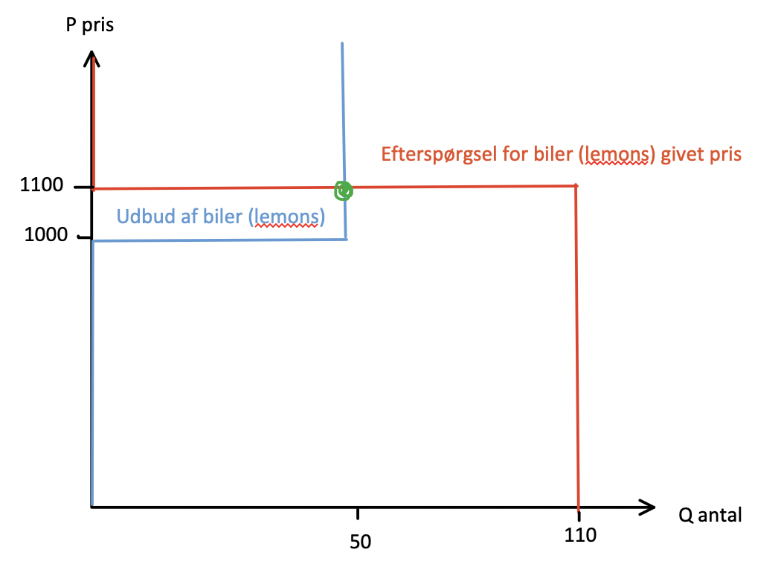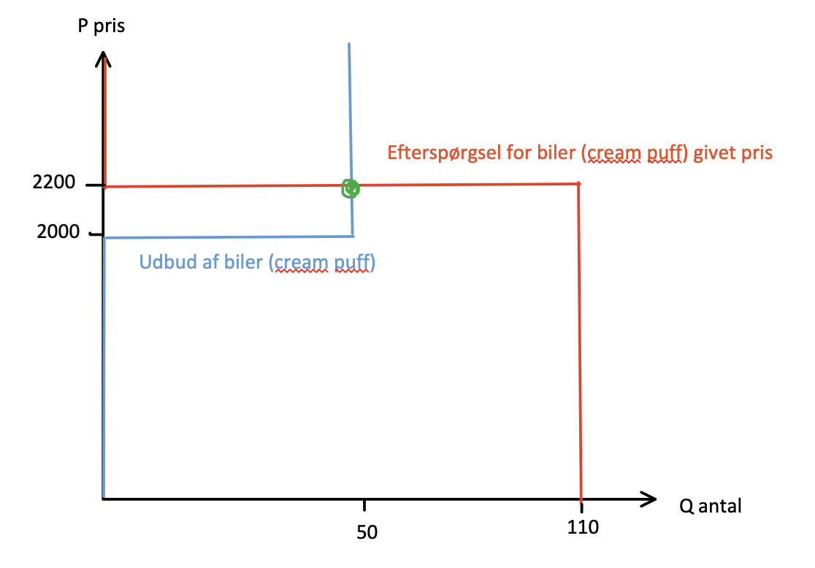

- Suppose potential owners cannot tell whether a used car is a cream puff or a lemon. They only know that 50 of the 100 used cars are cream puffs. What would be the competitive equilibrium allocation and price?
So the expected value to a buyer of a car is
$$E\left(car\right)=1100·\frac{1}{2}+2200·\frac{1}{2}=1650$$
But at this price we see that the sellers would only sell the lemons type
But the potential buyers know this and so will not buy a car for this price. So we would end up that only the lemons cars are sold for the price of 1100 as the sellers are not willing to sell the good cars at this price.

- Is there any way that a government, which cannot tell whether a used car is a cream puff or a lemon, can intervene to generate a Pareto improvement to the equilibrium in part (c)? Explain.
Øhhh?
They cannot as they cannot tell the value of a car either.

Mikro eksamen august 2022

Question 1 static and dynamic incomplete information BNE and PBE
There are two firms, 1 and 2, that produce the same good. The inverse demand
curve is given by
$$p=θ-q_{1}-q_{2}$$
where $q_{i}∈R_{+}$ is firm $i$’s output. Each firm has zero costs of production.
Demand for the good is uncertain with Nature determining the value of $θ$, assigning probability $α∈\left(0,1\right)$ to $θ=3$ and probability $1-α$ to $θ=4$. Firm 2 has a capable research team that has analysed the market, so that Firm 2 knows the value of $θ$, while firm 1 does not. The above description is common knowledge.
- The two firms choose quantities simultaneously.
- Formulate the situation as a game of incomplete information.
This means we write it up as a Bayesian game, here we need to mention things:
Players: firm 1 and firm 2
Types: nature chooses the state of the world:
$$θ=\left\{\begin{aligned}3, &with probability α \\ 4, &with probability 1-α\end{aligned}\right.$$
The type of firm 1 is always the same as it does not observe $θ$.
The type of firm 2 depends on $θ$ as it observes $θ$ and so can be $f_{2}∈\left\{3,4\right\}$.
Strategies: the strategy of firm 1 is to choose a quantity $q_{1}$ not depending on $θ$ as it does not observe it.
The strategy of firm 2 is depending on $θ$, so we have $q_{2}^{3}$ if $θ=3$ and $q_{2}^{4}$ if $θ=4$.
Payoffs: the profit of the two firms is:
$$π_{1}=q_{1}·\left(θ-q_{1}-q_{2}\right)$$
$$π_{2}=q_{2}·\left(θ-q_{1}-q_{2}\right)$$
The expected payoff of firm 1 given it does not know the state is
$$E\left(π_{1}\right)=α·\left(q_{1}·\left(3-q_{1}-q_{2}^{3}\right)\right)+\left(1-α\right)·\left(q_{1}·\left(4-q_{1}-q_{2}^{4}\right)\right)$$
The expected payoff of firm 2 is different depending on the known state
$$E\left(π_{2} | θ=3\right)=q_{2}^{3}·\left(3-q_{1}-q_{2}^{3}\right)$$
$$E\left(π_{2} | θ=4\right)=q_{2}^{4}·\left(3-q_{1}-q_{2}^{4}\right)$$
The common prior is that
$$P\left(θ=3\right)=α, P\left(θ=4\right)=1-α$$

- State the unique Bayesian Nash equilibrium.
So we need to find their best responses, first we look at the informed party, so firm 2.
If $θ=3$their best response is found by solving:
$$\max_{q_{2}^{3}}{q_{2}^{3}·\left(3-q_{1}-q_{2}^{3}\right)}$$
So we differentiate and set equal to 0
$$\frac{∂}{∂q_{2}^{3}}=3-q_{1}-2q_{2}^{3}=0$$
$⇕$ Ligningen løses for q_2 vha. WordMat.
$$q_{2}^{3⋆}=\frac{3-q_{1}}{2}$$
And if $θ=4$ we get
$$q_{2}^{4⋆}=\frac{4-q_{1}}{2}$$
Now we look at firm 1, they know this and so use this when maximizing their expected payoffs:
$$\max_{q_{1}}{α·\left(q_{1}·\left(3-q_{1}-\frac{3-q_{1}}{2}\right)\right)+\left(1-α\right)·\left(q_{1}·\left(4-q_{1}-\frac{4-q_{1}}{2}\right)\right)}$$
Differentiate and set equal to 0:
$$\frac{∂}{∂q_{1}}=α·\left(3-2q_{1}+q_{1}-\frac{3}{2}\right)+\left(1-α\right)·\left(4-2q_{1}+q_{1}-2\right)=0$$
$⇕$ Ligningen løses for q_1 vha. WordMat.
$$q_{1}=\frac{4-α}{2}$$
So now we have firm 1s best responses, we can then insert, so assuming they can also solve for this and guess we can get their equilibrium amounts:
$$q_{2}^{3⋆}=\frac{3-\frac{4-α}{2}}{2}=\frac{α+2}{4}$$
$$q_{2}^{4⋆}=\frac{4-\frac{4-α}{2}}{2}=\frac{α+4}{4}$$
Which is then the amount they will produce given a level of $α$.

- Determine the equilibrium payoffs. How do they depend on $α$?
So then we get the equilibrium payoffs if $θ=3$ of
$$π_{1}^{3}=q_{1}·\left(θ-q_{1}-q_{2}^{3}\right)=\frac{4-α}{2}·\left(3-\frac{4-α}{2}-\frac{α+2}{4}\right)=\frac{\left(4-α\right)\left(2+α\right)}{8}$$
$$π_{2}^{3}=q_{2}^{3}·\left(θ-q_{1}-q_{2}^{3}\right)=\frac{α+2}{4}·\left(3-\frac{4-α}{2}-\frac{α+2}{4}\right)={\left(\frac{α+2}{4}\right)}^{2}$$
And for $θ=4$
$$π_{1}^{4}=q_{1}·\left(θ-q_{1}-q_{2}^{4}\right)=\frac{4-α}{2}·\left(3-\frac{4-α}{2}-\frac{α+4}{4}\right)=\frac{4α-α^{2}}{8}$$
$$π_{2}^{4}=q_{2}^{4}·\left(θ-q_{1}-q_{2}^{4}\right)=\frac{α+4}{4}·\left(3-\frac{4-α}{2}-\frac{α+4}{4}\right)=\frac{α^{2}+4α}{16}$$
We can then find their expected payoffs:
$$E\left(π_{1}\right)=α·\frac{\left(4-α\right)\left(2+α\right)}{8}+\left(1-α\right)·\frac{4α-α^{2}}{8}=1,5·α-0,375·α^{2}$$
$$E\left(π_{2}\right)=α·{\left(\frac{α+2}{4}\right)}^{2}+\left(1-α\right)·\frac{α^{2}+4α}{16}=0,5·α+0,0625·α^{2}$$
So we see that when $α$ goes up firm 2 gets a higher payoff, this is because there is a larger chance of $θ=3$ and so firm 1 will produce less, and firm 3 which knows the outcome can use this information to get a higher payoff.

- Now suppose that Firm 1 chooses its quantity first. Firm 2 chooses its quantity afterwards, knowing Firm 1’s quantity.
- What is the appropriate equilibrium notion for this game and why?
So now when firm 2 has to set their amount they know both the specific amount of firm 1 and what $θ$ is.
This means that the game is no longer static, it is now dynamic. And so we are looking for a Perfect Bayesian equilibrium PBE.

- Specify an equilibrium of this game. Is it unique?
So now we need to look at the game a little differently. But we actually end up with the same functions, this is likely because they have no production costs and so the same is a little simple.
It is unique because they are choosing their best responses, for firm 1 and acting accordingly for firm 2, so they could not do better given their information.

Question 2 Signalling game
Newcomer firm A plans to enter a market dominated by incumbent firm B. With probability $\frac{1}{3}$ , A has received venture capital making it strong. With probability $\frac{2}{3}$, it has not succeeded in attracting capital and is therefore weak. A knows its type, but B does not. Firm A can either ready itself for battling or remain unready. Firm B observes whether A is ready or not and chooses whether to fight (f) or to acquiese (a). The following game tree describes the situation.
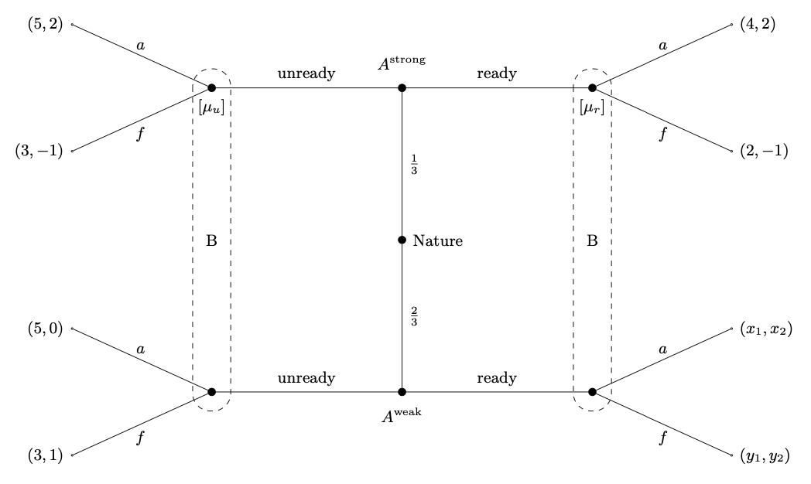
- For what values of $x_{1},x_{2},y_{1}$, and $y_{2}$, if any, does the game have a separating equilibrium in which a strong newcomer chooses ready and a weak newcomer chooses unready?
So we need to look at the game with
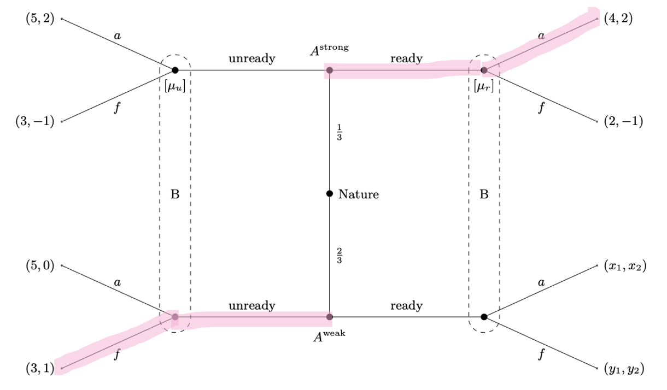
We see that in this setting the strong newcomer will never deviate, so we need to look at when the weak newcomer might deviate. We know that the incumbent will play $a_{ready}$ because it is a separating equilibrium and so we only need to look at the value of $x_{1}$ specifically, the weak newcomer will deviate if he can get a higher payoff from deviating, and so he will deviate if
$$x_{1}≥3$$
So this means that for any value of $x_{2},y_{1},y_{2}$ and $x<3$ this is a equilibrium.

- For what values, if any, does the game have a pooling equilibrium in which both types of newcomer choose unready?
So we have the game:
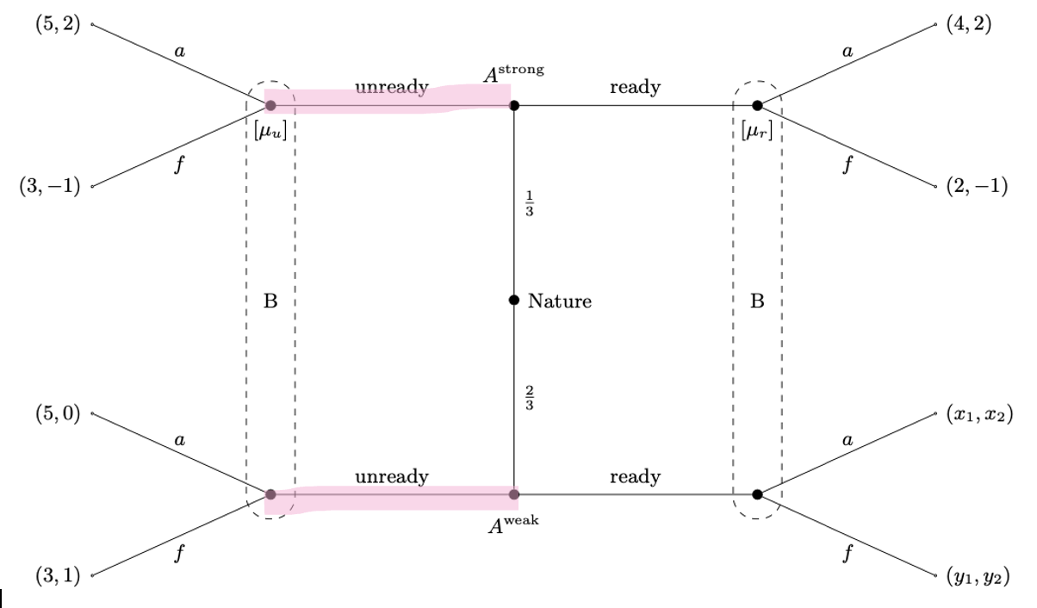
Here we need to look at what the incumbent will play, and so we look at their expected payoff
$$E\left(a\right)=\frac{1}{3}·2+\frac{2}{3}·0=\frac{2}{3}$$
$$E\left(f\right)=\frac{1}{3}·\left(-1\right)+\frac{2}{3}·1=\frac{1}{3}$$
So the incumbent will play a. we see then that the strong newcomer will never deviate as they cannot get a higher payoff. So we need to look at when the weak newcomer will deviate. Right now he is getting a payoff of 5, so if both $x_{1},y_{1}<5$ he will never deviate.
The incumbents expected payoffs for playing a and f given ready is here
$$E\left(a_{ready}\right)=μ_{r}·2+\left(1-μ_{r}\right)·x_{2}=\left(1-μ_{r}\right)·x_{2}+2·μ_{r}$$
$$E\left(f_{ready}\right)=μ_{r}·\left(-1\right)+\left(1-μ_{r}\right)·y_{2}=\left(1-μ_{r}\right)·y_{2}-μ_{r}$$
So we see that the incumbent will play a when
$$\left(1-μ_{r}\right)·x_{2}+2·μ_{r}≥\left(1-μ_{r}\right)·y_{2}-μ_{r}$$
$⇕$ Uligheden løses for mu_r vha. WordMat.
$$\left(μ_{r}-1\right)·y_{2}+\left(1-μ_{r}\right)·x_{2}+3·μ_{r}≥0$$
$$⇔μ_{r}·y_{2}-y_{2}+x_{2}-μ_{r}x_{2}+3μ_{r}≥0$$
$$⇔μ_{r}\left(y_{2}-x_{2}+3\right)≥y_{2}-x_{2}$$
$$⇔μ_{r}≥\frac{y_{2}-x_{2}}{y_{2}-x_{2}+3}$$
So when we have this, and $x_{1}>5$ the weak newcomer will deviate, so not a PBE.
Otherwise the incumbent will play f when
$$μ_{r}≤\frac{y_{2}-x_{2}}{y_{2}-x_{2}+3}$$
And so the weak newcomer will deviate when we have this and $y_{1}>5$. Then it is not a PBE.
So overall it is a PBE of pooling equilibrium if
$$μ_{r}≥\frac{y_{2}-x_{2}}{y_{2}-x_{2}+3}$$
And $x_{1}<5$.
Or if
$$μ_{r}≤\frac{y_{2}-x_{2}}{y_{2}-x_{2}+3}$$
And $y_{1}<5$. And for all other values not under this specific combination.

Question 3 Moral Hazard
A risk neutral insurance company wishes to provide health insurance to a risk
averse agent. The agent is endowed with wealth $W$. There are two possible states of the
world: either the agent gets an illness or he does not. In the former state, treatment at the doctor’s is necessary at the price $D$. The probability of the agent getting the illness depends on whether he exercises or not. Denote these two actions by $e$ and $n$, respectively. Let $π_{i}$ denote the probability of an illness when the agent takes action $i∈\{e,n\}$, where $π_{n}>π_{e}$.
The agent dislikes exercise. His payoff if he has consumption $x$ and does not exercise is $\sqrt{x}$, while if he exercises, his payoff is $\sqrt{x}-c$, where $c>0$. The agent’s reservation utility is $\overline{u}$. The insurance company’s problem is to choose a contract to offer to the agent. A contract specifies a premium $p$ and a payout $T$ to the agent in the event of an illness. If the action is observable, the contract also specifies an action $i$. The parameters of the model satisfy
$${\overline{u}}^{2}-{\left(\overline{u}+c\right)}^{2}+\left(π_{n}-π_{e}\right)·D>0$$
- Assume first that the insurer can observe whether or not the agent exercises. Solve for the contract that the insurer should offer the agent under this assumption.
The insurer would like to maximize their payoff, so
$$\max_{p,T,i}{p-π_{i}·T}$$
St.
$$π_{i}·\sqrt{W-p+T-D}+\left(1-π_{i}\right)·\left(\sqrt{W-p}\right)-c_{i}≥\overline{u}$$
Where we have that $c_{i}=0$ if he does not exercise and $c_{i}>0$ if he exercises.
So we need to solve this problem and see for which action the insurance company gets the highest expected payoff from.
So we write up lagrange
$$L=p-π_{i}·T+λ·\left(π_{i}·\sqrt{W-p+T-D}+\left(1-π_{i}\right)·\left(\sqrt{W-p}\right)-c_{i}-\overline{u}\right)$$
FOC
$$\frac{∂L}{∂p}=1+λ·\left(π_{i}\frac{1}{2\sqrt{W-p+T-D}}·\left(-1\right)+\left(1-π_{i}\right)·\frac{1}{2\sqrt{W-p}}·\left(-1\right)\right)=0$$
$$\frac{∂L}{∂T}=-π_{i}+λ·\left(π_{i}·\frac{1}{2\sqrt{W-p+T-D}}\right)=0$$
$$\frac{∂L}{∂λ}=0⇔π_{i}·\sqrt{W-p+T-D}+\left(1-π_{i}\right)·\left(\sqrt{W-p}\right)-c_{i}=\overline{u}$$
Which we can solve we can rewrite the first two:
$$-π_{i}+λ·\left(π_{i}·\frac{1}{2\sqrt{W-p+T-D}}\right)=0⇔λ=\frac{π_{i}}{π_{i}·\frac{1}{2\sqrt{W-p+T-D}}}=2·\sqrt{-p+W+T-D}$$
Which we can insert in the first one:
$$1+2·\sqrt{W-p+T-D}·\left(π_{i}\frac{1}{2\sqrt{W-p+T-D}}·\left(-1\right)+\left(1-π_{i}\right)·\frac{1}{2\sqrt{W-p}}·\left(-1\right)\right)=0$$
$$⇔1+\left(π_{i}\frac{2·\sqrt{W-p+T-D}}{2\sqrt{W-p+T-D}}·\left(-1\right)+\left(1-π_{i}\right)·\frac{2·\sqrt{W-p+T-D}}{2\sqrt{W-p}}·\left(-1\right)\right)=0$$
$$⇔1+\left(π_{i}·\left(-1\right)+\left(1-π_{i}\right)·\frac{\sqrt{W-p+T-D}}{\sqrt{W-p}}·\left(-1\right)\right)=0$$
$$⇔1-π_{i}-\left(1-π_{i}\right)·\frac{\sqrt{W-p+T-D}}{\sqrt{W-p}}=0$$
$$⇔\left(1-π_{i}\right)·\left(1-\frac{\sqrt{W-p+T-D}}{\sqrt{W-p}}\right)=0$$
$$⇒\sqrt{W-p+T-D}=\sqrt{W-p}$$
$$⇒T=D$$
So we need for the payout to be the same value as the price of the doctor.
Then we need to determine p as well, use this in the third one:
$$π_{i}·\sqrt{W-p}+\left(1-π_{i}\right)·\left(\sqrt{W-p}\right)-c_{i}=\overline{u}$$
$⇕$ Ligningen løses for p vha. WordMat.
$$p=W-{\left(\overline{u}+c_{i}\right)}^{2}$$
So we need to look at which of these two models for $i=e,n$ gives the insurance company the highest payoff. If they would like to implement $i=e$ they get
$$p=W-{\left(\overline{u}+c_{i}\right)}^{2}$$
So
$$Π_{e}=W-{\left(\overline{u}+c_{i}\right)}^{2}-π_{e}·T$$
And if they would like to implement $i=n$ they get
$$p=-{\overline{u}}^{2}+W$$
So
$$Π_{n}=-{\overline{u}}^{2}+W-π_{n}·T$$
We remember that $T=D$ and so the insurance company wants to implement e when
$$W-{\left(\overline{u}+c_{i}\right)}^{2}-π_{e}·D≥-{\overline{u}}^{2}+W-π_{n}·D$$
$$⇔{\overline{u}}^{2}-{\left(\overline{u}+c_{i}\right)}^{2}-π_{e}·D≥-π_{n}·D$$
$$⇔{\overline{u}}^{2}-{\left(\overline{u}+c_{i}\right)}^{2}+\left(π_{n}-π_{e}\right)·D≥0$$
Which we know it is, as it is given in the exercise. So the insurance company would like to implement i=e with
$$p=W-{\left(\overline{u}+c_{i}\right)}^{2}$$
$$T=D$$

For the rest of the question, assume that the insurer cannot observe the agent’s action.
- Write up the insurance company’s problem if it wants to implement $i=n$.
So then we have
$$\max_{p,T}{p-π_{n}·T}$$
St.
$$π_{n}·\sqrt{W-p+T-D}+\left(1-π_{n}\right)·\left(\sqrt{W-p}\right)≥\overline{u}$$
$$π_{n}·\sqrt{W-p+T-D}+\left(1-π_{n}\right)·\left(\sqrt{W-p}\right)≥π_{e}·\sqrt{W-p+T-D}+\left(1-π_{e}\right)·\left(\sqrt{W-p}\right)-c$$
So we have that we need the person to choose the right exercise level.

- What is the optimal contract if the insurance company wants to implement $i=n$?
We can actually just check if the first best solution works.
$$π_{n}·\sqrt{W-\left(-{\overline{u}}^{2}+W\right)+D-D}+\left(1-π_{n}\right)·\left(\sqrt{W-\left(-{\overline{u}}^{2}+W\right)}\right)=π_{n}·\sqrt{{\overline{u}}^{2}}+\left(1-π_{n}\right)·\left(\sqrt{{\overline{u}}^{2}}\right)=\left|\overline{u}\right|$$
Assuming $\overline{u}≥0$ we then have if fulfills the participation constraint, just like we would expect as it is the same from before. Now we check the IC, here we get
$$\overline{u}≥\overline{u}-c$$
Which always holds as $c>0$. So this is just the first best solution we need.

- Write up the insurance company’s problem if it wants to implement $i=e$.
So then we have
$$\max_{p,T}{p-π_{e}·T}$$
St.
$$π_{e}·\sqrt{W-p+T-D}+\left(1-π_{e}\right)·\left(\sqrt{W-p}\right)-c≥\overline{u}$$
$$π_{e}·\sqrt{W-p+T-D}+\left(1-π_{e}\right)·\left(\sqrt{W-p}\right)-c≥π_{n}·\sqrt{W-p+T-D}+\left(1-π_{n}\right)·\left(\sqrt{W-p}\right)$$
So we have that we need the person to choose the right exercise level.

- Show which constraint(s) hold(s) with equality if it wants to implement $i=e$.
Here we would expect the IC to hold with equality as it does when we have normally, only just enough incentive to choose the high one, depending on whether
$$π_{n}·\sqrt{W-p+T-D}+\left(1-π_{n}\right)·\left(\sqrt{W-p}\right)≥\overline{u}$$
Then if it is equal the PC also holds with equality, otherwise it is slack.
I think PC also binds.

- Solve for the optimal contract if the insurance company wants to implement $i=e$.
Because we have shown that the IC binds we can solve for T:
$$π_{e}·\sqrt{W-p+T-D}+\left(1-π_{e}\right)·\left(\sqrt{W-p}\right)-c=π_{n}·\sqrt{W-p+T-D}+\left(1-π_{n}\right)·\left(\sqrt{W-p}\right)$$
$$⇔π_{e}·\sqrt{W-p+T-D}-π_{n}·\sqrt{W-p+T-D}+\left(1-π_{e}\right)·\left(\sqrt{W-p}\right)-\left(1-π_{n}\right)·\left(\sqrt{W-p}\right)=c$$
$$⇔\left(π_{e}-π_{n}\right)·\sqrt{W-p+T-D}+\left(\left(1-π_{e}\right)-\left(1-π_{n}\right)\right)·\left(\sqrt{W-p}\right)=c$$
$$⇔\left(π_{e}-π_{n}\right)·\sqrt{W-p+T-D}-\left(π_{e}-π_{n}\right)·\left(\sqrt{W-p}\right)=c$$
$$⇔\left(π_{e}-π_{n}\right)·\left(\sqrt{W-p+T-D}-\left(\sqrt{W-p}\right)\right)=c$$
$$⇔\sqrt{W-p+T-D}-\left(\sqrt{W-p}\right)=\frac{c}{π_{e}-π_{n}}$$
$$⇔\sqrt{W-p+T-D}=\frac{c}{π_{e}-π_{n}}+\left(\sqrt{W-p}\right)$$
$$⇔W-p+T-D={\left(\frac{c}{π_{e}-π_{n}}+\left(\sqrt{W-p}\right)\right)}^{2}$$
$$⇔T={\left(\frac{c}{π_{e}-π_{n}}+\left(\sqrt{W-p}\right)\right)}^{2}+D+p-W$$
Now we can put this into the PC constraint that I think also binds
$$π_{n}·\sqrt{W-p+{\left(\frac{c}{π_{e}-π_{n}}+\left(\sqrt{W-p}\right)\right)}^{2}+D+p-W-D}+\left(1-π_{n}\right)·\left(\sqrt{W-p}\right)=\overline{u}$$
$$⇔π_{n}·\left(\frac{c}{π_{e}-π_{n}}+\left(\sqrt{W-p}\right)\right)+\left(1-π_{n}\right)·\left(\sqrt{W-p}\right)=\overline{u}$$
$$⇔π_{n}·\left(\frac{c}{π_{e}-π_{n}}+\left(\sqrt{W-p}\right)\right)+\left(1-π_{n}\right)·\left(\sqrt{W-p}\right)=\overline{u}$$
$$⇔π_{n}·\left(\frac{c}{π_{e}-π_{n}}\right)+\left(\sqrt{W-p}\right)=\overline{u}$$
$$⇔\sqrt{W-p}=\overline{u}-π_{n}·\left(\frac{c}{π_{e}-π_{n}}\right)$$
$$⇔W-p={\left(\overline{u}-π_{n}·\left(\frac{c}{π_{e}-π_{n}}\right)\right)}^{2}$$
$$⇔p=W-{\left(\overline{u}-π_{n}·\left(\frac{c}{π_{e}-π_{n}}\right)\right)}^{2}$$
So we see the optimal contract for T is
$$T={\left(\frac{c}{π_{e}-π_{n}}+\left(\sqrt{W-W-{\left(\overline{u}-π_{n}·\left(\frac{c}{π_{e}-π_{n}}\right)\right)}^{2}}\right)\right)}^{2}+D+W-{\left(\overline{u}-π_{n}·\left(\frac{c}{π_{e}-π_{n}}\right)\right)}^{2}-W$$
$$={\left(\frac{c}{π_{e}-π_{n}}+\overline{u}-π_{n}·\left(\frac{c}{π_{e}-π_{n}}\right)\right)}^{2}+D-{\left(\overline{u}-π_{n}·\left(\frac{c}{π_{e}-π_{n}}\right)\right)}^{2}$$
$$={\left(\frac{c}{π_{e}-π_{n}}+\overline{u}-π_{n}·\left(\frac{c}{π_{e}-π_{n}}\right)\right)}^{2}+D-{\left(\overline{u}-π_{n}·\left(\frac{c}{π_{e}-π_{n}}\right)\right)}^{2}$$
$$=\left(\frac{c}{π_{e}-π_{n}}\right)·\left(\frac{c}{π_{e}-π_{n}}+\overline{u}-π_{n}\right)+D$$
I think, and
$$p=W-{\left(\overline{u}-π_{n}·\left(\frac{c}{π_{e}-π_{n}}\right)\right)}^{2}$$
So not the same as under first best.

Question 4 Signalling in labour markets
Consider the following signaling model: There are two types of workers, $θ_{L}$ and $θ_{H}$, with $θ_{H}>θ_{L}>0$. The probability that a worker is of type $θ_{H}$is $λ∈\left(0,1\right).$ The output of a type-$θ$ worker is $θ$. Worker types are not observable to the firms. Both types have a reservation utility of zero.
Before entering the job market a worker can get non-productive education, the amount of which is observable, also to the firms. Let $e$ denote the education level the worker obtains. The cost of obtaining education level $e$ for a type-$θ$ worker is given by the twice continuously differentiable function $c\left(e,θ\right),$ with $c\left(0,θ\right)=0$, $c_{e}\left(e,θ\right)>0$, $c_{ee}\left(e,θ\right)>0$, $c_{θ}\left(e,θ\right)<0$, and $c_{eθ}\left(e,θ\right)<0$ for all $e>0$. The utility of a type-$θ$ worker who receives wage $w$ and chooses education level $e≥0$ is
$$u\left(w, e | θ\right)=w-c\left(e, θ\right)$$
The game is as follows:
- Nature chooses the worker’s type.
- The worker chooses e having observed his type.
- Firms simultaneously make wage offers.
- The worker accepts the best offer and produces. If a worker is indifferent, he chooses each firm with probability $\frac{1}{2}$.
- Define an equilibrium for this game.
For it to be an equilibrium in this game we need for the workers to be maximizing their utility, and we need for the firms to be offering a wage corresponding to their expected production(they are in Bertrand and so have expected profit of 0) so the wage offer is a function of this, if they are in a pooling equilibrium we would have
$$w\left(e\right)=E\left(θ | e\right)=λ·θ_{H}+\left(1-λ\right)·θ_{L}$$
So depending on if this wage is worth it for the workers instead of showing their type this might be an equilibrium.
Kopieret ind:
An equilibrium in this signaling model is a Perfect Bayesian Equilibrium (PBE) consisting of:
Education strategies e⋆(θ)e^\star(\theta)e⋆(θ) for each type θ∈{θL,θH}\theta \in \{\theta_L, \theta_H\}θ∈{θL​,θH​},
Wage offers w⋆(e)w^\star(e)w⋆(e) by firms based on the observed education level eee,
Beliefs μ(θ∣e)\mu(\theta \mid e)μ(θ∣e) of firms about the worker’s type after observing eee,
such that:
(Worker optimality): Given wage offers w⋆(e)w^\star(e)w⋆(e), each worker type θ\thetaθ chooses education level e⋆(θ)e^\star(\theta)e⋆(θ) to maximize utility
u(w⋆(e),e∣θ)=w⋆(e)−c(e,θ)u(w^\star(e), e \mid \theta) = w^\star(e) - c(e, \theta)u(w⋆(e),e∣θ)=w⋆(e)−c(e,θ)
(Firm optimality): Firms compete in Bertrand fashion and offer the expected output based on their posterior beliefs:
w⋆(e)=E[θ∣e]=μ(θH∣e)θH+(1−μ(θH∣e))θLw^\star(e) = \mathbb{E}[\theta \mid e] = \mu(\theta_H \mid e)\theta_H + (1 - \mu(\theta_H \mid e))\theta_Lw⋆(e)=E[θ∣e]=μ(θH​∣e)θH​+(1−μ(θH​∣e))θL​
(Belief consistency): Beliefs are consistent with Bayes’ rule whenever possible (i.e., on the equilibrium path).

- Prove that in any separating equilibrium of this game, $w^{⋆}\left(e^{⋆}\left(θ_{H}\right)\right)=θ_{H}$ and $w^{⋆}\left(e^{⋆}\left(θ_{L}\right)\right)=θ_{L}$
In any separating equilibrium we would have that $e_{H}≠e_{L}$ and so we would expect for the $θ_{H}$ worker to have a higher education level than the $θ_{L}$ worker, and so when we see the higher e(from a given cutoff point) the firm knows that it is a $θ_{H}$ worker and can pay then accordingly, the firm cannot offer anything above $θ_{H}$ as the wage as they would then have negative profits, and they cannot offer under as they are competing for the workers and the workers would just work somewhere else. The same goes for the wage for the $θ_{L}$ workers.
And so it is proved.

- Prove that in any separating equilibrium of this game, $e^{⋆}\left(θ_{L}\right)=0$
In a separating equilibrium we would expect $e_{L}<e_{H}$ and so because the high type have taken an education to showcase they are the high type, and this is an education level where the low type will not also take it(not worth it) then it is never worth it for the low type in a separating equilibrium to have any education level at all as it does nothing for their productivity or wage and the firm will never believe they are the high type.
And so it is proved.

Mikro eksamen juni 2023

Question 1 Extensive form game SPNE
- The following extensive form game describes the interaction between an entrant (E) and an incumbent firm (I). E can choose to enter the market (in) or stay out. After entry, each firm chooses either “fight” (f and F, respectively) or “accommodate” (a and A, respectively). The payoffs are given in order $u_{E},u_{I}$
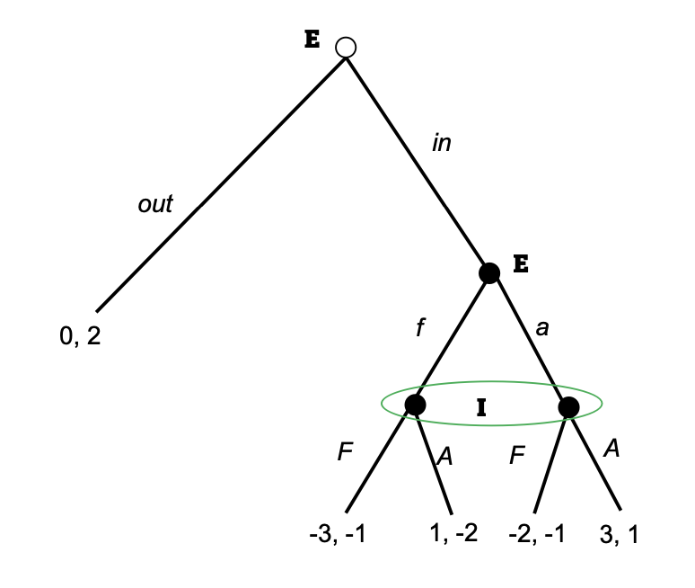
- Find all pure-strategy Nash equilibria.
We see that the incumbent will play A as long as they have a big enough belief that the entrant will play a
$$\left(1-μ\right)·\left(-2\right)+μ·1≥\left(1-μ\right)·\left(-1\right)+μ·\left(-1\right)$$
$⇕$ Uligheden løses for mu vha. WordMat.
$$μ≥\frac{1}{3}$$
Here $μ$ is the belief that the entrant will play a, and when this is larger than $\frac{1}{3}$ then the Incumbent will play A. The entrant will always play a as it is strictly dominating playing f.
We see however that if the Incumbent has the strategy to always play F, then the entrant will actually not even enter the market. So we have the two strategies of
$$\left(\left(in,a\right),A\right) for μ≥\frac{1}{3}$$
$$\left(\left(out,a\right),F\right)$$

- Which ones are subgame perfect Nash equilibria?
The first one is, the second one is only if $μ<\frac{1}{3}$ I believe as then that would actually be the best play for the incumbent.

- Now consider the following modification of the above game. When both players choose “accommodate” in the post-entry subgame, that is, after (in, a, A), instead of receiving payoffs $u_{E}=3$ and $u_{I}=1$, they must now play the following simultaneous-move game:
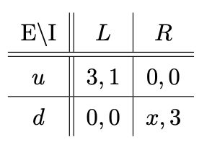
- What are the pure-strategy equilibria of the simultaneous-move game when $x≥0$? And when $x<0$?
When $x≥0$ we have:
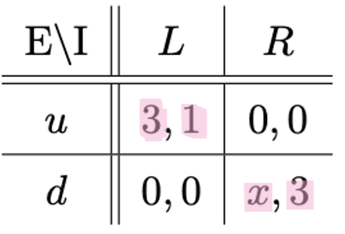
So $\left(u;L\right)$ and $\left(d;R\right)$ are pure strategy equilibria.
$$NE=\left(\left(u;L\right),\left(d,R\right)\right)$$

When $x<0$ we have
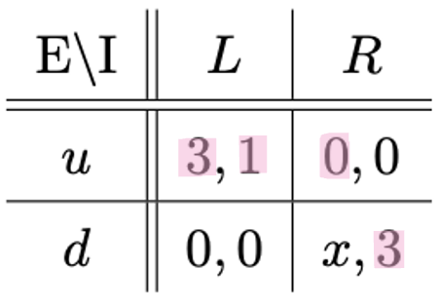
Then we see that u stronly dominates d for the Entrant and it is only $\left(u;L\right)$.
$$NE=\left(u;L\right)$$

- State the subgame-perfect Nash equilibria, both in pure strategies and in mixed strategies, of the full modified game. Hint: Distinguish different cases for x.
We have the longer game:
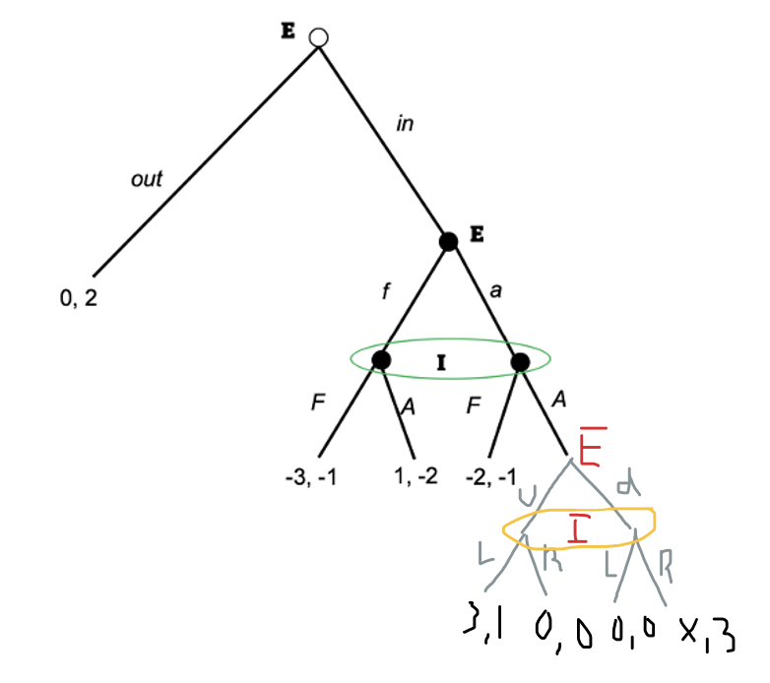
We now have a combination of two subquestions from TØ.
Kopirer bare lige svaret ind for langt:
We now have For $X<0$
E \ I | $$\left(F,L\right)$$ | $$\left(A,L\right)$$ | $$\left(F,R\right)$$ | $$\left(A,R\right)$$
$$\left(in,a,u\right)$$ | -2, -1 | 3, 1 | -2, -1 | 0,0
$$\left(in,a,d\right)$$ | -2,1 | 0,0 | -2,-1 | X,3
$$\left(in,f,u\right)$$ | -3,-1 | 1,-2 | -3,-1 | 1,-2
$$\left(in,f,d\right)$$ | -3,-1 | 1,2 | -3,-1 | 1,-2
$\left(out,X\right)$ for X the different ones but they all have the same payoff | 0,2 | 0,2 | 0,2 | 0,2
Tror jeg
$$NE=\left(\left(in,a,u\right);\left(A,L\right),\left(out,X\right);\left(F,Y\right)\right)$$
For $Y∈\left\{L,R\right\}$ and $X$ for the ones a/f and u/d.
We do the same for $X≥0$.
Look at the distinction of $0<X<1$ and $X≥1$ as we get different ones, for $0<X<1$ we get the same answers as for $X<0$. So it only changes once $X≥1$ then we also get $\left(\left(in,a,d\right);\left(A,R\right)\right)$ as a new Nash equilibrium.

Now if we also look at the mixed strategies we have:
E \ I | L $〈q〉$ | R$〈1-q〉$
u $〈p〉$ | 3,1 | 0,0
d $〈1-p〉$ | 0,0 | X,3
For $X∈\left(0,1\right)$
$$G_{1}=\left(G_{1E},G_{1I}\right)=\left(\left(\frac{3}{4},\frac{1}{4}\right);\left(\frac{X}{X+3},\frac{3}{X+3}\right)\right)$$
$$U_{E}\left(G_{1}\right)=\frac{3X}{X+3}$$
$$U_{I}\left(G_{1}\right)=\frac{3}{4}$$
We now have
 | F $〈q〉$ | A $〈1-q〉$
f$〈p〉$ | -3, -1 | 1, -2
a$〈1-p〉$ | -2, -1 | $$\left(\frac{3X}{X+3},\frac{3}{4}\right)$$
Der er en masse mellemregninger her og vi får
$$q=\frac{4}{11}, 1-q=\frac{7}{11}$$
$$p=\frac{3-2X}{6-X}, 1-p=1-\frac{3-2X}{6-X}$$
We have a new strategy set now
$$G_{2}=\left(G_{2E},G_{2I}\right)=\left(\left(\frac{4}{11},\frac{7}{11}\right);\left(\frac{3-2X}{6-X}, \left(1-\frac{3-2X}{6-X}\right)\right)\right)$$
This gives us the payoffs
$$U_{E}\left(G_{2}\right)=\frac{6-7X}{X-6}$$
$$U_{I}\left(G_{2}\right)=-1$$
When is player 1 indifferent between entering the game or staying out of the game, we have rewritten the game to be
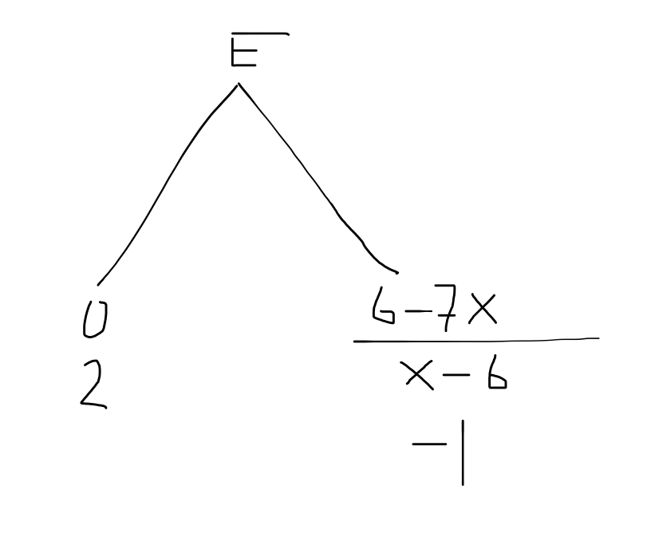
So for player 1 to be indifferent we need $X=\frac{6}{7}$ for him to be indifferent between entering the game or not.
So we need to mix the strategies the whole way up until we only need to look at two number and then we can find it.
Vi reducerer vores spil nedefra og op, men vi skal hele tiden løse spillet nedefra for at finde ud af hvad der ligesom kommer med op.
$$G_{3}=\left\{\begin{aligned}\left(in,a,u\right);\left(A,L\right) når X<0 \\ \left(out,G_{1E},G_{2E}\right);\left(G_{1I},G_{2I}\right) når 0≤X<\frac{6}{7} \\ \left(\left(\frac{1}{2}\left(out,G_{1E},G_{2E}\right),\frac{1}{2}\left(in,G_{1E},G_{2E}\right)\right);\left(G_{1I},G_{2I}\right)\right) for x=\frac{6}{7} \\ \left(\left(in,G_{1E},G_{2E}\right);\left(G_{1I},G_{2I}\right)\right) når\frac{6}{7}<X≤1 \\ \left(\left(\frac{3}{4}·\left(in,a,u\right),\frac{1}{4}·\left(in,a,d\right)\right);\frac{3}{3+X}\left(A,L\right),\frac{X}{3+X}\left(A,R\right)\right) når X>1\end{aligned}\right.$$
Når vi bruger definitionerne for understrategierne skrevet tidligere.
Mixed strategy subgame perfect nash equilibirum

Question 2 Signalling game
Consider the following dynamic game of incomplete information between a Sender
S and Receiver R:
- Nature draws a type $t_{i}∈\{t_{L}, t_{H}\}$for the Sender according to the probability distribution $Pr(t_{i}=t_{L})=p$ and $Pr\left(t_{i}=t_{H}\right)=1-p$, $p∈(0, 1).$ The prior probability distribution is common knowledge.
- The Sender observes $t_{i}$ and then chooses a message $m_{j}$. The Sender can either send the message “I am of the low type” denoted by $m_{l}$, or the message “I am of the high type”, denoted by $m_{h}$.
- The Receiver observes $m_{j}$ (but not the true type $t_{i}$) and then chooses an action $a_{k}∈\{a_{L}, a_{H}\}$.
- The payoffs of the Sender and the Receiver depend on the type of the Sender and the action of the Receiver, but not on the message of the Sender. They are as follows:
- $U_{S}\left(a_{L},t_{L}\right)=x$and $U_{R}\left(a_{L},t_{L}\right)=1$
- $U_{S}\left(a_{L},t_{H}\right)=y$and $U_{R}\left(a_{L},t_{H}\right)=0$
- $U_{S}\left(a_{H},t_{L}\right)=z$and $U_{R}\left(a_{H},t_{L}\right)=0$
- $U_{S}\left(a_{H},t_{H}\right)=w$and $U_{R}\left(a_{H},t_{H}\right)=1$
The following game tree describes the situation:
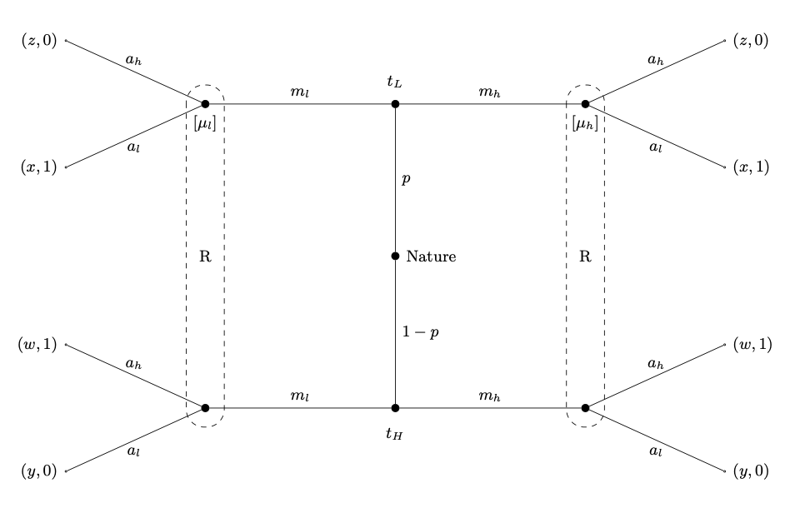
- In the following consider a separating equilibrium in which type$t_{L}$ sends the message $m_{l}$ and type $t_{H}$ sends the message $m_{h}$.
So we have the game:
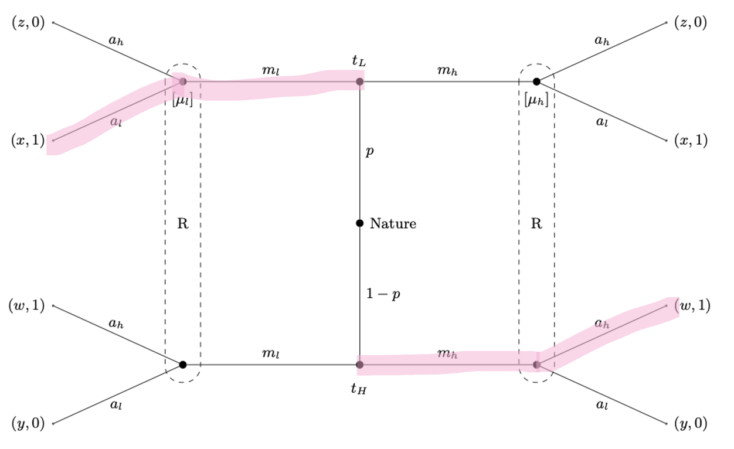
- Suppose such a separating equilibrium exists. State the beliefs of the Receiver in such a separating equilibrium.
So we see that because it is a separating equilibrium we must have that
$$μ_{l}=1, μ_{h}=0$$
Because the receiver “knows” who sends the message.

- Suppose such a separating equilibrium exists. State for each possible message the best response of the Receiver, i.e., state for each possible message which action he would choose.
We can see this in the drawing I made, if he receives $m_{l}$ he chooses $a_{l}$ and if he receives $m_{h}$ he chooses $a_{h}$.

- Suppose $x>z$ and $y>w$. Can a separating equilibrium exist? Derive your answer and characterize the separating equilibrium if it exists.
When $x>z$ it means that the low type would not deviate as he cannot get a higher payoff from deviating than he currently has now.
When $y>w$ it means that the high type might deviate, he will only deviate if he believes the receiver will play $a_{l}$ when he does, and because of the beliefs we have found where $μ_{l}=1$ it means that the receiver will play $a_{l}$ and so the high type will deviate. So this is not a PBE.

- Suppose $z>x$ and $w>y$. Can a separating equilibrium exist? Derive your answer and characterize the separating equilibrium if it exists.
So now when $z>x$ it means that the high type might deviate, and because of separating equilibrium the receiver plays ‚ $a_{h}$ and so the high type will deviate.
So this is not a PBE.

- Suppose $x≥z$ and $y≤w$. Can a separating equilibrium exist? Derive your answer and characterize the separating equilibrium if it exists.
When $x≥z$ it means that the high type will not deviate, because he can maybe get the same payoff from deviating, but he cannot get a better one, so he might be indifferent between the two messages but this would not mean he would deviate.
When $y≤w$ the same holds for the low type, and so even though he might be indifferent he will not explicitly deviate.
And so this is a PBE.

- Argue that a pooling equilibrium always exists.
Now I need to argue that a pooling equilibrium always exists, so we need to look at the two possibilities:
- Pooling on $m_{l}$
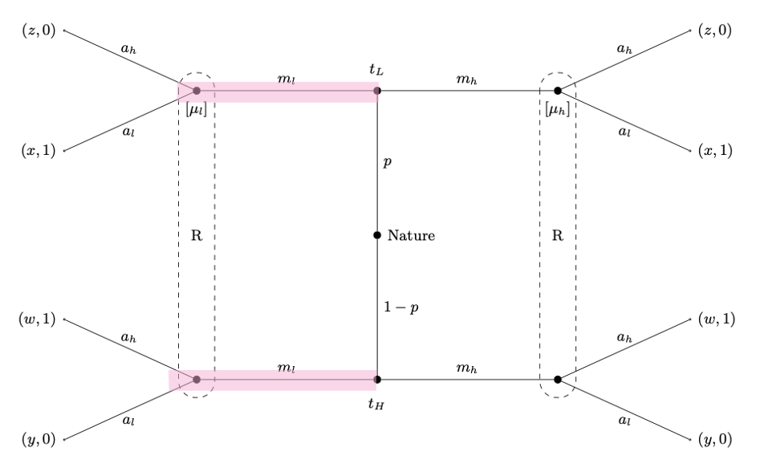
So we need to look at what the receiver believes then
$$E\left(a_{h} | m_{l}\right)=p·0+\left(1-p\right)·1=1-p$$
$$E\left(a_{l} | m_{l}\right)=p·1+\left(1-p\right)·0=p$$
So we see that the receiver will play $a_{h}$ when
$$1-p>p$$
$⇕$ Uligheden løses for p vha. WordMat.
$$p<\frac{1}{2}$$
This means that there is a pooling equilibrium if $p≤\frac{1}{2}$ and $z≥x$ and $w≥y$then no will will deviate, the same if $p≥\frac{1}{2}$ then the receiver play $a_{h}$ and there is a pooling equilibrium if $x≥z$ and $y≥w$.

- Pooling on $m_{h}$
Then we have
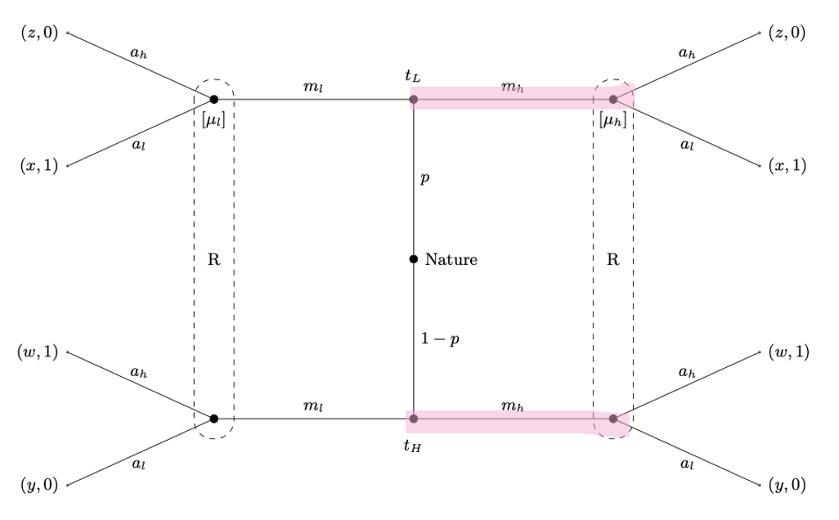
So we see that the receiver plays
$$E\left(a_{h} | m_{h}\right)=p·0+\left(1-p\right)·1=1-p$$
$$E\left(a_{l} | m_{h}\right)=p·1+\left(1-p\right)·0=p$$
So the receiver plays $a_{h}$ when
$$1-p>p$$
$⇕$ Uligheden løses for p vha. WordMat.
$$p<\frac{1}{2}$$
So when $p≤\frac{1}{2}$ the receiver plays $a_{h}$ and no one wants to deviate if $z≥x$ and $w≥y$. And if $p≥\frac{1}{2}$ the receiver plays $a_{l}$ and no one wants to deviate if $x≥z$ and $y≥w$.

So this should overall mean that :
So depending on the beliefs of the receiver there is always a pooling equilibrium.
I think. So then if we do not have that for example $x≥z$ and $y≥w$ then depending on the beliefs of the receiver and $μ_{l},μ_{h}$ then we can always find a pooling equilibrium. It looks different depending on the numbers but there is always one.

- The game described above is called “cheap talk game”. How does it differ from a conventional signaling game?
We see that the receiver only gets payoff of 0 or 1 and always opposite what it plays, there is never one that is just better than the other. We also see that the sender has the same payoffs for both sides for the same play of the receiver.
It is mirrored doble game for the players.

Question 3 Adverse selection
Consider an adverse selection model with many identical firms that can hire workers. The price of output is one. Each firm’s production technology exhibits constant returns to scale and uses only labor. Workers differ in their productivity, such that a worker of type $θ$ produces $θ$ units of output. Thus, a firm’s profit of employing a worker of type $θ$ is $θ-w$, where $w$ is the wage the firm pays to the worker. Workers’ types are unobservable to the firms.
Workers are uniformly distributed on the interval $[0,1].$ Workers are earnings maximizers and a worker of type$θ$ can earn $r(θ)$ in home production. Hence, a worker’s utility is $w$ if the worker works for the firm and $r(θ)$ if the worker stays at home.
Suppose first that $r(θ)=θ^{\frac{1}{4}}$.
- What is the Pareto efficient allocation of workers? I.e. which subset of $[0, 1]$ should work?
When $r\left(θ\right)=θ^{\frac{1}{4}}$ we have that
$$r\left(0\right)=0^{\frac{1}{4}}=0$$
$$r\left(1\right)=1^{\frac{1}{4}}=1$$
And for any $θ∈\left(0,1\right)$ we have
$$r\left(θ\right)>θ$$
So the only workers that should be working are for $θ=0,1$ all others should be at home as they have a higher utility from being at home than they get from the wage the firms can pay, we have $w≤θ$ as otherwise they get negative profits.

- Can the firms offer different wages to different types? What will happen if they do so? Explain in at most 2 sentences.
Not when they cannot see the workers type, we see that they would like to offer the wage of $w=0$for $θ=0$ and $w=1$ for $θ=1$ but if they offer $w=1$ then everyone will take it and the firm will have negative profits.

- Find all competitive equilibria through the following steps:
- At a given wage w, which types will work?
At a given wage the types working are the types where
$$Θ\left(w\right)=\left\{θ|r\left(θ\right)≤w\right\}=\left\{θ|θ^{\frac{1}{4}}≤w\right\}=\left\{θ|θ≤w^{4}\right\}$$

- At a given wage w, what is the expected productivity of those willing to work?
The expected productivity of those working can be found using the fact that the amount of workers are uniformly distributed so that
$$E\left(X\right)=\frac{b+a}{2}$$
Where $b=w^{4}$ and $a=0$. So
$$E\left(θ | θ≤w^{4}\right)=\frac{w^{4}+0}{2}=\frac{w^{4}}{2}$$
Calculate integral if not uniformly distributed.

- Is there an equilibrium with a positive equilibrium wage $w^{⋆}$? Is there an equilibrium with equilibrium wage $w^{⋆}=0$? For each equilibrium, state the equilibrium wage as well as the subset of types that are working.
Because there are multiple firms in Bertrand competition we know that the firms must have a profit of 0, so the wage they can offer is the wage where the expected productivity of those willing to work is equal to the wage they are offering, so when
$$w=\frac{w^{4}}{2}$$
$⇕$ Ligningen løses for w vha. WordMat.
$$w=0 ∨ w=1,259921$$
As we we have the workers are uniformly distributed on $\left[0,1\right]$ it is never worth it for the firm to offer a wage above 1 as they are sure to have a negative profit.
So the only equilibrium we have is for a $w^{⋆}=0$ where the only type working is $θ=0$.

- Which equilibrium is constrained Pareto efficient? Is that equilibrium also Pareto efficient in the unconstrained sense?
The only equilibrium I found was $w=0$with $θ=0$ and so this is the constrained Pareto efficient equilibrium.
We see in a) we found that $w=0$ and $w=1$ were Pareto efficient, so we see that the equilibrium we found is also Pareto efficient in the unconstrained sense, but there is one more equilibrium there as well.

Suppose now that $r(θ)=θ^{4}$.
- What is the Pareto efficient allocation of workers?
We have that
$$r\left(0\right)=0^{4}=0$$
$$r\left(1\right)=1^{4}=1$$
But now for $θ∈\left(0,1\right)$ we have that
$$θ≥r\left(θ\right)=θ^{4}$$
And so the efficient allocation of workers is that all workers are working and no one is at home as everyone is at least better off working.

- Find all competitive equilibria through the following steps:
- At a given wage w, which types will work?
We do the same as earlier
$$Θ\left(w\right)=\left\{θ|r\left(θ\right)≤w\right\}=\left\{θ|θ^{4}≤w\right\}=\left\{θ|θ≤w^{\frac{1}{4}}\right\}$$

- At a given wage w, what is the expected productivity of those willing to work?
The workers are still uniformly distributed so we use $b=w^{\frac{1}{4}}$ and $a=0$. So
$$E\left(θ | θ≤w^{4}\right)=\frac{w^{\frac{1}{4}}+0}{2}=\frac{w^{\frac{1}{4}}}{2}$$

- Is there an equilibrium with a positive equilibrium wage $w^{⋆}$? Is there an equilibrium with equilibrium wage $w^{⋆}=0$? For each equilibrium, state the equilibrium wage as well as the subset of types that are working.
So now we check when
$$w=\frac{w^{\frac{1}{4}}}{2}$$
$⇕$ Ligningen løses for w vha. WordMat.
$$w=0 ∨ w=0,3968503$$
So we have two possible wages, just like before we know that 0 is an equilibrium as the only type working will be $θ=0$, so we need to check the other wage.
This means we need to check which types will be working for this wage and whether their expected productivity equals the wage, then we have an equilibrium:
$$Θ\left(0,3968503\right)=\left\{θ|θ≤w^{\frac{1}{4}}\right\}=\left\{θ|θ≤{0,3968503}^{\frac{1}{4}}\right\}=\left\{θ|θ≤0,7937005\right\}$$
So we need to look at the productivity when $θ∈\left[0, 0.7937005\right]$
We we find that this is
$$E\left(θ | θ≤0.7937005\right)=\frac{0.7937005+0}{2}≈0,3968503$$
Which we see is exactly the wage and so this is also an equilibrium.

- Which equilibrium is constrained Pareto efficient? If there are multiple equilibria, which workers are strictly better off in the dominating equilibrium?
The highest wage equilibrium is constrained Pareto efficient this means the equilibrium with wage $w^{⋆}=0,3968503$ is constrained Pareto efficient as a higher wage pareto dominates a lower wage when wage is all we are looking at.
We see that all workers working are strictly better off in the equilibrium with the higher wage as that is the whole reason they are working, that they are better off than at home, which all but $θ=0$ would be in the other equilibrium.

Question 4 Investment opportunity
There are two firms in the economy, firm 1 and firm 2. Firm 1 has assets in place of value $200 and an investment opportunity (growth option) available with net present value (NPV) of $25. Firm 2 has assets in place of value $75 and an investment opportunity (growth option) available with NPV of $15. The up-front investment required to take advantage of the investment opportunity is $I=\$110$ for either firm. The interest rate is $r=0$. Firms must issue equity to finance the project.
- Suppose first that there is no asymmetric information, and nobody knows which firm is which.
- What are the values of firms 1 and 2 before and after raising capital?
No one knows which firm is which, so the value of both firms is the average value of a firm:
Before they issue equity, assuming they take their NPV positive investment, it is
$$\overline{V}=\frac{200+75+25+15}{2}=157,5$$
They both have to raise equity of $\$110$ so after they do this it is
$$157,5+110=267,5$$

- What are the old (current) equity holders’ and the new equity holders’ shares of firms 1 and 2, respectively?
The old owners of the firm now own
$$\frac{157,5}{267,5}≈0,588785$$
Of the firm. The new owners own
$$\frac{110}{267,5}≈0,411215$$
Of the firm. This means that the new owners get expected paid back size of
$$0,411215·267,5≈110$$
And so they will take the investment as they get the same amount back as they invested.

- Suppose now managers know which firm is which and that they act to maximize current shareholders’ value, when they decide whether to issue new equity.
- If both firms choose to issue equity to finance their projects, what will be the old (current) equity holders’ and the new equity holders’ shares of firms 1 and 2, respectively?
So now the manager knows, but the investors do not, so the investors can only go by their expected amounts if they would invest. We have a pooling equilibrium.
For firm 1 we have: the old owners share will be (here we use the $0,588785$ from above!)
$$335·0,588785≈197,243$$
And the new owners will have
$$335·0,411215≈137,757$$
And for firm 2 we have the old owners value is
$$200·0,588785=117,757$$
And the new owners will have
$$200·0,411215=82,243$$

- What is the true value of firm 1 without the investment, with the investment, and with the investment plus the capital raised? What is the true value of firm 2 without the investment, with the investment, and with the investment plus the capital raised?
The value if firm 1 if they do not issue equity is $200$, 225 if they take the investment and $335$ if they take the investment and issue equity.
For firm 2 the value is 75 is they do not issue equity, 90 if they take the investment, and 200 if they issue equity and take the investment.

- Will firm 1 indeed choose to issue new equity to finance the project? Will firm 2 indeed choose to issue new equity to finance the project? Why?
So we see that it is not worth it for firm 1 to issue equity as the current owners have a value of 200 before and only 197 after issuing equity and taking the investment. So firm 1 will not.
Firm 2 will issue equity as the current owners have a value of 70 before and 117 after.

- What can the outside investors learn from the equity issue? Relate to the models discussed in the course. Do we have a pooling or a separating equilibrium?
This the outside investors know, so they know that if a firm issues equity it is firm 2. This means we have a separating equilibrium not a pooling equilibrium.

- What happens to the stock price of firm 2? What will be the old (current) equity holders’ and the new equity holders’ shares of firm 2?
So this means that the investors learn the type of firm 2, so they go from an expected value with investment of the 267,5 to just 200. This means the stock price of firm 2 falls. The current owners share of the firm after issuing equity then falls to
$$\frac{200-110}{200}=0,45$$
And the new owners share is now
$$\frac{110}{200}=0,55$$
So this means that the current owners have to give up a larger share of the firm when the investors know which firm it is.

- Suppose now the NPV of the investment opportunity is 100 for firm 1. Still $I=\$110$.
- If both firms choose to issue equity to finance their projects, what will be the old (current) equity holders’ and the new equity holders’ shares of firms 1 and 2, respectively?
So this is a lot the same as b but with some new numbers, this is still looking at a pooling equilibrium. The new value of firm 1 with the investment is now $200+100+110=410$. This means that the average firm also changes, so we have that when the managers also do not know the type we get
$$\overline{V}=\frac{200+75+100+15}{2}=195$$
They both have to raise equity of $\$110$ so after they do this it is
$$195+110=305$$
The old owners of the firm now own
$$\frac{195}{305}≈0,6393443$$
Of the firm. The new owners own
$$\frac{110}{305}≈0,3606557$$
So we can use these number when calculating what the value of the firm for the current owners and new owner are after issuing the equity:
The current owners share of firm 1 is
$$410·0,6393443≈262,1312$$
And the new owners will have
$$410·0,3606557≈147,8688$$
And for firm 2 we have the old owners value is
$$200·0,6393443≈127,8689$$
And the new owners will have
$$200·0,3606557=72,13114$$

- What is the true value of firm 1 without the investment, with the investment, and with the investment plus the capital raised?
The value if firm 1 if they do not issue equity is $200$, 300 if they take the investment and $410$ if they take the investment and issue equity.
For firm 2 the value is 75 is they do not issue equity, 90 if they take the investment, and 200 if they issue equity and take the investment.

- Will firm 1 indeed choose to issue new equity to finance the project? Will firm 2 indeed choose to issue new equity to finance the project? Why?
Now we see that both firms will choose to issue equity as for both firms the current owners have a higher value of the firm after issuing equity. For firm 1 the current owners have a value of 200 if they do not issue equity and 262 if they do.
Same goes for firm 1, it is worth it to issue equity, they get 127 from issuing versus the 75 they had from not issuing equity.

- What can the outsiders learn from the equity issue? Do we have a pooling or a separating equilibrium?
So now we have a pooling equilibrium as both firms issue equity, so the outsiders do not learn anything about which firm they are investing in.

Mikro eksamen august 2023

Question 1 Normal form game NE infinitely repeated game
Consider the 2-person game G given by
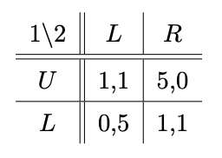
- Describe the outcome of this game when played once.
So we have
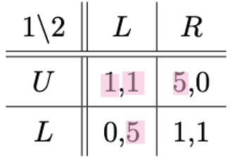
So we see that they end up playing $\left(U,L\right)$.

- If the game were played n times with $1<n<∞,$ and both players knew that the game is being repeated n times, what would be the average payoffs per round for both players? Please justify your answer.
As we see that U for player 1 and L for player 2 strictly dominates their other plays we would expect them to keep playing this, so the average payoff would be 1. They could get a higher payoff by switching between deviating so the other gets a higher payoff, but if we work backwards with the last n game and then forwards we see that they will always end up choosing $\left(U,L\right)$ I think.
They can at most if evenly distributed get average payoff of $\left(2.5, 2.5\right)$ if they switch between $\left(L,L\right)$ and $\left(U,R\right)$. Maybe if n is even number they deviate to the equilibrium of $\left(U,L\right)$in the last round I believe. This is possible because both get a higher payoff from cooperating and can “punish” the other by continuous play of their dominating strategy.

- How many pure strategies does each player have in $G^{2}$, i.e., the repeated game where G is played twice with the outcomes of the stage game being observed after each period? Explain how you derive this number.
Here we can use the formula that
Number of pure strategies = actions^(number of subgames)
We know they each have two actions in each game, so we need to find the number of subgames: there are four possible outcomes of the first round, so that is four subgames, and then there is the subgame which is the whole game, so there is 5. This means that each player has
$$2^{5}=32$$
Pure strategies.

- Depict the feasible payoff vectors of game $G$ in a graph. Provide a calculation showing that $(2,2)$ is a feasible payoff vector.
The drawing:
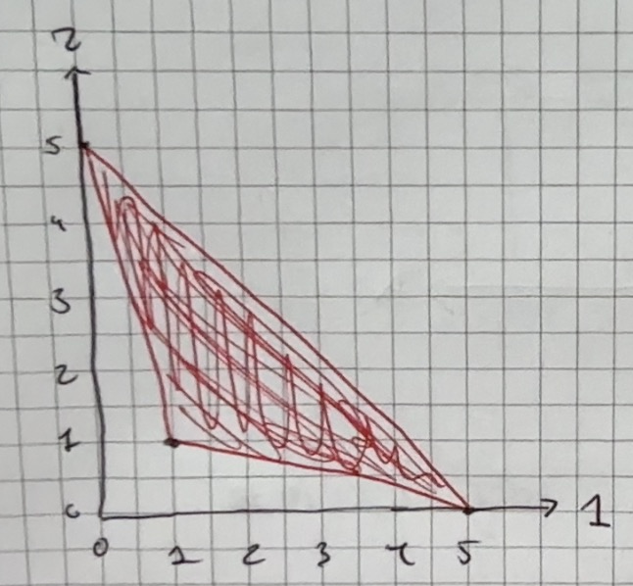
To show that $\left(2,2\right)$ is a feasible payoff vector we need to look at when their expected payoff from a strategy is 2 for each player.
If they play $\left(U,L\right)$ in the first round, $\left(U,R\right)$ in the second, and $\left(L,L\right)$ in the third, then over these three rounds they each get an average payoff of about
$$\frac{1+5+0}{3}=2$$
If we have to look at a mixed strategy in the one game we would need for both of them to have mixed strategies and then add the four different outcomes possibilities up so they give 2 for each. So I p in the probability that player 1 plays U and q is the probability that player 2 plays L, then for player 1 to get an expected payoff of 2 we would need for player 1 and 2. It did not give me a good answer but I think one should be able to?
$$p·q·1+p·\left(1-q\right)·5+\left(1-p\right)·q·0+\left(1-p\right)·\left(1-q\right)·1=2$$
$$p·q·1+p·\left(1-q\right)·0+\left(1-p\right)·q·5+\left(1-p\right)·\left(1-q\right)·1=2$$
$⇕$ Ligningssystemet løses for p,q vha. WordMat's 'Løs Ligninger' funktion,
$$\left[p,q\right]∈∅$$
So we can see that it does not work like this, their beliefs depend on each other and so it is not possible to do.
From the drawing we know it is possible, if we look at the game where they have the payoff vector of $\left(2.5, 2.5\right)$ and the game where they have payoff vector of $\left(1,1\right)$ (because they play $\left(U,L\right)$ forever. Then we see that there must be some kind of combination of these two plays that gives a payoff vector of $\left(2,2\right)$ so we would have that for each player it is the same solution we are looking for where
$$p·2,5+\left(1-p\right)·1=2$$
$⇕$ Ligningen løses for p vha. WordMat.
$$p=\frac{2}{3}$$
So if we see that they simultaneously switch between these two strategies then we get the desired payoff vector of $\left(2,2\right)$.

- Consider now the game $G^{∞}$ that consists of playing $G$ infinitely often, and where the payoffs of the infinite game are the average payoffs. Describe an outcome path such that each player achieves an average payoff of $2$.
So this means they would play the play I described above. So they would have and average payoff, with discount factor $δ$ of:
$$\left(1-δ\right)·\left(\sum_{i=0}^{∞}{δ^{3i}·1}+\sum_{i=1}^{∞}{δ^{3i}·5}\right)=\left(1-δ\right)·\left(\frac{5·δ^{3}}{1-δ^{3}}+\frac{1}{1-δ^{3}}\right)$$
When $δ=1$ so there is no discounting this is equal to 2 but with discounting it becomes a little smaller.
$$\left(1-0.99\right)·\left(\frac{5·{0.99}^{3}}{1-{0.99}^{3}}+\frac{1}{1-{0.99}^{3}}\right)=1,9701340022221507$$

- Describe a strategy profile such that each player achieves an average payoff of $2$ and the strategy profile is a subgame perfect Nash equilibrium.
We have that this strategy profile is subgame perfect if no one wants to deviate, so we look at for which discount factors it might be worth it to deviate. The only time it might be wort it to deviate if one can get a higher payoff, but as from the strategy we have that they cannot deviate themselves to get the 5 payoff only when the other player does it, so they only time they might be able to deviate if they deviate in round 2 to get payoff of 1 instead of 0, and we know the other would punish and make sure they would never get above 1, so we get that they would deviate if
$$\left(1-δ\right)·\left(\sum_{i=0}^{∞}{δ^{i}·1}\right)≥\left(1-δ\right)·\left(\frac{5·δ^{3}}{1-δ^{3}}+\frac{1}{1-δ^{3}}\right)$$
$⇕$ Uligheden løses for delta vha. WordMat.
$$δ≤-\left(\frac{\sqrt{21}-1}{10}\right) ∨ \left(δ≥0 ∧ δ≤\frac{\sqrt{21}+1}{10}\right)$$
Where
$$\frac{\sqrt{21}+1}{10}≈0,5582576$$
So we see it is worth it to deviate if $δ≤0,5582576$ and so it is only a Nash equilibrium when $δ>0,5582576$.

Question 2 normal form and SPNE
Consider the following normal-form game:
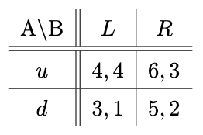

- Determine the pure strategy Nash equilibria.
We have
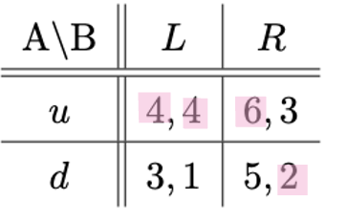
So the pure strategy equilibria is $\left(u,L\right)$

- Suppose that player A moves first and that his choice is observed by player B before she moves. State the pure strategy subgame perfect Nash equilibria of this extensive-form game.
So then we get the game:
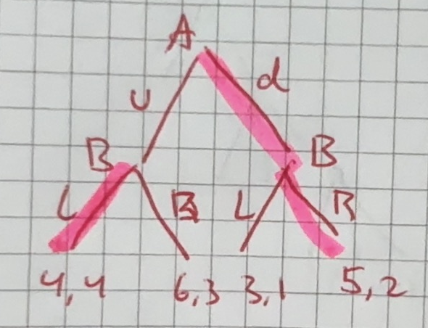
So then the subgame perfect pure strategy Nash equilibria is
$$SPNE:\left(d;\left(L,R\right)\right)$$
So L if u and R if d.

- Suppose again that player A moves first. After that Nature sends a signal from the set $\left\{\hat{u},\hat{d}\right\}$ that player B observes. Player B does, however, not observe the action of player A. If player A played $u$, player B receives the signal $\hat{u}$ with probability $1-ε$ and $\hat{d}$ with probability $ε$. Similarly, if player A played $d$, player B sees $\hat{d}$ with probability $1-ε$ and $\hat{u}$ with probability $ε$. Assume that $0<ε<1$.
- Draw the extensive form of this game, that is, the game tree.
So we have the game:
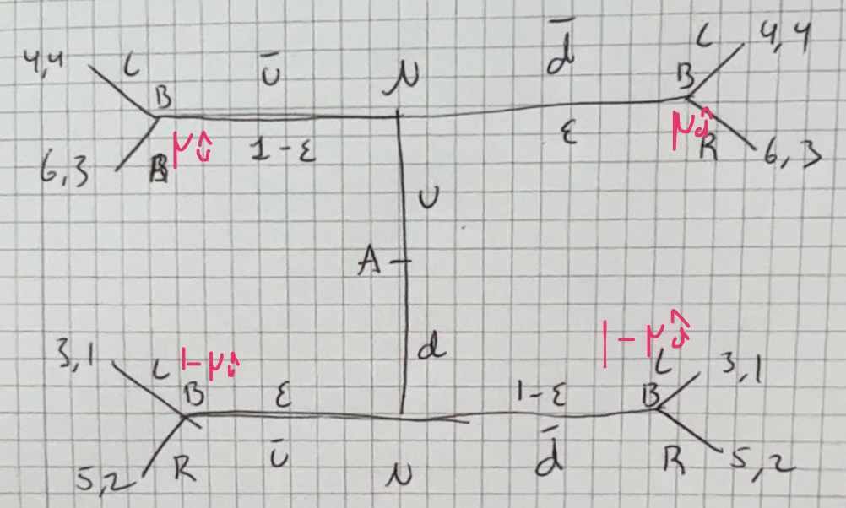

- Find all pure strategy perfect Bayesian equilibria.
There are two possibilities, either A plays u or A plays d, and then B has to try and act accordingly.
Assume player A plays d then $P\left(u\right)=0$. We use Bayes rule to get
The probability that we are in the top left corner is then:
$$μ_{\hat{u}}=P\left(u|\hat{u}\right)=\frac{P\left(\hat{u}|u\right)·P\left(u\right)}{P\left(\hat{u}\right)}=0$$
And the probability that we are in the top right corner is then:
$$μ_{\hat{d}}=P\left(u|\hat{d}\right)=\frac{P\left(\hat{d}|u\right)·P\left(u\right)}{P\left(\hat{d}\right)}=0$$
So player B knows they are at the bottom, so they play R. But if player A knows that player B will play R then player A will deviate and play u instead of d as player A gets the payoff 6 instead of 5. There is not really a “straf” for deviating. So there cannot be a perfect Bayesian Equilibrium when A plays d.
It is not an equilibrium when player A plays d.

Now look at if player A plays u then $P\left(d\right)=0$
We use the law of total probability now, probability for left top corner?
$$μ_{\hat{u}}=P\left(u|\hat{u}\right)=\frac{P\left(\hat{u}|u\right)·P\left(u\right)}{P\left(\hat{u}\right)}=\frac{P\left(\hat{u}|u\right)·P\left(u\right)}{P\left(\hat{u}|u\right)·P\left(u\right)+P\left(\hat{u}|d\right)·P\left(d\right)}=\frac{P\left(\hat{u}|u\right)·P\left(u\right)}{P\left(\hat{u}|u\right)·P\left(u\right)}=1$$
And probability for top right corner, also use law of total probability
$$μ_{\hat{d}}=P\left(u|\hat{d}\right)=\frac{P\left(\hat{d}|u\right)·P\left(u\right)}{P\left(\hat{d}\right)}=1$$
Now player B knows they are at the top, and play accordingly. So now player B will play L, and now player A will not want to deviate, cannot get a higher payoff(because if they deviate and play d instead player B will plays L and so they get a payoff of 3 instead of 4.

$$PBE:\left(u;\left(\left(L|\hat{u}\right),\left(L|\hat{d}\right)\right)\right), μ_{\hat{u}}=μ_{\hat{d}}=1$$

- Comment briefly [max. two sentences] on the difference between the results in (c2) from those in part (b).
In the c2 game player 1 gets a lower payoff, player 2 gets a higher payoff. So the move from nature helps make it a more even distribution.

Question 3 Moral Hazard BoD
Consider the following principal-agent problem: a firm needs a manager to run its operations. The company’s Board of Directors (BoD) can observe the company’s gross earnings $π$, but not necessarily how much effort$e$ the manager puts in.
The firm will have gross earnings of either $π_{H}=850$ or $π_{L}=200$. The manager can either work hard ($W$) or shirk ($S$). His effort determines the probability of high vs. low earnings: If $e=W$, it is $prob(π_{H}|W)=\frac{3}{5}$, while if $e=S$, it is $prob(π_{H}|S)=\frac{1}{5}.$
The manager’s utility when he is paid salary$C$ and puts in effort $e$ is
$$u(C, e) = v(C) - g(e),$$
Where $v\left(c\right)=\sqrt{C}$ and $g(W)=10$, while $g(S)=5$. The manager could find a job giving him net utility $\overline{u}=2$ elsewhere.
The BoD has to choose a compensation scheme $(C_{H},C_{L}),$ where$C_{H}$ denotes the manager’s compensation if profits are$π_{H}$ and $C_{L}$ denotes the manager’s compensation if profits are $π_{L}$. Moreover, the BoD chooses which effort level it wants to implement.
When the manager signs his contract with the company, he does not yet know whether earnings will be high or low, so he maximizes his expected utility:
$$prob\left(π_{H} | e\right)\left(v\left(C_{H}\right)-g\left(e\right)\right) + \left(1 - prob\left(π_{H} | e\right)\right)\left(v\left(C_{L}\right)-g\left(e\right)\right)$$
The BoD aims to maximize the shareholders’ expected utility, which is given by the expected net profits of the firm:
$$prob\left(π_{H} | e\right)\left(π_{H}-C_{H}\right) + \left(1-prob\left(π_{H} | e\right)\right)\left(π_{L}-C_{L}\right)$$

- Suppose first that the BoD could observe and verify the manager’s effort.
- Write down the constraint(s) the BoD faces when maximizing the shareholders’ expected utility.
So because the BoD can verify the effort level they only need the Participation constraints, so for the high effort level we need
$$prob\left(π_{H} | W\right)·\sqrt{C_{H}}+\left(1-prob\left(π_{H} | W\right)\right)·\sqrt{C_{L}}-g\left(W\right)=\frac{3}{5}·\sqrt{C_{H}}+\frac{2}{5}·\sqrt{C_{L}}-10≥\overline{u}=2$$
And for the low effort level we need
$$prob\left(π_{H} | S\right)·\sqrt{C_{H}}+\left(1-prob\left(π_{H} | S\right)\right)·\sqrt{C_{L}}-g\left(S\right)=\frac{1}{5}·\sqrt{C_{H}}+\frac{4}{5}·\sqrt{C_{L}}-5≥\overline{u}=2$$

- What is the optimal compensation scheme if the BoD wants to implement $e=W$?
They know the effort level the agent is taking so just need to maximize their profit given this
$$\max_{C_{H},C_{L}}{prob\left(π_{H} | W\right)\left(π_{H}-C_{H} \right)+\left(1-prob\left(π_{H} | W\right)\right)\left(π_{L}-C_{L}\right)}$$
So we have
$$\max_{C_{H},C_{L}}{\frac{3}{5}·\left(850-C_{H}\right)+\frac{2}{5}·\left(200-C_{L}\right)}$$
We expect the PC to be binding under first best, so
$$\frac{3}{5}·\sqrt{C_{H}}+\frac{2}{5}·\sqrt{C_{L}}-10=2$$
$⇕$ Ligningen løses for C_L vha. WordMat.
$$C_{L}=\frac{9}{4}·C_{H}-90·\sqrt{C_{H}}+900$$
Insert and differentiate
$$\max_{C_{H}}{\frac{3}{5}·\left(850-C_{H}\right)+\frac{2}{5}·\left(200-\frac{9}{4}·C_{H}+90·\sqrt{C_{H}}-900\right)}$$
$$\frac{∂}{∂C_{H}}=-\frac{3}{5}+\frac{2}{5}·\left(-\frac{9}{4}+90·\frac{1}{2\sqrt{C_{H}}}\right)=0$$
$⇕$ Ligningen løses for C_H vha. WordMat.
$$C_{H}=144$$
And
$$C_{L}=\frac{9}{4}·144-90·\sqrt{144}+900=144$$
So the optimal compensation scheme when they want to implement high effort is to pay a constant wage here as they can condition on the effort.

- What is the optimal compensation scheme if the BoD wants to implement $e=S$?
So same as above for S this time
$$\max_{C_{H},C_{L}}{prob\left(π_{H} | S\right)\left(π_{H}-C_{H} \right)+\left(1-prob\left(π_{H} | S\right)\right)\left(π_{L}-C_{L}\right)}$$
So we have
$$\max_{C_{H},C_{L}}{\frac{1}{5}·\left(850-C_{H}\right)+\frac{4}{5}·\left(200-C_{L}\right)}$$
And we have
$$\frac{1}{5}·\sqrt{C_{H}}+\frac{4}{5}·\sqrt{C_{L}}-5=2$$
$⇕$ Ligningen løses for C_H vha. WordMat.
$$C_{H}=16·C_{L}-280·\sqrt{C_{L}}+1225$$
So we get
$$\max_{C_{L}}{\frac{1}{5}·\left(850-16·C_{L}+280·\sqrt{C_{L}}-1225\right)+\frac{4}{5}·\left(200-C_{L}\right)}$$
Differentiate and set equal to 0
$$\frac{∂}{∂C_{L}}=\frac{1}{5}·\left(-16+280·\frac{1}{2·\sqrt{C_{L}}}\right)+\frac{4}{5}·\left(-1\right)=0$$
$⇕$ Ligningen løses for C_L vha. WordMat.
$$C_{L}=49$$
And
$$C_{H}=16·49-280·\sqrt{49}+1225=49$$
So a constant wage of 49, again because they condition on e.

- What is the shareholders’ expected utility (i.e. net profits) when $e=W$ and $e=S$, respectively?
Now we know their payments so just need to look at the shareholders expected utility under these payment schemes.
When $e=W$ they have expected utility of
$$prob\left(π_{H} | W\right)\left(π_{H}-C_{H} \right)+\left(1-prob\left(π_{H} | W\right)\right)\left(π_{L}-C_{L}\right)=\frac{3}{5}·\left(850-144\right)+\frac{2}{5}·\left(200-144\right)=446$$
And for $e=S$ we have
$$prob\left(π_{H} | S\right)\left(π_{H}-C_{H} \right)+\left(1-prob\left(π_{H} | S\right)\right)\left(π_{L}-C_{L}\right)=\frac{1}{5}·\left(850-49\right)+\frac{4}{5}·\left(200-49\right)=281$$

- Which effort level should the BoD implement and what will the compensation scheme be?
So we see that the BoD would like to implement $e=W$ with a wage scheme of $C=144$ no matter the profit level as they can condition on the effort level.

- Suppose now that the manager’s effort is unobservable and unverifiable to the BoD.
- Write down the constraint(s) the BoD faces if it wants to implement $e=W$.
So we also need an incentive compatibility constraint, so the agent chooses the effort level we would like. If they want to implement high effort they need
$$\frac{3}{5}·\sqrt{C_{H}}+\frac{2}{5}·\sqrt{C_{L}}-10≥\frac{1}{5}·\sqrt{C_{H}}+\frac{4}{5}·\sqrt{C_{L}}-5$$
As well as the participation constraint from before:
$$\frac{3}{5}·\sqrt{C_{H}}+\frac{2}{5}·\sqrt{C_{L}}-10≥\overline{u}=2$$

- What is the optimal compensation scheme if the BoD wants to implement $e=W$?
So they have the problem
$$\max_{C_{H},C_{L}}{\frac{3}{5}·\left(850-C_{H}\right)+\frac{2}{5}·\left(200-C_{L}\right)}$$
s.t.
$$\frac{3}{5}·\sqrt{C_{H}}+\frac{2}{5}·\sqrt{C_{L}}-10≥2$$
$$\frac{3}{5}·\sqrt{C_{H}}+\frac{2}{5}·\sqrt{C_{L}}-10≥\frac{1}{5}·\sqrt{C_{H}}+\frac{4}{5}·\sqrt{C_{L}}-5$$
Here we can assume that both of them bind(proof???) , so we get
$$\frac{3}{5}·\sqrt{C_{H}}+\frac{2}{5}·\sqrt{C_{L}}-10=2$$
$$\frac{3}{5}·\sqrt{C_{H}}+\frac{2}{5}·\sqrt{C_{L}}-10=\frac{1}{5}·\sqrt{C_{H}}+\frac{4}{5}·\sqrt{C_{L}}-5$$
$⇕$ Ligningssystemet løses for C_H,C_L vha. WordMat's 'Løs Ligninger' funktion,
$$C_{H}=289 ∧ C_{L}=20,25$$
So we get the optimal wage scheme when they want to implement $e=W$ is $C_{H}=289$ and $C_{L}=20,25$.

- What is the optimal compensation scheme if the BoD wants to implement $e=S$?
Here the first best solution actually works, we know that the worker would not by himself choose the higher effort when he gets no higher pay for it. So we have $C_{L}=C_{H}=49$.

- What is the shareholders’ expected utility (i.e. net profits) when $e=W$ and $e=S$, respectively?
So we calculate for $e=W$
$$prob\left(π_{H} | W\right)\left(π_{H}-C_{H} \right)+\left(1-prob\left(π_{H} | W\right)\right)\left(π_{L}-C_{L}\right)=\frac{3}{5}·\left(850-289\right)+\frac{2}{5}·\left(200-20,25\right)=408,5$$
And for $e=S$ we had $281$

- Which effort level should the BoD implement and what will the compensation scheme be?
So we see that the BoD would still like to implement $e=W$ but now with the compensation scheme of
$$C_{H}=289 ∧ C_{L}=20,25$$

- What is the cost of not being able to observe the manager’s effort?
So the cost of not being able to observe the managers effort is the BoD’s lower profit, so it is
$$446-408,5=37,5$$
So the cost is 37,5 from first best to second best.

Question 4 Signalling for used cars
Two used-car dealerships compete right next to each other on a main road. The first, Harry’s, sells high quality cars that it carefully inspects and services if necessary. It costs Harry’s on average $8000 to buy and service each car it sells. The second dealership, Larry’s, sells low quality cars. It costs Larry’s on average only $5000 for each car that it sells. If consumers knew the quality of the used cars they were buying they would be willing to pay $10,000 on average for cars Harry sells, and $7,000 on average for cars Larry sells. Unfortunately, the dealerships are new and have not had time to establish reputations, so consumers don’t know the quality of each dealership’s cars. They figure that they have a 50-50 chance of ending up with a high-quality car, no matter which dealership they go to, and hence are willing to pay $8,500 on average for a car $(\frac{1}{2}(7000 + 10000))$. Harry’s has an idea — offer a a bumper-to-bumper warranty, covering all parts of the car, for all the cars it sells. He knows that on average a warranty lasting $Y$years will cost $\$500·Y$ per car, and he also knows that if Larry tries to offer the same warranty, it will cost Larry’s $\$2000·Y$ on average.
- Suppose that Harry’s offers a one-year warranty on all the cars it sells. Will this generate a credible signal of quality. Will Larry’s match the offer, or not? Will consumers conclude that Harry’s cars are of high quality and worth $10000?
This means that a car for Harry costs 8500.
If Larry also offers the warranty his cost will be $7000$.
If only Harry offers a warranty and this means that the consumers can differentiate a good and a bad car it means that Harrys cars will sell for 10000 and he will get a profit of 1500.
If Larry does not offer a warranty his cars will then sell for 7000 as the buyers know he must have the bad car, here he will have a profit of $7000-5000=2000$.
If Larry also offers the insurance the buyers are willing to spend $8500$ on a car, as now they again do not know the type, so Larry will make a profit of $8500-7000=1500$.
So we see that it is better for Larry not to offer the warranty when it costs 2000 for him to do so.
So this means that in this instance the warranty will be a credible signal of quality.

- Suppose that Larry’s average cost per car to provide the warranty for $Y$ years was $\$1000·Y$ instead of $\$2000·Y$ . Consider this case. What would happen if Harry’s now offered a two-year warranty?
If Larrys cost for the one year warranty was 1000 only we see that if they both provided the warranty of 1 year Larry would have a profit of $8500-6000=2500$ so he would also choose to offer the warranty, and so it is not an indicator of a good car.

If instead Harry chooses to offer a 2 year warranty it means that the cost for Harry will be $8000+2·500=9000$ per car, so we needs to differentiate himself as if they both offer the warranty and people are only willing to pay 8500 he gets negative payoff.
If only Harry offers the 2 year warranty(I assume that Larry would then offer no warranty as it would not make sense for him to offer a 1 year warranty then as people could still differentiate so it would just be money out the window for him) then the profit for Harry when people knows he has the good cars is $10000-9000=1000$.
If Larry chooses not to issue a warranty he still has the payoff of $7000-5000=2000$.
If Larry also offers a 2 year warranty he has a payoff of $8500-\left(5000+2·1000\right)=1500$. So we see again that Larry cannot keep up and it is better for him not to offer a warranty.

- Suppose that Larry’s average cost per car to provide the warranty for $Y$ years is $\$1000·Y$ . How long a warranty would you recommend Harry’s to provide?
Then I would recommend Harry to offer the 2 year warranty as I have just shown Harry then needs to offer the 2 year warranty to stand out and have a separating equilibrium.

We can find a more specific amount than this: we can find when Larry is indifferent between offering the warranty or not and then assume he will not because it is easier not to, so we need to look at when Larry is indifferent between the warranty or not, we know he has a profit of 2000 per car if he offers no warranty, so it is when
$$2000=8500-5000-1000·Y$$
$⇕$ Ligningen løses for Y vha. WordMat.
$$Y=\frac{3}{2}$$
So we see that Larry is indifferent when offering a warranty of 1.5 years. Here Harry(assuming he can then sell for the higher price) gets a profit of
$$10000-\left(8000+500·\frac{3}{2}\right)=1250$$
So it is still worth it for Harry to offer the insurance(which we know as he has profit of 500 when offering no warranty).
So I would advise Harry to offer a warranty of 1.5 years.

Mikro eksamen juni 2024

Question 1 Normal form volunteer’s dilemma
There are two players $i=1,2$ who were at the scene where a crime was committed. Neither player knows whether she has been the only witness to the crime, or whether there was another witness as well. Let $π$ be the probability with which each player believes the other player is a witness. Each player - if she is a witness - can call the police or not. The payoff to player $i$ is $\frac{2}{3}$ if she calls the police, regardless of what the other player does; $1$ if only the other player calls the police; and$0$ if neither player calls the police.
- For each value of $π∈[0, 1],$ find the Bayesian Nash equilibria.
In a way we have the stage game:
1 / 2 | call | Don’t
Call | $$\frac{2}{3},\frac{2}{3}$$ | $$\frac{2}{3}, 1$$
Don’t | $$1,\frac{2}{3}$$ | $$0,0$$
For when they both believe that the other is also a witness. If they do not believe the other is a witness, they have the simple game of call/don’t call for their own payoff of either $\frac{2}{3}$ or $0$.
We see that if a player believes they are the only one to have seen the crime they will always call, get a higher payoff. If they believe the other player is also a witness, they might or might not call.
The payoff from calling is higher than the payoff from not calling when
$$\frac{2}{3}≤π$$
As if the other player calls the highest payoff they can get is 1, so if the probability the other player has even seen the crime is less than $\frac{2}{3}$ they will always just call themselves.
This means that we have a BNE of
$$BNE: \left(call, call\right), if π≤\frac{2}{3}$$
Now we need to look at if $π≥\frac{2}{3}$. Here it is dependent on whether they believe the other person calls. This means we cannot find an equilibrium in pure strategies, so we need to look at mixed strategies. So if $p_{1}, p_{2}$is the probability that the other player calls given they are a witness we have that a player is indifferent between calling and not calling when
$$\frac{2}{3}=π·p⇔p=\frac{2}{3π}$$
This is mirrored for both players, they are only working from their own beliefs, and so we get that each player will play this mixes strategy and we have a BNE of
$$BNE:\left(\left(\frac{2}{3π}, 1-\frac{2}{3π}\right);\left(\frac{2}{3π}, 1-\frac{2}{3π}\right)\right), if π≥\frac{2}{3}$$

Question 2 SPNE bargaining
A buyer and a seller have valuations $v_{b}$ and $v_{s}$, respectively.
It is common knowledge that $v_{b}>v_{s}$, i.e., there are gains from trade. However, the size of the gains is private information: The seller knows both $v_{b}$ and $v_{s}$, while the buyer knows neither $v_{b}$ nor $v_{s}$.
The following facts are common knowledge: The seller’s valuation $v_{S}$ is uniformly distributed on $[0,1],$ and the buyer’s valuation is $v_{b}=k·v_{s}$, where $k>1$.
Suppose the buyer makes a single offer, $p$, which the seller either accepts or rejects.
- Draw the game-tree.
I am assuming that k is common knowledge.
So we can see it so that a value for $v_{s}$ is chosen by Nature, then the buyer makes an offer, and then the seller can either accept or reject, and then they get payoffs. If the seller rejects the offer they get payoffs of $v_{s}$ for the seller, and $0$ for the buyer. If the seller accepts the offer then the seller gets payoff of $p$ and the buyer of $v_{b}-p=v_{s}·k-p$ where p is the price paid.
So we have the game tree:
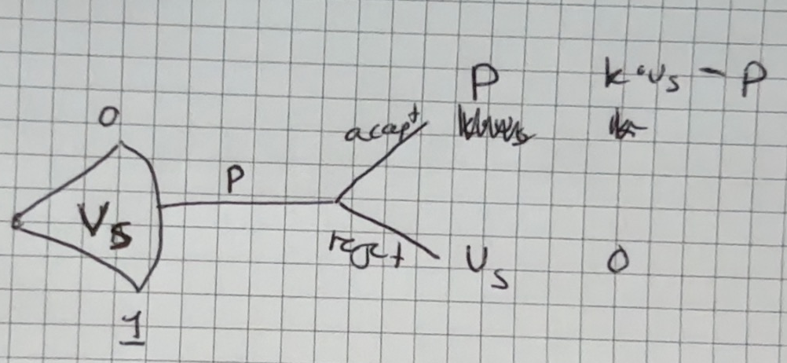

- What is the perfect Bayesian equilibrium when $k<2$?
We know that the seller will never accept a price below $v_{s}$, so $p≥v_{s}$. As they would then themselves get a negative payoff. The expected value of $v_{s}$ is $E\left(v_{s}\right)=\frac{1}{2}$ because it is uniformly distributed. This means that the buyer will have a positive expected payoff when
$$k·\frac{1}{2}-p≥0$$
$⇕$ Uligheden løses for p vha. WordMat.
$$p≤\frac{k}{2}<\frac{2}{2}=1$$
So the highest price the buyer is willing to offer is $\frac{k}{2}$, here the seller will only accept if $\frac{k}{2}≥v_{s}$ which in turn means the expected value of $v_{s}$ is smaller, and so we can keep going until the only price the buyer is willing to offer is 0:

$$PBE:\left(0;\left( \left(accept | p≥v_{s}\right),\left(reject | p<v_{s}\right)\right)\right)$$

- What is the perfect Bayesian equilibrium when $k>2$?
Now when $k>2$ the expected value for the buyer, and so the price they would maximum be willing to pay, is
$$p=k·\frac{1}{2}>\frac{2}{2}>1$$
Because $v_{s}$ is uniformly distributed on $\left[0,1\right]$we know that the seller would accept a price when $p≥1≥v_{s}$ and so the seller will always accept the price of 1, and the buyer will always have expected value of over 0 when offering the price 1 and so we get
$$PBE:\left(1;\left( \left(accept | p≥v_{s}\right),\left(reject | p<v_{s}\right)\right)\right)$$

Question 3 Signalling game
Consider a lawsuit between a plaintiff (P) and a defendant (D). The plaintiff knows whether or not he will win the case if it goes to trial, but the defendant lacks this information. The defendant has prior beliefs with a probability of $\frac{1}{3}$ that the plaintiff will win.
The plaintiff can take one of two actions:
- Demand a low settlement, $s=1$, or
- Demand a high settlement, $s=2$.
If the defendant accepts the settlement offer $s$, the payoffs are:
- Plaintiff’s payoff: $s$
- Defendant’s payoff: $-s$
If the defendant rejects the settlement offer, the case proceeds to trial. The payoffs from trial are defined as follows:
- If the plaintiff wins the case, his payoff is $3$ and the defendant’s payoff is $-4$.
- If the plaintiff loses the case, his payoff is $-1$ and the defendant’s payoff is $0$.
The following game tree describes the situation:
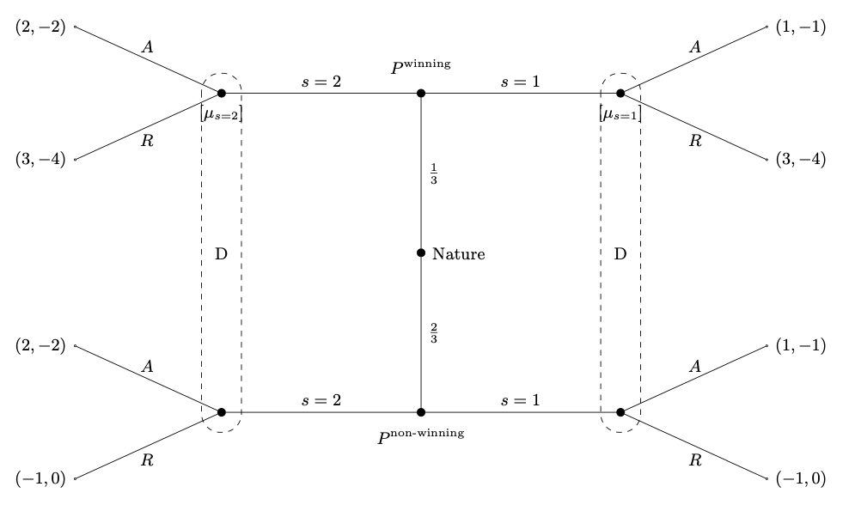
- Find all the pure-strategy Perfect Bayesian equilibria (PBE) of the game specified above.
This means that we need to look at the four possible equilibria, pooling and separating:

- Pooling on $s=2$
Here we get
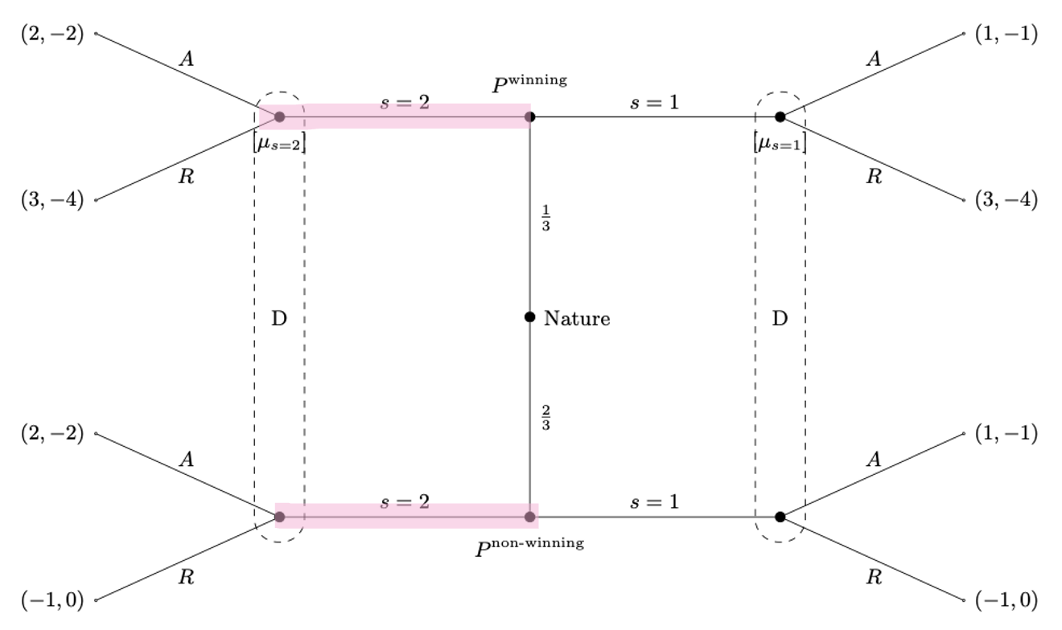
Now we need to look at whether the defendant will accept or reject. His expected payoffs are
$$E\left(A\right)=\frac{1}{3}·\left(-2\right)+\frac{2}{3}·\left(-2\right)=-2$$
$$E\left(R\right)=\frac{1}{3}·\left(-4\right)+\frac{2}{3}·0=-\left(\frac{4}{3}\right)$$
So we see that the defendant would choose to reject the offer, R.
Now we need to look if someone has incentive to deviate. We see that the winning type can never get a better payoff from deviating, only the same, whereas the non-winning type can get either a better payoff or the same. if we assume that an indifferent player will not deviate then we have an equilibrium if the plaintiff believes the defendant will play R, as then both types are indifferent between deviating, if the plaintiff believes the defendant will play A then the non-winning type will deviate. So we need to look at when the defendant will play R, this is when
$$E\left(A | 1\right)=μ_{1}·\left(-1\right)+\left(1-μ_{1}\right)·\left(-1\right)=-1$$
$$E\left(R | 1\right)=μ_{1}·\left(-4\right)+\left(1-μ_{1}\right)·0=-\left(4·μ_{1}\right)$$
So the defendant will play R when
$$-1≤-\left(4·μ_{1}\right)$$
$⇕$ Uligheden løses for mu_1 vha. WordMat.
$$μ_{1}≤\frac{1}{4}$$
And so we have a pooling equilibrium for pooling on 1 when $μ_{1}≤\frac{1}{4}$. As then neither has incentive to deviate. So the PBE is
$$PBE:\left(\left(\left(2|win\right),\left(2 | non-win\right)\right);\left(\left(R|2\right),\left(R|1\right)\right)\right), for μ_{1}≤\frac{1}{4}$$

- Pooling on 1
So we have
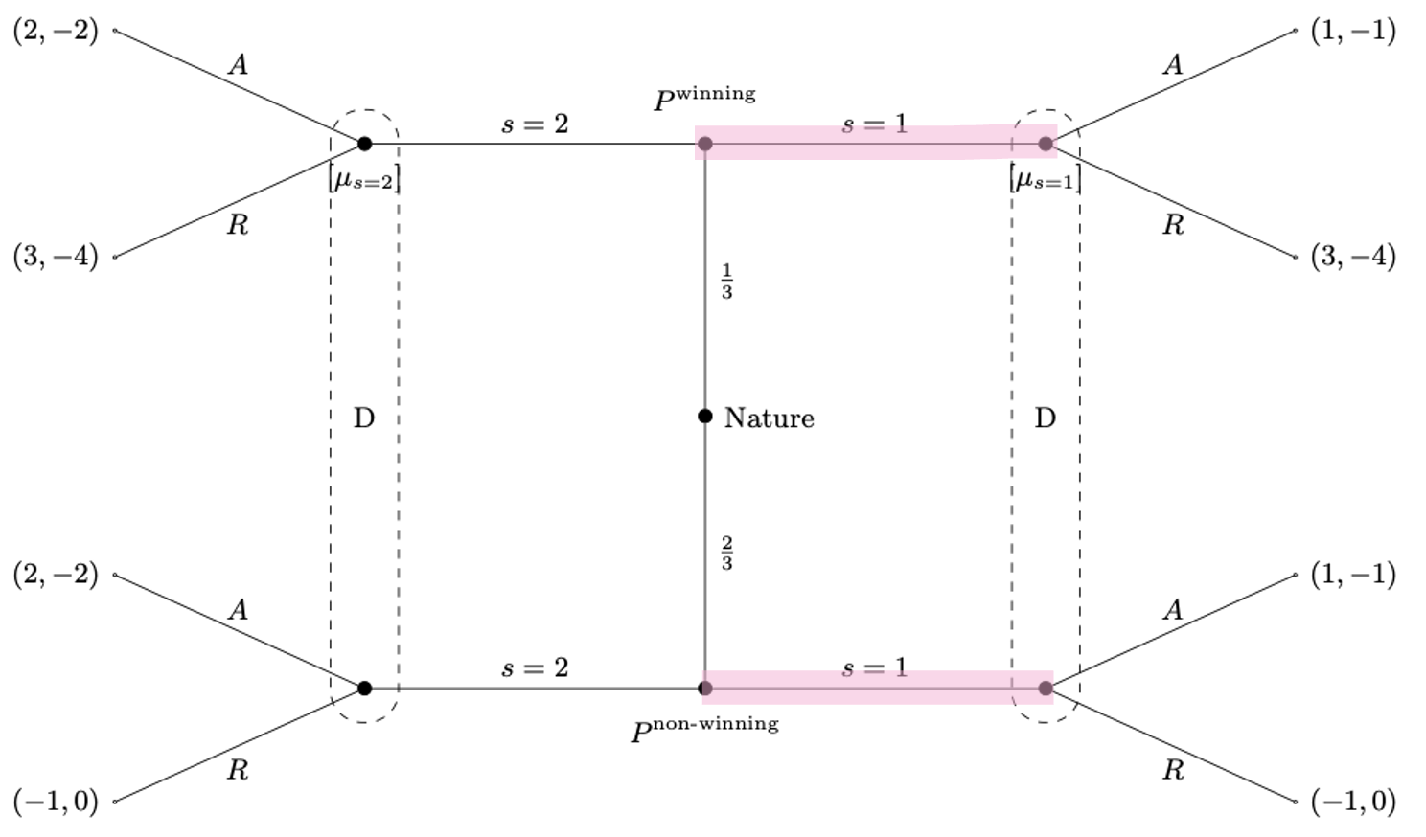
Here the defendant will play
$$E\left(A\right)=\frac{1}{3}·\left(-1\right)+\frac{2}{3}·\left(-1\right)=-1$$
$$E\left(R\right)=\frac{1}{3}·\left(-4\right)+\frac{2}{3}·0=-\left(\frac{4}{3}\right)$$
So we see that the defendant will choose to accept the offer, A.
We see here that the winning type will always deviate and so we do not have a PBE.

- Separating winning = 1, non-winning = 2
So we have
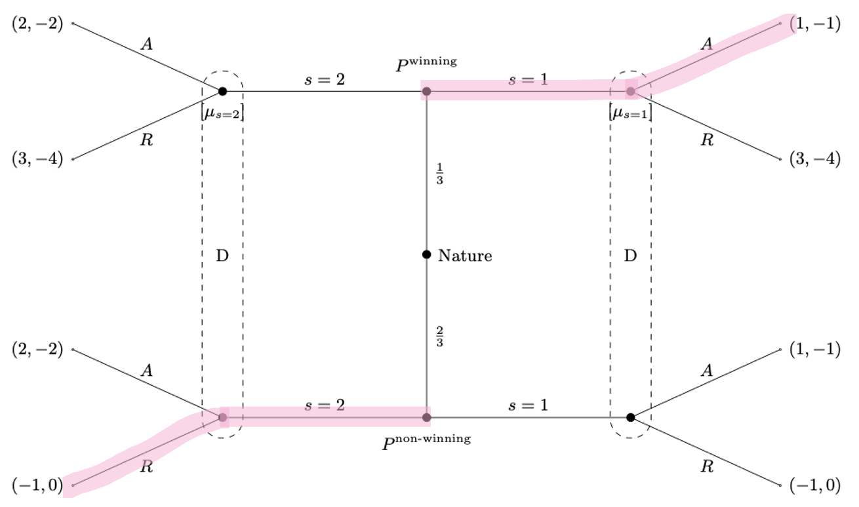
Here we see that both types have incentive to deviate, and so it is not a PBE.

- Separating winning=2, non-winning = 1
So we have:
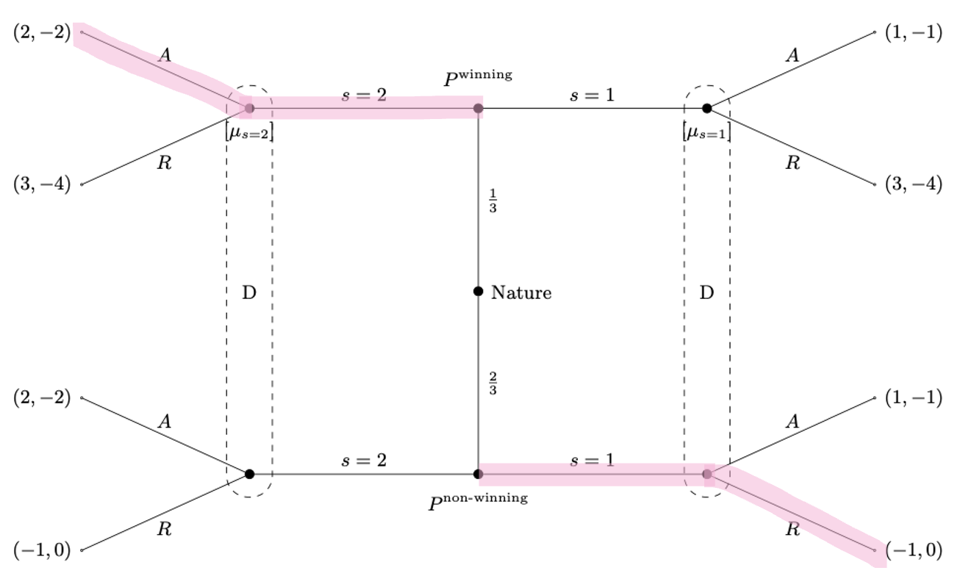
Here we see that both types have incentive to deviate, so not a PBE.

So overall the only PBE we have is
$$PBE:\left(\left(\left(2|win\right),\left(2 | non-win\right)\right);\left(\left(R|2\right),\left(R|1\right)\right)\right), for μ_{1}≤\frac{1}{4}$$

Question 4 Moral Hazard
A risk neutral owner wishes to hire a manager to operate a project. If he undertakes the project, the manager must choose an action from the set $\left\{a_{1},a_{2}\right\}.$ The utility cost to the manager of action $a_{i}$ is $c_{i}$ where $c_{1}<c_{2}$.
The project yields a return for the owner of either $π_{H}$ or $π_{L}$ where $π_{H}>π_{L}$. The probability that the return is $π_{H}$ when the manager takes action $a_{i}$is $γ_{i}$where $γ_{1}<γ_{2}$. The manager’s utility of income function is $u\left(y\right)=\sqrt{y}$. If he receives payment $w$ for doing the project and undertakes action $a_{i}$, he obtains a payoff $\sqrt{w}-c_{i}$.
The owner’s problem is to choose a contract to offer to the manager. The manager’s reservation utility is $0$, so that the contract must offer him at least this utility level. The parameters satisfy the inequality $γ_{2}>\frac{γ_{1}c_{2}}{c_{1}}.$
Note: vi har lavet den her som aflevering 8, så mest bare for jeg lige går igennem den igen, men tjek der for svar ellers!
- Under the assumption that the owner can observe the manager’s action choice, solve for the optimal contract that the owner should offer the manager. Your solution should include a parameter condition for when it is optimal to implement action $a_{1}$, respectively $a_{2}$.
So we need to maximize the owners profit:
$$\max_{w_{H},w_{L}}{γ_{i}·\left(π_{H}-w_{H}\right)+\left(1-γ_{i}\right)·\left(π_{L}-w_{L}\right)}$$
S.t.
$$γ_{i}·\sqrt{w_{H}}+\left(1-γ_{i}\right)·\sqrt{w_{L}}-c_{i}≥0$$
For $i=H,L$.
Here we write up lagrange to solve:
$$L=γ_{i}·\left(π_{H}-w_{H}\right)+\left(1-γ_{i}\right)·\left(π_{L}-w_{L}\right)+λ·\left(γ_{i}·\sqrt{w_{H}}+\left(1-γ_{i}\right)·\sqrt{w_{L}}-c_{i}\right)$$
Find FOC:
$$\frac{∂L}{∂w_{1}}=-\left(1-γ_{i}\right)+λ·\left(1-γ_{i}\right)·\frac{1}{2\sqrt{w_{1}}}=0$$
$$\frac{∂L}{∂w_{2}}=-γ_{i}+λ·γ_{i}·\frac{1}{2\sqrt{w_{2}}}=0$$
$$\frac{∂L}{∂λ}=0⇔γ_{i}\sqrt{w_{2}}+\left(1-γ_{i}\right)·\sqrt{w_{1}}-c_{i}=0$$
Now we isolate:
$$-y_{i}+λ·y_{i}·\frac{1}{2·\sqrt{w_{2}}}=0$$
$⇕$ Ligningen løses for λ vha. WordMat.
$$λ=2·\sqrt{w_{2}}$$
Use in next one
$$-\left(1-y_{i}\right)+2·\sqrt{w_{2}}·\left(1-y_{i}\right)·\frac{1}{2·\sqrt{w_{1}}}=0$$
$⇕$ Ligningen løses for w_2 vha. WordMat.
$$w_{2}=w_{1}$$
Use this in the last one:
$$y_{i}·\sqrt{w_{1}}+\left(1-y_{i}\right)·\sqrt{w_{1}}-c_{i}=0$$
$⇕$ Ligningen løses for w_1 vha. WordMat.
$$w_{1}=c_{i}^{2}$$

So we get that
$$w_{1}=w_{2}=c_{i}^{2}$$
So the wage is dependent on the disutility for the manager.
Now we need to look at when the owner gets the highest utility.
Utility for implementing low effort:
$$γ_{1}·\left(π_{H}-c_{1}^{2}\right)+\left(1-γ_{1}\right)·\left(π_{L}-c_{1}^{2}\right)$$
Utility for implementing high effort:
$$γ_{2}·\left(π_{H}-c_{2}^{2}\right)+\left(1-γ_{2}\right)·\left(π_{L}-c_{2}^{2}\right)$$
So we wee that the manager will choose to implement high effort when
$$y_{2}·\left(π_{H}-c_{2}^{2}\right)+\left(1-y_{2}\right)·\left(π_{L}-c_{2}^{2}\right)≥y_{1}·\left(π_{H}-c_{1}^{2}\right)+\left(1-y_{1}\right)·\left(π_{L}-c_{1}^{2}\right)$$
This means that we get the wage function of
$$w\left(a\right)=\left\{\begin{aligned}a_{2}, if y_{2}·\left(π_{H}-c_{2}^{2}\right)+\left(1-y_{2}\right)·\left(π_{L}-c_{2}^{2}\right)≥y_{1}·\left(π_{H}-c_{1}^{2}\right)+\left(1-y_{1}\right)·\left(π_{L}-c_{1}^{2}\right) \\ a_{1}, else \end{aligned}\right.$$

- Under the assumption that the owner cannot observe the manager’s action choice, write down the constraints she faces when implementing action $a_{i}, i=1,2.$
So now we also need some incentive constraints, not just participation constraints, this means we have 4 constraints in total:
$$\begin{aligned}γ_{1}·\sqrt{w_{H}}+\left(1-γ_{1}\right)·\sqrt{w_{L}}-c_{1}≥0\#\left(PC_{1}\right)\end{aligned}$$
$$\begin{aligned}γ_{2}·\sqrt{w_{H}}+\left(1-γ_{2}\right)·\sqrt{w_{L}}-c_{2}≥0\#\left(PC_{2}\right)\end{aligned}$$
$$\begin{aligned}γ_{1}·\sqrt{w_{H}}+\left(1-γ_{1}\right)·\sqrt{w_{L}}-c_{1}≥γ_{2}·\sqrt{w_{H}}+\left(1-γ_{2}\right)·\sqrt{w_{L}}-c_{2}\#\left(IC_{1}\right)\end{aligned}$$
$$\begin{aligned}γ_{2}·\sqrt{w_{H}}+\left(1-γ_{2}\right)·\sqrt{w_{L}}-c_{2}≥γ_{1}·\sqrt{w_{H}}+\left(1-γ_{1}\right)·\sqrt{w_{L}}-c_{1}\#\left(IC_{2}\right)\end{aligned}$$

- Under the assumption that the owner cannot observe the manager’s action choice, solve for the optimal compensation scheme if she wants to implement action $a_{2}$.
So then the owner has the maximization problem of:
$$\max_{w_{H},w_{L}}{γ_{2}·\left(π_{H}-w_{H}\right)+\left(1-γ_{2}\right)·\left(π_{L}-w_{L}\right)}$$
s.t.
$$\begin{aligned}γ_{2}·\sqrt{w_{H}}+\left(1-γ_{2}\right)·\sqrt{w_{L}}-c_{2}≥0\#\left(PC_{2}\right)\end{aligned}$$
$$\begin{aligned}γ_{2}·\sqrt{w_{H}}+\left(1-γ_{2}\right)·\sqrt{w_{L}}-c_{2}≥γ_{1}·\sqrt{w_{H}}+\left(1-γ_{1}\right)·\sqrt{w_{L}}-c_{1}\#\left(IC_{2}\right)\end{aligned}$$
Here we start by rewriting $IC_{2}$ so it is a little easier to work with:
$$\left(γ_{2}-γ_{1}\right)\left(\sqrt{w_{2}}-\sqrt{w_{1}}\right)≥c_{2}-c_{1}$$
Write up lagrange function:
$$L\left(w_{1},w_{2},λ,μ\right)=γ_{2}\left(π_{H}-w_{2}\right)+\left(1-γ_{2}\right)\left(π_{L}-w_{1}\right)+λ\left(γ_{2}\sqrt{w_{2}}+\left(1-γ_{2}\right)·\sqrt{w_{1}}-c_{2}\right)+μ\left(\left(γ_{2}-γ_{1}\right)\left(\sqrt{w_{2}}-\sqrt{w_{1}}\right)-(c_{2}-c_{1})\right)$$
If PC doesn’t bind, we are able to lower the wage, which in turn would raise $P'$s profit. We still need IC to hold when lowering the wage, i.e. we need to lower the wage just enough for $A$ to still have incentive to choose the high effort, $a_{2}$.

We have that the wages should be the same, and the owner wants to maximize her utility, which would mean setting $w$ as low as possible. The low wage can be obtained by implementing $a_{1}$, which is the low effort. That is the contradiction, because we earlier said that she should try to implement $a_{2}$.
This means we can set the constraints as equal and find the optimal wage scheme
$$y_{2}·\sqrt{w_{2}}+\left(1-y_{2}\right)·\sqrt{w_{1}}-c_{2}=0$$
$$\left(y_{2}-y_{1}\right)\left(\sqrt{w_{2}}-\sqrt{w_{1}}\right)=c_{2}-c_{1}$$
Now we isolate $\sqrt{w_{2}}$
$$\left(y_{2}-y_{1}\right)\sqrt{w_{2}}-\sqrt{w_{1}}\left(y_{2}-y_{1}\right)=c_{2}-c_{1}$$
$$\left(y_{2}-y_{1}\right)\sqrt{w_{2}}=c_{2}-c_{1}+\sqrt{w_{1}}\left(y_{2}-y_{1}\right)$$
$$\sqrt{w_{2}}=\frac{c_{2}-c_{1}}{y_{2}-y_{1}}+\sqrt{w_{1}}$$
And again
$$y_{2}·\left(\frac{c_{2}-c_{1}}{y_{2}-y_{1}}+\sqrt{w_{1}}\right)+\left(1-y_{2}\right)·\sqrt{w_{1}}-c_{2}=0$$
$$y_{2}·\frac{c_{2}-c_{1}}{y_{2}-y_{1}}+y_{2}·\sqrt{w_{1}}+\sqrt{w_{1}}-y_{2}·\sqrt{w_{1}}-c_{2}=0$$
$$y_{2}·\frac{c_{2}-c_{1}}{y_{2}-y_{1}}+\sqrt{w_{1}}-c_{2}=0$$
$$\sqrt{w_{1}}=c_{2}-y_{2}·\frac{c_{2}-c_{1}}{y_{2}-y_{1}}$$
We also get
$$\sqrt{w_{2}}=\frac{c_{2}-c_{1}}{y_{2}-y_{1}}+c_{2}-y_{2}·\frac{c_{2}-c_{1}}{y_{2}-y_{1}}=\left(1-y_{2}\right)\frac{c_{2}-c_{1}}{y_{2}-y_{1}}+c_{2}$$
So the optimal wage scheme when the principal would like to implement $a_{2}$ is then
$$w_{1}={\left(c_{2}-y_{2}·\frac{c_{2}-c_{1}}{y_{2}-y_{1}}\right)}^{2}$$
$$w_{2}={\left(\left(1-y_{2}\right)\frac{c_{2}-c_{1}}{y_{2}-y_{1}}+c_{2}\right)}^{2}$$
We know that $w_{2}$ the wage to make the agent want to take the high effort is higher because they are the same but for the 1 extra in $w_{2}$ and so the higher wage will incentivize the agent to choose the higher effort level. The agent gets a higher wage than in 1. For the high effort. And a lower wage for the low effort.

- Under the assumption that the owner cannot observe the manager’s action choice, solve for the optimal contract that the owner should offer the manager. Again, your solution should include a parameter condition for when it is optimal to implement action $a_{1}$, respectively $a_{2}$.
Because we have shown that we can make the constraints bind in question 3. we have that the wages are the same no matter if the principal would like to implement $a_{1}$ or $a_{2}$, which means the agent would have no incentive to choose $a_{2}$. That means we can use our answer from question 1 to find the best wage scheme when the principal would like to implement $a_{1}$.
We have the payoff for the principal when implementing $a_{1}$ is
$$Π_{1}=\left(π_{H}-π_{L}\right)·y_{1}-c_{1}^{2}+π_{L}=π_{H}·y_{1}+\left(1-y_{1}\right)π_{L}-c_{1}^{2}$$
If the owner wants to implement $a_{2}$ instead, we need to look at the owners expected profit assuming the manager chooses $a_{2},$ as we did in question 3, so we can use the wages we found there.
For the owner to offer the agent a contract in which action $a_{2}$ should be implemented, we get

$$Π_{2}=γ_{2}\left(π_{H}-w_{2}\right)+\left(1-γ_{2}\right)\left(π_{L}-w_{1}\right)=y_{2}·\left(π_{H}-{\left(\left(1-y_{2}\right)\frac{c_{2}-c_{1}}{y_{2}-y_{1}}+c_{2}\right)}^{2}\right)+\left(1-y_{2}\right)·\left(π_{L}-{\left(c_{2}-y_{2}·\frac{c_{2}-c_{1}}{y_{2}-y_{1}}\right)}^{2}\right)$$
Now we need to compare the two profits, the owner would like to implement $a_{1}$when:
$$π_{H}·y_{1}+\left(1-y_{1}\right)π_{L}-c_{1}^{2}≥ y_{2}·\left(π_{H}-{\left(\left(1-y_{2}\right)\frac{c_{2}-c_{1}}{y_{2}-y_{1}}+c_{2}\right)}^{2}\right)+\left(1-y_{2}\right)·\left(π_{L}-{\left(c_{2}-y_{2}·\frac{c_{2}-c_{1}}{y_{2}-y_{1}}\right)}^{2}\right)$$
When $Π_{1}>Π_{2}$ the owner wants to choose the contract where the manager would provide effort $a_{1}$, otherwise she should implement $a_{2}$.

- Prove that if the optimal contract in the unobservable action case involves the manager taking action $a_{2}$, then so does the optimal contract in the observable action case.
Note: den her er blevet gennemgået til TØ, har kopieret ind:
$$E\left[π_{i}\right]=γ_{i}π_{H}+\left(1-γ_{i}\right)π_{L}$$
$$E\left[w_{i}\right]=γ_{i}w_{L}+\left(1-γ_{i}\right)w_{L}$$
Vi skal vise at hvis:
$$E\left[π_{2}\right]-E\left[w_{2}\right]≥E\left[π_{1}\right]-E\left[w_{1}\right]$$
Så gælder (I den observable):
$$E\left[π_{2}\right]-c_{2}^{2}≥E\left[π_{1}\right]-c_{1}^{2}$$

Vi ved også fra den unobservable case at:
$$E\left[π_{1}\right]-E\left[w_{1}\right]=E\left[π_{1}\right]-c_{1}^{2}$$
Så vi kan omskrive:
$$E\left[π_{2}\right]-c_{2}^{2}≥E\left[π_{1}\right]-c_{1}^{2}⇒E\left[π_{2}\right]-c_{2}^{2}≥E\left[π_{2}\right]-E\left[w_{2}\right]≥E\left[π_{1}\right]-c_{1}^{2}$$

Det kan vi reducere på:
$$⇒E\left[w_{2}\right]≥c_{2}^{2}, \text{som er det vi skal vise}$$

Fra $PC$ I den unobservable case har vi:
$$E\left[u\left(w^{unobs}\right) | a_{2}\right]=c_{2}$$
Bruger Jensens ligning? Når vi har en konkav funktion kan vi rykke indenfor parentesen og så bliver det større?
$$c_{2}=E\left[u\left(w^{unobs}\right) | a_{2}\right]≤u\left(E\left[w^{unobs} | a_{2}\right]\right)$$
Fra opgaven har vi utility function så det bliver lig:
$$\sqrt{E\left[w^{unobs} | a_{2}\right]}=c_{2}$$
Ophæver kvadratroden og får:
$$E\left[w^{unobs} | a_{2}\right]=c_{2}^{2}$$
Så det giver det samme. Yay

Question 5 Signalling market for used goods
There exists a buyer and a seller of a good. The seller’s marginal cost of producing the good is $0$.
The buyer is either a high valuation type ($i=H$) or a low valuation type ($i=L$). The high valuation type’s reservation value for the good is $\overline{b}$, while the low valuation type’s reservation value is $\overset{̲}{b}$, where $\overline{b}>\overset{̲}{b}>0$. The seller does not known whether the buyer is a high valuation type or a low valuation type.
The high valuation buyer’s payoff from agreeing to a price of $p$ at time$t$ is
$$u_{\overline{b}}\left(p,t\right)=δ^{t}\left(\overline{b}-p\right)$$
where $δ∈(0, 1)$ is the discount factor. The low valuation buyer’s payoff from agreeing to price $p$ at time $t$ is
$$u_{\overset{̲}{b}}\left(p,t\right)=δ^{t}\left(\overset{̲}{b}-p\right)$$
- Show that the single crossing property holds between the high valuation buyer and the low valuation buyer. (Hint: $\frac{∂}{∂x}\left(a^{x}\right)=a^{x}·ln\left(a\right)$
Note: det her er aflevering 10, gider ikke lige til at lave den!

- Depict the single crossing property by drawing in (p, t)-space representative indifference curves for the high valuation buyer and for the low valuation buyer.

Suppose a separating equilibrium occurs where $p_{H}$ is the price that the high valuation buyer pays, $p_{L}$ is the price that the low valuation buyer pays, $t_{H}$ is the time of agreement for the high valuation buyer and $t_{L}$ is the time of agreement for the low valuation buyer.
- State the incentive compatibility (IC) constraint for the high valuation buyer and for the low valuation buyer.

- Prove that $p_{H}>p_{L}$ and $t_{H}<t_{L}$in all separating equilibrium outcomes. (If you are having difficulty with the proof, make a graphical argument.)

- Suppose the separating equilibrium is such that $p_{H}=\frac{\overline{b}}{2}, t_{H}=0$ and $p_{L}=\frac{\overset{̲}{b}}{2}$. What is the possible range of values for $t_{L}$?

Mikro eksamen august 2024

Question 1 Normal form game NE, prisoners dilemma
Two farmers, Adam (A) and Beatrice (B), graze their animals on a common land. They can choose to use the common resource lightly or heavily and the resulting strategic interaction may be described as a simultaneous-move game. The payoff matrix is the following:
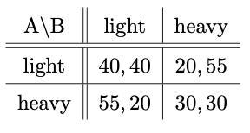
- Find the Nash equilibrium of the game. Explain briefly why this is an example of the “Prisoners’ Dilemma” game.
We have
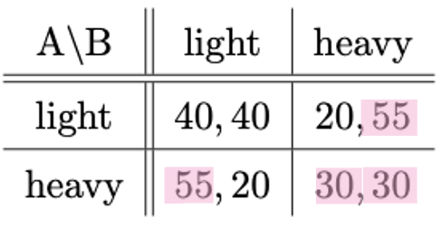
So we see the NE is $\left(heavy,heavy\right)$this is a prisoners dilemma as we see that they would both be better off from playing (light, light) but because they would both have incentive to deviate they end up with a lower payoff both of them.

- Suppose that the above matrix is the stage game of an infinitely repeated game.
- Consider a grim trigger strategy $s_{i}^{gt}$defined as follows:
- Play light in period 1
- In period t = 2,3,4,...,
- play light if the outcome of the previous stages has always been (light; light.
- play heavy otherwise
What is the lowest discount factor for which $\left(s_{A}^{gt} ,s_{B}^{gt} \right)$ is a Nash equilibrium?
So we see that if they both stick to the strategy and play light forever they each get an average payoff of 40. So we need to see when it is worth it to deviate, we would assume they would deviate in the first round, here a player would get the average payoff of
$$\left(1-δ\right)·\left(55+\sum_{i=1}^{∞}{30δ^{i}}\right)=\left(1-δ\right)·\left(\frac{30·δ}{1-δ}+55\right)$$
So it is worth it to deviate when
$$\left(1-δ\right)·\left(\frac{30·δ}{1-δ}+55\right)≥40$$
$⇕$ Uligheden løses for delta vha. WordMat.
$$δ≤\frac{3}{5}$$
This means we have that the grim trigger strategy is a Nash equilibrium when $δ>\frac{3}{5}$.

- Is the equilibrium from (i) subgame-perfect? Briefly explain why or why not.
As it is an infinite game then yes it is, if it was finite then it would always be worth it to deviate in the last round, but as long as $δ>\frac{3}{5}$ it is never worth it to deviate in the infinite game and so it is subgame perfect.

- Recall the tit-for-tat strategy $s_{i}^{tft}$ described as follows: Play light at stage 1, then do whatever the other player did in the previous period.
Suppose there exist discount factors such that $\left(s_{A}^{tft},s_{B}^{tft}\right)$is a Nash equilibrium. Do you expect the lowest such discount factor to be greater or less than the discount factor you identified in sub-question (i)? Explain briefly.
This means if they never deviate they also get the average payoff of 40, whereas if one deviates they end up switching between (heavy, light) and (light, heavy) so it is worth it to deviate when
$$\left(1-δ\right)·\left(\sum_{i=0}^{∞}{55·δ^{2·i}}+\sum_{i=0}^{∞}{20δ^{2·i+1}}\right)=\frac{55}{1+δ}+\left(1-δ\right)·\frac{20δ}{1+δ}$$
So we get
$$\frac{55}{1+δ}+\left(1-δ\right)·\frac{20δ}{1+δ}≥40$$
$⇕$ Uligheden løses for delta vha. WordMat.
$$δ≤-\left(\frac{3}{2}\right) ∨ \left(δ≥-1 ∧ δ≤\frac{1}{2}\right)$$
So we see that it is a Nash equilibrium when $δ>\frac{1}{2}$. This means we get a lower discount factor, there is a bigger chance of deviating as one does not get the same “straf” and so might be more willing to deviate.

Question 2 Signalling game as normal form
Suppose HAL Corporation is a monopolist in the market for supercomputers. Assume that the market is a “natural monopoly,” meaning that only one firm can survive in the long run. HAL faces only one potential competitor, EBM. In the first period, HAL moves first and chooses one of two prices for its supercomputers: High or Low. EBM moves second and decides whether to enter the market or not. Here are the first-period profits of the two firms:
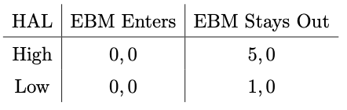
In the second period, three scenarios can occur:
- EBM did not enter in the first period. Then HAL retains its monopoly in the second period and earns monopoly profits of $125-C$, where $C$ is its costs. EBM earns zero profits.
- EBM entered in the first period and has lower costs. HAL leaves the market, and EBM gains the monopoly in the second period, earning monopoly profits of $100=125-25$, where $25$are its costs, which is common knowledge. HAL earns zero profits.
- EBM entered in the first period and HAL has the lower costs. In this case, EBM drops out of the market, HAL retains its monopoly in the second period, and it earns monopoly profits of $125-C$, where$C$ is its costs. EBM earns zero profits.
EBM’s payoff from playing this game equals 0 if it decides to stay out, and it equals the sum of its profits in the two periods minus entry costs of $40$ if it decides to enter. HAL’s payoff equals the sum of its profits in the two periods. HAL’s costs, $C$, can be either $30$ (high) or $20$ (low). This cost is HAL’s private information. EBM only knows that$Pr(C=20)=0.75$ and $Pr(C=30)=0.25$.
- Formulate the problem as a signaling game, i.e., draw the game tree.
I draw the game tree:
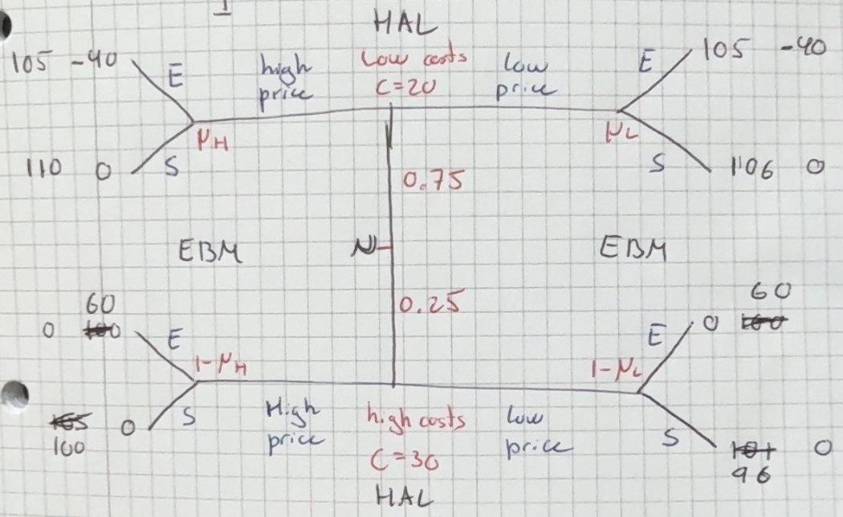

- Write down the normal form representation of the game, i.e., the game matrix, and find the pure strategy Nash equilibria.
So we have that HAL either has low costs or high costs, and they can set a low price or a high price. EBM can either enter or stay out, given the low/high price. So we get
Here the first for Hal is the price given low costs, the second is the price given high costs.
For EBM the first is if given low price, the second is given high price.
HAL / EBM | Enter, Enter | Enter, stay out | Stay out, enter | Stay out, Stay out
Low, low | $$78.75, -15$$ | $$78.75, -15$$ | $$103. 5, 0$$ | $$103. 5, 0$$
Low, high | $$78.75, -15$$ | $$103.75, -30$$ | $$79.5, 15$$ | $$104.5, 0$$
High, low | $$78.75, -15$$ | $$82.5, 15$$ | $$102.5, -30$$ | $$106.5, 0$$
High, high | $$78.75, -15$$ | $$107. 5, 0$$ | $$78.75, -15$$ | $$107. 5, 0$$
Explanations of the calculations:
LL, EE:
$$0,75·105+0,25·0=78,75$$
$$0,75·\left(-40\right)+0,25·60=-15$$
LL, ES: same
LL, SE: same for LL,SS
$$0,75·106+0,25·96=103,5$$
$$0,75·0+0,25·0=0$$
HH, EE: and HH, SE
$$0,75·105+0,25·0=78,75$$
$$0,75·\left(-40\right)+0,25·60=-15$$
HH, ES and HH, SS:
$$0,75·110+0,25·100=107,5$$
$$0,75·0+0,25·0=0$$
LH, EE:
$$0.75·105+0.25·0=78,75$$
$$0.75·\left(-40\right)+0.25·60=-15$$
LH, SS:
$$0.75·106+0.25·100=104,5$$
$$0.75·0+0.25·0=0$$
HL, SS:
$$0.75·110+0.25·96=106,5$$
$$0.75·0+0.25·0=0$$
LH, ES:
$$0.75·105+0.25·100=103,75$$
$$0.75·\left(-40\right)+0.25·0=-30$$
LH, SE:
$$0.75·106+0.25·0=79,5$$
$$0.75·0+0.25·60=15$$
HL, ES:
$$0.75·110+0.25·0=82,5$$
$$0.75·0+0.25·60=15$$
HL, SE:
$$0.75·105+0.25·96=102,75$$
$$0.75·\left(-40\right)+0.25·0=-30$$

I think this is correct?
Now I need to find the pure strategy Nash equilibria:
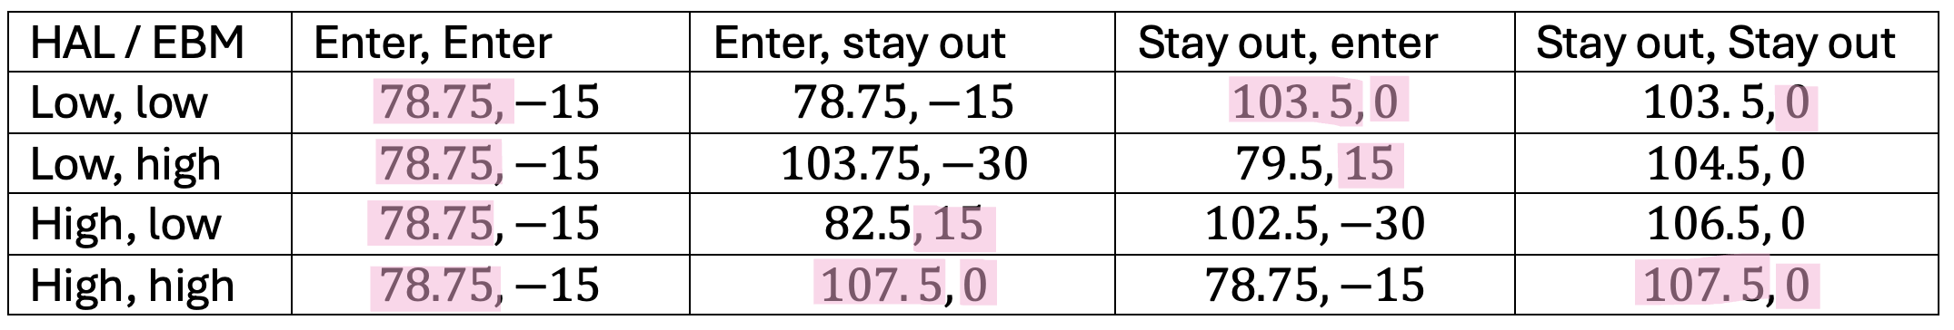
So we see that there are 3:
$$\left(\left(\left(High|20\right),\left(high|30\right)\right);\left(\left(enter|low\right),\left(stay out|high\right)\right)\right)$$
$$\left(\left(\left(Low|20\right),\left(Low|30\right)\right);\left(\left(stay out|low\right),\left(enter|high\right)\right)\right)$$
$$\left(\left(\left(High|20\right),\left(high|30\right)\right);\left(\left(stay out|low\right),\left(stay out|high\right)\right)\right)$$

- For each of the pure-strategy Nash equilibria identified in (b), state the beliefs for which the equilibrium is a Perfect Bayesian Equilibrium (PBE).
For the first one:
$$\left(\left(\left(High|20\right),\left(high|30\right)\right);\left(\left(enter|low\right),\left(stay out|high\right)\right)\right)$$
We see that this is a pooling on high equilibrium where EBM chooses to stay out of the market. This means we have:
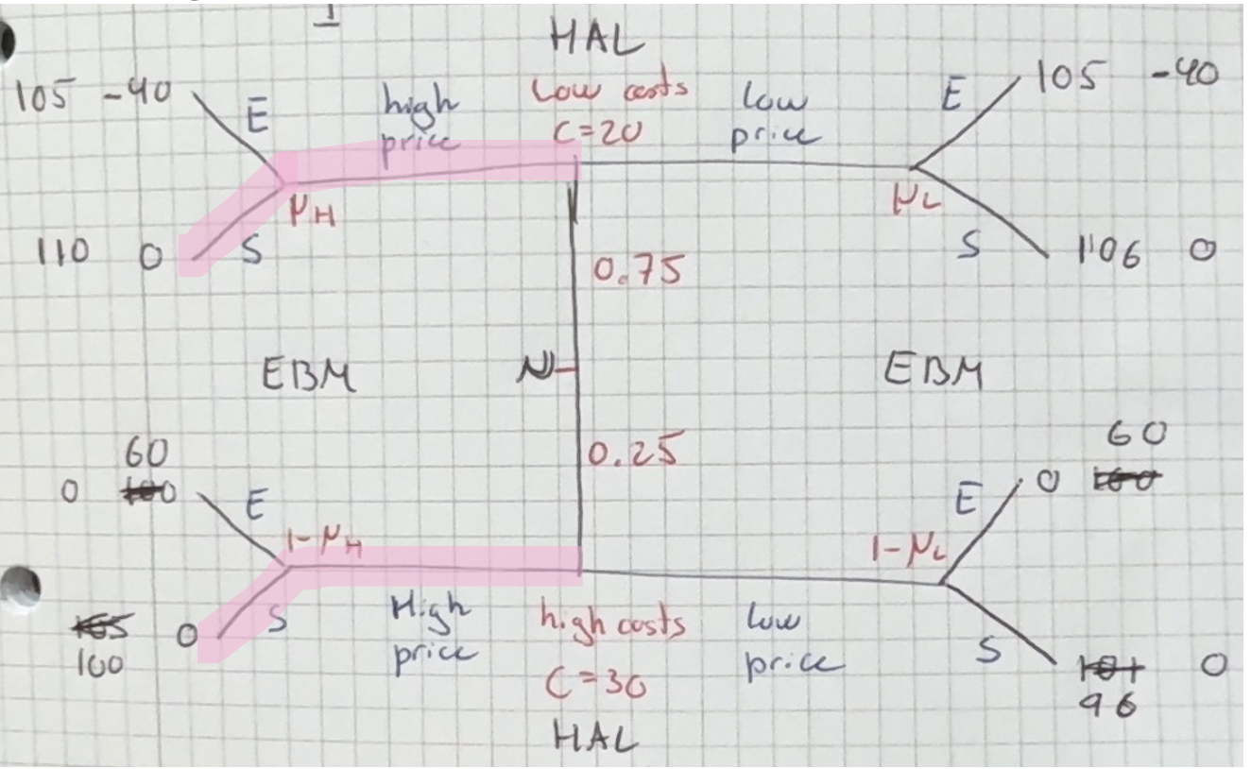
So we see that neither type will want to deviate as they cannot get a higher payoff. This means that it is always an equilibrium, so it is a PBE.
For the second one:
$$\left(\left(\left(Low|20\right),\left(Low|30\right)\right);\left(\left(stay out|low\right),\left(enter|high\right)\right)\right)$$
We have a pooling on low where EBM chooses to stay out:
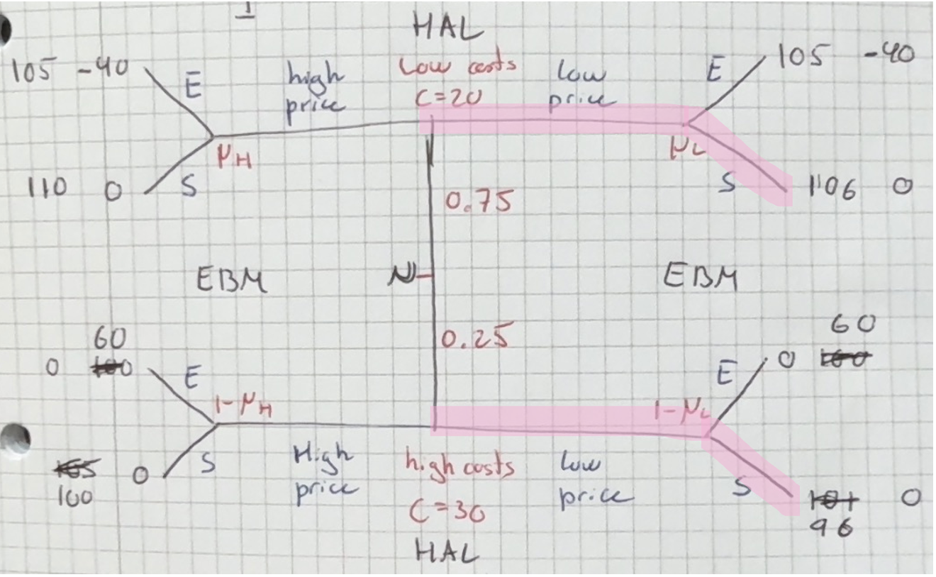
Here we see that both types could have incentive to deviate.
We check when the high costs type might deviate, they will if they believe EBM will play Stay out, so if
$$μ_{H}·0+\left(1-μ_{H}\right)·0≥μ_{H}·40+\left(1-μ_{H}\right)·60$$
$⇕$ Uligheden løses for mu_H vha. WordMat.
$$μ_{H}≥3$$
So we see that they will never deviate. The high type will also only deviate if they believe they will play stay out, and as we see they will never play stay out it means that this is a PBE. This also makes sense as we see the strategy is to play enter given a high price.
For the third one:
$$\left(\left(\left(High|20\right),\left(high|30\right)\right);\left(\left(stay out|low\right),\left(stay out|high\right)\right)\right)$$
This is a pooling on high equilibrium where EBM chooses to stay out, so this is the same as the first one and they will never deviate.

This means that I have found that all 3 are PBE for all beliefs.

Question 3 Adverse selection
Consider an adverse selection model with many identical firms that can hire workers. The price of output is one. Each firm’s production technology exhibits constant returns to scale and uses only labor. Workers differ in their productivity, such that a worker of type $θ$ produces $θ$ units of output. Thus, a firm’s profit of employing a worker of type $θ$ is $θ-w$, where $w$ is the wage the firm pays to the worker. Workers’ types are unobservable to the firms.
Workers are uniformly distributed on the interval $\left[0,1\right].$ Workers are earnings maximizers and a worker of type $θ$can earn $r(θ)$ in home production. Hence, a worker’s utility is $w$ if the worker works for the firm and $r(θ)$ if the worker stays at home.
Suppose first that $r(θ)=θ^{\frac{1}{8}}$.
Note: det her er aflevering 12, jeg har dog ikke skrevet den af fra afleveringen men fulgt en anden eksamensopgave jeg har lavet med andre tal fordi der var lidt fejl I afleveringen.
- What is the Pareto efficient allocation of workers? I.e. which subset of [0, 1] should work?
When $r\left(θ\right)=θ^{\frac{1}{8}}$ we have that
$$r\left(0\right)=0^{\frac{1}{8}}=0$$
$$r\left(1\right)=1^{\frac{1}{8}}=1$$
And for any $θ∈\left(0,1\right)$ we have
$$r\left(θ\right)>θ$$
So the only workers that should be working are for $θ=0,1$ all others should be at home as they have a higher utility from being at home than they get from the wage the firms can pay, we have $w≤θ$ as otherwise they get negative profits.

- Can the firms offer different wages to different types? What will happen if they do so? Explain in at most 2 sentences.
Not when they cannot see the workers type, we see that they would like to offer the wage of $w=0$for $θ=0$ and $w=1$ for $θ=1$ but if they offer $w=1$ then everyone will take it and the firm will have negative profits.

- Find all competitive equilibria through the following steps:
- At a given wage w, which types will work?
At a given wage the types working are the types where
$$Θ\left(w\right)=\left\{θ|r\left(θ\right)≤w\right\}=\left\{θ|θ^{\frac{1}{8}}≤w\right\}=\left\{θ|θ≤w^{8}\right\}$$

- At a given wage w, what is the expected productivity of those willing to work?
The expected productivity of those working can be found using the fact that the amount of workers are uniformly distributed so that
$$E\left(X\right)=\frac{b+a}{2}$$
Where $b=w^{8}$ and $a=0$. So
$$E\left(θ | θ≤w^{8}\right)=\frac{w^{8}+0}{2}=\frac{w^{8}}{2}$$
Calculate integral if not uniformly distributed.

- Is there an equilibrium with a positive equilibrium wage $w^{⋆}$? Is there an equilibrium with equilibrium wage $w^{⋆}=0$? For each equilibrium, state the equilibrium wage as well as the subset of types that are working.
Because there are multiple firms in Bertrand competition we know that the firms must have a profit of 0, so the wage they can offer is the wage where the expected productivity of those willing to work is equal to the wage they are offering, so when
$$w=\frac{w^{8}}{2}$$
$⇕$ Ligningen løses for w vha. WordMat.
$$w=0 ∨ w=1,10409$$
As we we have the workers are uniformly distributed on $\left[0,1\right]$ it is never worth it for the firm to offer a wage above 1 as they are sure to have a negative profit.
So the only equilibrium we have is for a $w^{⋆}=0$ where the only type working is $θ=0$.

- Which equilibrium is constrained Pareto efficient? Is that equilibrium also Pareto efficient in the unconstrained sense?
The only equilibrium I found was $w=0$with $θ=0$ and so this is the constrained Pareto efficient equilibrium.
We see in a) we found that $w=0$ and $w=1$ were Pareto efficient, so we see that the equilibrium we found is also Pareto efficient in the unconstrained sense, we don’t need for the whole amount to be working, but the amount that is working should also be working under the optimal Pareto efficient allocation.

Suppose now that $r\left(θ\right)=θ^{8}$.
- What is the Pareto efficient allocation of workers?
We have that
$$r\left(0\right)=0^{8}=0$$
$$r\left(1\right)=1^{8}=1$$
But now for $θ∈\left(0,1\right)$ we have that
$$θ≥r\left(θ\right)=θ^{8}$$
And so the efficient allocation of workers is that all workers are working and no one is at home as everyone is at least better off working.

- Find all competitive equilibria through the following steps:
- At a given wage $w$, which types will work?
We do the same as earlier
$$Θ\left(w\right)=\left\{θ|r\left(θ\right)≤w\right\}=\left\{θ|θ^{8}≤w\right\}=\left\{θ|θ≤w^{\frac{1}{8}}\right\}$$

- At a given wage $w$, what is the expected productivity of those willing to work?
The workers are still uniformly distributed so we use $b=w^{\frac{1}{8}}$ and $a=0$. So
$$E\left(θ | θ≤w^{4}\right)=\frac{w^{\frac{1}{8}}+0}{2}=\frac{w^{\frac{1}{8}}}{2}$$

- Is there an equilibrium with a positive equilibrium wage $w^{⋆}$? Is there an equilibrium with equilibrium wage$w^{⋆}=0$? For each equilibrium, state the equilibrium wage as well as the subset of types that are working.
So now we check when
$$w=\frac{w^{\frac{1}{8}}}{2}$$
$⇕$ Ligningen løses for w vha. WordMat.
$$w=0 ∨ w=0,4528618$$
So we have two possible wages, just like before we know that 0 is an equilibrium as the only type working will be $θ=0$, so we need to check the other wage.
This means we need to check which types will be working for this wage and whether their expected productivity equals the wage, then we have an equilibrium:
$$Θ\left(0,4528618\right)=\left\{θ|θ≤w^{\frac{1}{8}}\right\}=\left\{θ|θ≤{0,4528618}^{\frac{1}{8}}\right\}=\left\{θ|θ≤0,9057237\right\}$$
So we need to look at the productivity when $θ∈\left[0, 0.9057237\right]$
We find that this is
$$E\left(θ | θ≤0,9057237\right)=\frac{0,9057237+0}{2}≈0,4528619$$
Which we see is exactly the wage and so this is also an equilibrium.

- Which equilibrium is constrained Pareto efficient? If there are multiple equilibria, which workers are strictly better off in the dominating equilibrium?
The highest wage equilibrium is constrained Pareto efficient this means the equilibrium with wage $w^{⋆}=0,4528619$ is constrained Pareto efficient as a higher wage pareto dominates a lower wage when wage is all we are looking at.
We see that all workers working are strictly better off in the equilibrium with the higher wage as that is the whole reason they are working, that they are better off than at home, which all but $θ=0$ would be in the other equilibrium.

Question 4 Adverse selection
A village has not seen a drop of rain for months, and there is serious fear of a drought. The village mayor is now ready to try any measure to bring rain to the region. One of her aides tells her about a sorcerer who is able to make it rain. The mayor is unconvinced that the sorcerer is for real, and is afraid that he will turn out to be a fake.
Everybody knows that a fake sorcerer has no power over the rain. If the mayor contracted
a fake, the probability of rain would remain unchanged. It is currently estimated that the
probability of rain in the next week is$Pr_{F}=\frac{2}{100}$. On the other hand, an authentic sorcerer,
in spite of having powers, is not infallible, but can increase the probability of rain to $Pr_{A}=\frac{20}{100}$. Both authentic sorcerers and fakes are risk-averse, their utility function over wealth (which is all they care about here) being of the form $u\left(w\right)=\sqrt{w}$. An authentic sorcerer will not work unless the utility he receives from the contract is at least ${\overset{̲}{U}}_{A}=10$. Fakes, on the other hand, have a reservation utility of ${\overset{̲}{U}}_{F}=1$.
The mayor, who is risk-neutral, is concerned about hiring a fake, since the political cost of being publicly ridiculed should anyone somehow realize that a fake has been hired, is prohibitively high. So the mayor is trying to design a contract (with payments contingent on whether or not there is rain in the next week) that would only be accepted by an authentic sorcerer, and not by a fake.
Note: det her er aflevering 11, jeg har rimelig meget bare kopieret den ind da der er nogle lidt kedelige mellemregninger!
- Assume that the mayor does not know whether the sorcerer is authentic or fake. Formulate the mayor’s problem.
The mayor would like to only have a genuine sorcerer so he has a minimization problem for what he needs to pay for the higher chance of rain given only the genuine sorcerer will accept. She will need to construct the contract, so only the genuine sorcerer wants to accept.
So, she pays one wage if it rains $w_{R}$and another if it does not $w_{D}$, where $w_{R},w_{D}≥0$
$$\min{P_{G}·w_{R}+\left(1-P_{G}\right)·w_{D}}=\min{\frac{20}{100}·w_{R}+\left(1-\frac{20}{100}\right)·w_{D}}$$
s.t.
$$\begin{aligned}\frac{2}{100}·\sqrt{w_{R}}+\left(1-\frac{2}{100}\right)·\sqrt{w_{D}}≤1\#\left(PC_{F}\right)\end{aligned}$$
$$\begin{aligned}\frac{20}{100}·\sqrt{w_{R}}+\left(1-\frac{20}{100}\right)·\sqrt{w_{D}}≥10\#\left(PC_{G}\right)\end{aligned}$$
This is because the mayor would like to only offer the contract to a real sorcerer, as a fake sorcerer would just take the money but not raise the chance of rain at all. So we need to make sure the fake does not take the offer, and we are minimizing over the payments given we use the higher chances of rain.

- Calculate the optimal contract that the mayor will offer (i.e. find the solution to the problem in part a)).
First, we rewrite $\left(PC_{F}\right)$
$$1-\frac{2}{100}·\sqrt{w_{R}}-\left(1-\frac{2}{100}\right)·\sqrt{w_{D}}≥0$$
Now we write up Lagrange
$$L=\frac{20}{100}·w_{R}+\left(1-\frac{20}{100}\right)·w_{D}+λ\left(1-\frac{2}{100}·\sqrt{w_{R}}-\left(1-\frac{2}{100}\right)·\sqrt{w_{D}}\right)+μ·\left(\frac{20}{100}·\sqrt{w_{R}}+\left(1-\frac{20}{100}\right)·\sqrt{w_{D}}-10\right)$$
We find FOC:
$$\begin{aligned}\frac{∂L}{∂w_{R}}=\frac{20}{100}-\frac{2·λ}{2·100\sqrt{w_{R}}}+\frac{20·μ}{2·100\sqrt{w_{R}}}=0 \#\left(1\right)\end{aligned}$$
$$\begin{aligned}\frac{∂L}{∂w_{D}}=\frac{80}{100}-\frac{98·λ}{2·100\sqrt{w_{D}}}+\frac{80·μ}{2·100·\sqrt{w_{D}}}=0\#\left(2\right)\end{aligned}$$
$$\begin{aligned}\frac{∂L}{∂λ}=1-\frac{2}{100}·\sqrt{w_{R}}-\left(1-\frac{2}{100}\right)·\sqrt{w_{D}}=0 \#\left(3\right)\end{aligned}$$
$$\begin{aligned}\frac{∂L}{∂μ}=\frac{20}{100}·\sqrt{w_{R}}+\left(1-\frac{20}{100}\right)·\sqrt{w_{D}}-10=0\#\left(4\right)\end{aligned}$$
We find $w_{R}$ and $w_{D}$ in $(1)$ and $(2)$
$$\frac{20}{100}-\frac{λ}{100·\sqrt{w_{R}}}+\frac{μ}{10·\sqrt{w_{R}}}=0⇔20-\frac{λ}{\sqrt{w_{R}}}+\frac{10·μ}{\sqrt{w_{R}}}=0⇔20·\sqrt{w_{R}}-λ+10·μ=0$$
$$⇔20·\sqrt{w_{R}}=λ-10·μ⇔w_{R}={\left(\frac{λ-10·μ}{20}\right)}^{2}$$
And
$$\frac{80}{100}-\frac{98·λ}{2·100\sqrt{w_{D}}}+\frac{80·μ}{2·100·\sqrt{w_{D}}}=0⇔\frac{4}{5}-\frac{49·λ}{100\sqrt{w_{D}}}+\frac{4·μ}{10·\sqrt{w_{D}}}=0$$
$$⇔80-\frac{49·λ}{\sqrt{w_{D}}}+\frac{40·μ}{\sqrt{w_{D}}}=0⇔80·\sqrt{w_{D}}-49·λ+40·μ=0$$
$$⇔80·\sqrt{w_{D}}=49·λ-40·μ⇔w_{D}={\left(\frac{49·λ-40·μ}{80}\right)}^{2}$$
Now we write up their four equations and solve:
$$1=\frac{2}{100}·\sqrt{w_{R}}-\left(1-\frac{2}{100}\right)·\sqrt{w_{D}}$$
$$\frac{20}{100}·\sqrt{w_{R}}+\left(1-\frac{20}{100}\right)·\sqrt{w_{D}}=10$$
$$w_{R}={\left(\frac{λ-10·μ}{20}\right)}^{2}$$
$$w_{D}={\left(\frac{49·λ-40·μ}{80}\right)}^{2}$$
$⇕$ Ligningssystemet løses for w_R,w_D,λ,μ vha. WordMat's 'Løs Ligninger' funktion,
$$\left(μ=\frac{980}{9} ∧ w_{D}=0 ∧ w_{R}=2500 ∧ λ=\frac{800}{9}\right) ∨ \left(μ=-\left(\frac{980}{9}\right) ∧ w_{D}=0 ∧ w_{R}=2500 ∧ λ=-\left(\frac{800}{9}\right)\right)$$
So, we get that they will get a payment of $2500$ if it rains next week and no payment if there is still a drought.
So the optimal contract offered is
$$\left(w_{R}^{⋆},w_{D}^{⋆}\right)=\left(2500,0\right)$$

- Suppose it was common knowledge that this particular sorcerer is authentic. What contract would he be offered then?
So then the mayor has the simpler minimization problem of
$$\min{\frac{20}{100}·w_{R}+\left(1-\frac{20}{100}\right)·w_{D}}$$
s.t.
$$\begin{aligned}\frac{20}{100}·\sqrt{w_{R}}+\left(1-\frac{20}{100}\right)·\sqrt{w_{D}}≥10\#\left(PC_{G}\right)\end{aligned}$$
We can assume that the $PC_{G}$ is binding and therefore set the constraint as an equation instead. We can do this because we are minimizing and it is positive in both wages so we know it will bind. since we only have one constraint:
$$\min{\frac{20}{100}·w_{R}+\left(1-\frac{20}{100}\right)·w_{D}}$$
s.t.
$$\begin{aligned}\frac{20}{100}·\sqrt{w_{R}}+\left(1-\frac{20}{100}\right)·\sqrt{w_{D}}=10\#\left(PC_{G}\right)\end{aligned}$$

To solve the problem, we isolate for $w_{R}$in the $PC_{G}$ and insert the answer in the minimization.
Start by isolating $w_{R}$:
$$\frac{20}{100}·\sqrt{w_{R}}+\left(1-\frac{20}{100}\right)·\sqrt{w_{D}}=10$$
$⇕$ Ligningen løses for w_R vha. WordMat.
$$w_{R}=25·{\left(10-0.8·\sqrt{w_{D}}\right)}^{2}$$
Inserting:
$$\min{\frac{20}{100}·\left(25·{\left(10-0.8·\sqrt{w_{D}}\right)}^{2}\right)+\left(1-\frac{20}{100}\right)·w_{D}}=\min{4·w_{D}-80·\sqrt{w_{D}}+500}$$

Now we minimize with regards to $w_{D}$ by differentiating and setting equal to 0:
$$\frac{∂}{∂w_{D}}\left(4·w_{D}-80·\sqrt{w_{D}}+500\right)=4-\frac{80}{2\sqrt{w_{D}}}=0$$
$$4-\frac{80}{2\sqrt{w_{D}}}=0$$
$⇕$ Ligningen løses for w_D vha. WordMat.
$$w_{D}^{⋆}=100$$
For $w_{R}$ we get:
$$w_{R}^{⋆}=25·{\left(10-0.8·\sqrt{100}\right)}^{2}=100$$

This means the genuine sorcerer gets a constant wage of 100, no matter if it rains or not and the optimal contract would then be:
$$\left(w_{R}^{⋆},w_{D}^{⋆}\right)=\left(100,100\right)$$

- Assume again that the mayor does not know whether the sorcerer is authentic or fake. What would be the optimal contract if a fake sorcerer had a higher reservation utility than an authentic one?
We have that ${\overset{̲}{U}}_{F}>{\overset{̲}{U}}_{G}=10$, then we know from $3)$ that the minimum wage that mayor wants to pay to the genuine sorcerer, when he also wants to participate is $w^{⋆}=100$, this means we have
$$E\left[U_{F}\left(w_{R}=w_{D}=100\right)\right]=\frac{2}{100}·\sqrt{100}+\left(1-\frac{2}{100}\right)·\sqrt{100}=10={\overset{̲}{U}}_{G}$$
Since we have ${\overset{̲}{U}}_{F}>{\overset{̲}{U}}_{G}$ then we know that the fraudster sorcerer will not participate if $w=100$, hence this must be the optimal contract,
$$\left(w_{R}^{⋆},w_{D}^{⋆}\right)=\left(100,100\right)$$

